Cours 2 – Préparation

**The chapter 2 of the book Greenberg, Kee and Weeramantry**

1. « Law governing the arbitration and role of the site »

* This chaper examines how, why and on what basis the process of international commercial arbitration is legally permitted. It also covers the main practical functions of the seat of arbitration
  + The seat/place is the jurisdiction in which an arbitration takes place legally
    - To be distinguished from the location of any physical hearings or meetings held has part of the arbitration proceedings

1. Terminology: seat or place of arbitration

* “seat of arbitration” and “place of arbitration” are often used interchangeably to mean the legal jurisdiction to which an arbitration is attached
  + often said to be a language evolution from English and French
* An arbitration will be conducted according to the arbitration law at the seat of arbitration (lex arbitri), even if hearings or other meetings are held elsewhere
  + Under no circumstances should the terms seat or place be confused with the venue, location or place of hearings

1. Distinction between the seat of arbitration and venue of hearings

* the seat or place of arbitration is the primary legal jurisdiction to which the arbitration is attached
  + it is the legal location of an arbitration proceeding
* Must be distinguished from the physical location of any arbitration hearings and meetings
  + Can be held at any convenient location
  + An arbitration proceeding encompasses an entire process, commencing from the appointment of an arbitrator(s) to the rendering of the final award
    - In practice hearings and meetings are often held at the seat
  + Virtually, all arbitration laws and rules expressly permit arbitration hearings to be held in a location other than the seat of arbitration
    - Art 20(2) Model Law
    - Supreme Court of New South Wales, Australia, 2000
      * The fact that the arbitration hearing is held outside the seat of arbitration does not and cannot of itself change the legal seat of arbitration
        + Confirmed in the Singapore Court of Appeal, PT Garuda Indonesia v. Birgen Air:

“*it should be apparent that from art 20 of the Model Law, there is a distinction between “place of arbitration” and the place where the arbitral tribunal carries on hearing witnesses, experts or the parties, namely the “venue of the hearing*”

1. Lex arbitri, arbitral procedural law and arbitration rules

* lex arbitri, arbitral procedural law, and arbitration rules are all terms referring to provisions that regulate, among other matters, the procedure of an international arbitration
  + differences between them : important but difficult to grasp
    - lex arbitri: latin, means the law of arbitration
      * the lex arbitri is not directly chosen by the parties: when they choose a country Y as the seat, the automatic consequence, without the need for express words, is that aspects of country Y’s laws and legal framework become lex arbitri
        + Singapore Court of Appeal PT Garuda Indonesia v. Birgen Air
      * The lex arbitri legitimises and provides a general legal framework for international arbitration
      * The relevant law itself might be found in an independent stature on international arbitration or might be in another law such as the law governing domestic arbitration
      * The lex arbitri of a given jurisdiction can also include other statutes and codes and case law which relates to the basic legal framework of international arbitration seated there
      * Other general features: the lex arbitri gives (with certain exceptions) parties the freedom to choose the law and rules to apply and it indicates what types of matters cannot be arbitrated
    - Procedural law: sets out the parameters of the procedure and support for international arbitration
      * It provides for instance mandatory rules about how arbitration can be conducted
        + Equal treatment, due process, independence of arbitrators

One way to conceptualise the differences between lex arbitri and procedural law is to consider that

Lex arbitri as governing matters external to the arbitration

Procedural law: governing matters internal to the arbitration procedure (but excluding substantive issues)

* + - Procedural rules/arbitration rules: rules chosen by the parties that relate to the mechanism and processes of arbitration
      * Typically regulate the conduct of the arbitration from its initiation until a final award is rendered and can be likened to the civil procedures rules of a court
        + Arbitral institution, UNCITRAL Arbitration rules, …
      * Arbitration rules generally apply as a matter of contract(not law) although default arbitration rules are generally found in procedural law
        + Practical aspects on how to commence an arbitration,…
  1. Lex arbitri v. arbitral procedural law
* rarely separated : many people do not distinguish between lex arbitri and procedural law
  + understandable and problematic
    - Redfern & Hunter: “the lex arbitri is is the law that gives arbitration its nationality and legal validity”
  + Different: the parties may seat the arbitration in one jurisdiction and choose the procedural law of a different jurisdiction
    - Gary Born: “the foreign procedural law will not ordinarily supplant, but rather operate within the arbitration legislation of the arbitral seat”
  + Choosing a foreign procedural law can create many practical problems
    - Which court to go for interim measures?
      * Great difficulties
  + Two cases when the choice of a foreign procedural law might be warranted:
    - When the award will need to be enforced in a specific and known non-NC signatory
      * Choosing that country procedural law might provide recourse for enforcement procedures in that law, without the need to seat the arbitration in that jurisdiction
    - When the chosen arbitral sear has less than a modern arbitration legal system but is chosen nevertheless to avoid award enforcement problems based on a “reciprocity reservation” that a state has made when concluding the NYC
  1. Arbitral procedural law v. arbitration rules
* generally an overlap between the two
  + procedural law will provide default procedural rules in case the parties have not otherwise agreed
  1. Procedural pyramid

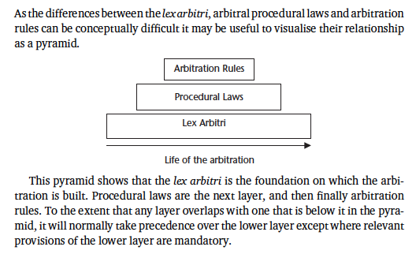

1. Diverging views on link between arbitration proceedings and seat of arbitration

Theoretical debate about the extent to which arbitration proceedings are linked and constrained by seat of arbitration’s laws and courts

* 1. Traditional view
* The traditional or jurisdictional view is that every private, commercial arbitration must be attached to a legal seat of arbitration
  + According to this view the seat of arbitration is the jurisdiction that gives legitimacy and legality to the arbitration proceedings and resulting award
    - Consequently, without the international arbitration law of the seat (the lex arbitri) which permits arbitration to take place, any arbitration proceedings would not exist legally
  1. Delocalised view
     1. Definition
* The delocalised or contractual conception of arbitration is that no link need exist between the seat of arbitration and arbitration proceedings taking place in that jurisdiction
  + Arbitration proceedings are said to gain legitimacy and existence from the parties’ contract
    - Principle consequence is that arbitration proceedings should be free from any interference from local laws at the seat of arbitration
    - The only domestic courts that can interfere are those asked to enforce a resulting arbitral award
      * It is only these enforcement courts that need to give the arbitral award state recognition because that is required before state-backed mechanism can be deployed to enforce and execute the award
        + Before the award is enforced, it exists simply as an extension of the parties’ contract
    1. International relations theory and delocalisation
* Delocalisation theory: many parallels with international relations theory
* When delocalisation advocates argue against the traditional view that international arbitration is attached to the seat of arbitration, they are not just arguing against it in the context of arbitration, but also against the Realism school’s understanding of how the world interacts.
  + To battle with any level of success, the delocalised view must itself have an equally developed theoretical analogy.
    - That analogy can be found in the international relations theory of Liberal Internationalism.
    1. Delocalisation in practice: relevant legal provisions
* Despite the theoretical attractions of delocalisation, it is important to keep in mind what the laws say and what domestic courts will do.
* The legal effectiveness of international arbitration depends principally on laws that facilitate the enforcement of international arbitration agreements and awards, that is mainly the New York Convention, and subsidiarily the various domestic lex arbitri which permit, legitimise and positively support international arbitration.
* The most significant barrier to the pure delocalisation view is found in Article I of the New York Convention:
  + “This Convention shall apply to the recognition and enforcement of arbitral awards made in the territory of a state other than the state where the recognition and enforcement of such awards are sought. (Emphasis added)”
    1. Conclusions on delocalisation
* A good example of delocalisation’s influence on the enactment of laws is the Model Law, which as explained above and elsewhere throughout this book, provides for very limited court interference and a very high degree of party autonomy. is not a phenomenon in its own right, but rather permitted by the state.`
  + Notwithstanding these theoretical conclusions, we consider the delocalisation debate to have had a very positive effect on the success of international arbitration by decreasing the level of court interference at the seat of arbitration and reducing the application of otherwise irrelevant local mandatory laws

1. Choosing the seat of arbitration
   1. General principles

* The parties to an arbitration are free to agree on the seat at any time. Usually, it is agreed in the arbitration agreement. If not, it might be agreed later.
* The freedom to choose the seat of arbitration is widely recognised by institutional arbitration rules. Such rules simply restate a fundamental right that parties have been granted by virtually all lex arbitri
  1. Factors to consider in choosing a seat of arbitration
* Realistically, the most important factor is the presence of laws and courts that are favourable to international arbitration : several criterias :
  + 1) The seat should be a party to the NYC
    - the seat’s arbitration law should provide for the desired level of judicial interference and control (id the desired level of delocalisation)
  + 2) Geographic and infrastructure convenience should be the second main criteria after the quality of the legal system and courts
    - Seat should be geo. convenient for most people
  + 3) the neutrality of the seat
    - a seat outside of the jurisdiction of any contracting parties
  1. Changing the seat of arbitration
* Once the seat of arbitration has been agreed or decided, as a general rule it can be changed only by agreement of all of the parties. If the arbitration has already begun, such an agreement would in practice need to be made in consultation with the arbitral tribunal itself.
* Indeed the chosen seat could be considered a condition of the consent to arbitrate. A court order to change the seat would give rise to an argument that the arbitration proceedings were not conducted in accordance with the parties’ agreement. Failing to follow the parties’ agreement exposes a resulting arbitral award to attack.
  + The only circumstance in which an agreed seat of arbitration could be changed under protest of one party is when the agreement on the initial seat has become frustrated or impossible.
    - A sufficient ground would appear to be that subsequent to the agreement on the seat of arbitration some legal or physical impediment had arisen which prevented the parties from seating their arbitration at the chosen location.

1. The Model Law as lex arbitri
   1. Asia Pacific and the Model Law

* many Asian jurisdiction have separate laws dealing with international arbitration or arbitration in general with special provision for international arbitration
  + this statute regulate issues that include:
    - validity of the arbitration agreement
    - nomination and removal of arbitrators
    - fundamental procedural rules
    - formal and substantive requirement for arbitral awards
    - recognition and enforcement of arbitration agreement and arbitral awards
  1. Mandatory provisions of the Model Law (1985)
* the pple of party autonomy in international arbitration dictates that parties should be free to agree on the procedure of their arbitrations
  + like all laws the model law contains mandatory provisions
    - applying irrespective of the parties’ choice
    - however as the Model Law is supposed to be non mandatory
    1. Article 1: Scope of application
* not typically included in the list of mandatory provisions
  + but it at least in part mandatory
* Article 1 of ML states when the ML applies
  + Even if derogations are possible, the parties cannot prevent the application of the ML under art 1 as to do so would create a paradox
    1. Article 7: Definition and form of arbitration agreement (1985)
* provides a definition and stipulates form requirements for an arbitration agreement
  + fails to be mandatory
    - especially since the 2006 revision of the ML offers an Option II whoch does not refer to writing at all
      * oral agreement possible
    - However, as a matter of practice it would generally be advantageous for an arbitration agreement to be in writing or evidenced in writing
  + The NYC requires the arbitration agreement to be in writing in order to have the award enforced
    1. Article 8(1): Arbitration agreement and substantive claim before court
* The ML imposes a mandatory stay of court proceedings where a valid arbitration agreement exists
  + 1. Article 11 (4) and (5): Appointment of arbitrators
* 11(4) is mandatory so far as its purpose is to ensure that the arbitration proceeds and cannot be frustrated by an unwilling participant
* 11(5) refers to the mandatory requirements that arbitrators be impartial and independent
  + both are essential characteristics of arbitration
    1. Article 12(1): Grounds for challenge
* 12(1) is not mandatory however it is identified in this list because it might at first sight be considered such
  + disclosure
    1. Article 18: Equal treatment of parties
* 18 can be described as a true cornerstone of arbitration
  + breach of “natural justice”
    1. Article 24(2) and (3): Hearings and written proceedings
* 24(2) relates to giving parties sufficient notice of hearings and meetings
* 24(3) is also mandatory: the basic obligation in this article is that all statements, documents or other information supplied to the arbitral tribunal by one party shall be communicated to the other party
  + 1. Article 34: Application for setting aside as exclusive recourse against arbitral award
* 34 deals with applications to set aside awards
  + 1. Article 35: Recognition and enforcement
* 35 sets out one of the fundamental tenets of arbitration: its binding and enforceable nature
  + parties are not able to undermine this principle by permitting the courts to review awards on grounds other than those provided by the law

**The New York Convention, especially Articles II and V**

**Article II**

1. Each Contracting State shall recognize an agreement in writing under which the parties undertake to submit to arbitration all or any differences which have arisen or which may arise between them in respect of a defined legal relationship, whether contractual or not, concerning a subject matter capable of settlement by arbitration.

2. The term "agreement in writing" shall include an arbitral clause in a contract or an arbitration agreement, signed by the parties or contained in an exchange of letters or telegrams.

3. The court of a Contracting State, when seized of an action in a matter in respect of which the parties have made an agreement within the meaning of this article, shall, at the request of one of the parties, refer the parties to arbitration, unless it finds that the said agreement is null and void, inoperative or incapable of being performed.

**Article V**

1. Recognition and enforcement of the award may be refused, at the request of the party against whom it is invoked, only if that party furnishes to the competent authority where the recognition and enforcement is sought, proof that:

1. The parties to the agreement referred to in article II were, under the law applicable to them, under some incapacity, or the said agreement is not valid under the law to which the parties have subjected it or, failing any indication thereon, under the law of the country where the award was made; or
2. The party against whom the award is invoked was not given proper notice of the appointment of the arbitrator or of the arbitration proceedings or was otherwise unable to present his case; or
3. The award deals with a difference not contemplated by or not falling within the terms of the submission to arbitration, or it contains decisions on matters beyond the scope of the submission to arbitration, provided that, if the decisions on matters submitted to arbitration can be separated from those not so submitted, that part of the award which contains decisions on matters submitted to arbitration may be recognized and enforced; or
4. The composition of the arbitral authority or the arbitral procedure was not in accordance with the agreement of the parties, or, failing such agreement, was not in accordance with the law of the country where the arbitration took place; or
5. The award has not yet become binding on the parties, or has been set aside or suspended by a competent authority of the country in which, or under the law of which, that award was made.

2. Recognition and enforcement of an arbitral award may also be refused if the competent authority in the country where recognition and enforcement is sought finds that:

1. The subject matter of the difference is not capable of settlement by arbitration under the law of that country; or
2. The recognition or enforcement of the award would be contrary to the public policy of that country.

**The UNCITRAL Model Law, especially Articles 1, 4, 5, 18, 19, 20 and 34.**

**Article 1. Scope of application**

* 1. This Law applies to international commercial arbitration, subject to any agreement in force between this State and any other State or States.
  2. The provisions of this Law, except articles 8, 9, 17 H, 17 I, 17 J, 35 and 36, apply only if the place of arbitration is in the territory of this State.

(Article 1(2) has been amended by the Commission at its thirty-ninth session, in 2006)

* 1. An arbitration is international if:

1. the parties to an arbitration agreement have, at the time of the conclusion of that agreement, their places of business in different States; or
2. one of the following places is situated outside the State in which the parties have their places of business:
3. the place of arbitration if determined in, or pursuant to, the arbitration agreement;
4. any place where a substantial part of the obligations of the commercial relationship is to be performed or the place with which the subject-matter of the dispute is most closely connected; or
5. the parties have expressly agreed that the subject matter of the arbitration agreement relates to more than one country.
   1. For the purposes of paragraph (3) of this article:
6. if a party has more than one place of business, the place of business is that which has the closest relationship to the arbitration agreement;
7. if a party does not have a place of business, reference is to be made to his habitual residence.
   1. This Law shall not affect any other law of this State by virtue of which certain disputes may not be submitted to arbitration or may be submitted to arbitration only according to provisions other than those of this Law.

**Article 4. Waiver of right to object**

A party who knows that any provision of this Law from which the parties may derogate or any requirement under the arbitration agreement has not been complied with and yet proceeds with the arbitration without stating his objection to such non-compliance without undue delay or, if a time-limit is provided therefor, within such period of time, shall be deemed to have waived his right to object.

**Article 5. Extent of court intervention**

In matters governed by this Law, no court shall intervene except where so provided in this Law.

**Article 18. Equal treatment of parties**

The parties shall be treated with equality and each party shall be given a full opportunity of presenting his case.

**Article 19. Determination of rules of procedure**

* 1. Subject to the provisions of this Law, the parties are free to agree on the procedure to be followed by the arbitral tribunal in conducting the proceedings.
  2. Failing such agreement, the arbitral tribunal may, subject to the provisions of this Law, conduct the arbitration in such manner, as it considers appropriate. The power conferred upon the arbitral tribunal includes the power to determine the admissibility, relevance, materiality and weight of any evidence.

**Article 20. Place of arbitration**

1. The parties are free to agree on the place of arbitration. Failing such agreement, the place of arbitration shall be determined by the arbitral tribunal having regard to the circumstances of the case, including the convenience of the parties.
2. Notwithstanding the provisions of paragraph (1) of this article, the arbitral tribunal may, unless otherwise agreed by the parties, meet at any place it considers appropriate for consultation among its members, for hearing witnesses, experts or the parties, or for inspection of goods, other property or documents.

**Article 34. Application for setting aside as exclusive recourse against arbitral award**

* 1. Recourse to a court against an arbitral award may be made only by an application for setting aside in accordance with paragraphs (2) and (3) of this article.
  2. An arbitral award may be set aside by the court specified in article 6 only if:

1. The party making the application furnishes proof that:
2. a party to the arbitration agreement referred to in article 7 was under some incapacity; or the said agreement is not valid under the law to which the parties have subjected it or, failing any indication thereon, under the law of this State; or
3. the party making the application was not given proper notice of the appointment of an arbitrator or of the arbitral proceedings or was otherwise unable to present his case; or
4. the award deals with a dispute not contemplated by or not falling within the terms of the submission to arbitration, or contains decisions on matters beyond the scope of the submission to arbitration, provided that, if the decisions on matters submitted to arbitration can be separated from those not so submitted, only that part of the award which contains decisions on matters not submitted to arbitration may be set aside; or
5. the composition of the arbitral tribunal or the arbitral procedure was not in accordance with the agreement of the parties, unless such agreement was in conflict with a provision of this Law from which the parties cannot derogate, or, failing such agreement, was not in accordance with this Law; or
6. the court finds that:
7. the subject-matter of the dispute is not capable of settlement by arbitration under the law of this State; or
8. the award is in conflict with the public policy of this State.
   1. An application for setting aside may not be made after three months have elapsed from the date on which the party making that application had received the award or, if a request had been made under article 33, from the date on which that request had been disposed of by the arbitral tribunal.
   2. The court, when asked to set aside an award, may, where appropriate and so requested by a party, suspend the setting aside proceedings for a period of time determined by it in order to give the arbitral tribunal an opportunity to resume the arbitral proceedings or to take such other action as in the arbitral tribunal’s opinion will eliminate the grounds for setting aside.

Cours 3 – Préparation

**Chapter 6 of book by Greenberg, Kee and Weeramantry ;**

1. **The arbitral tribunal: Introduction:**

* Redfern, Hunter: ‘[t]he reputation and accept- ability of international arbitration depends on the quality of the arbitra- tors themselves’
* The composition of the arbitral tribunal can significantly affect a range of important factors including:
  + whether the arbitration is conducted efficiently and economically,
  + whether the award is susceptible to challenge,
  + and even an individual party’s chances of success or failure.

Issues surrounding the constitution of the arbitral tribunal therefore deserve special attention.

* Life cycle of an arbitral tribunal chronologically

1. **Constitution of the arbitral tribunal**

* the main pple guiding appointment of arbitrators is party autonomy
  + in their contract or even after a dispute arises, parties are free to agree on the number of arbitrators, how they will be appointed and who they will be
    - when no agreement: the applicable arbitration rules or procedural law will provide a fallback mechanism to prevent the constitution process from being frustrated

1. Numbers of arbitrators

For obvious reasons, the number of arbitrators should be odd – usually one or three, but occasionally five. Parties often specify the number of arbitrators in their arbitration agreement, or agree on it once the dispute has arisen.

ICC statistics show that when the number of arbitrators is determined by party 6.8 agreement, the number agreed is usually three. In 2008, a three-member tribunal was appointed in 61% of ICC arbitrations. In 93.5% of those cases, the number of three was determined by party agreement rather than by the ICC Court.10 This is different for sole arbitrator cases. In the ICC arbitrations where there were sole arbitrators in 2008, the parties decided the number in only 69.4% of cases. In the remaining 30.6% of cases, it was the ICC Court which decided that there would be a sole arbitrator

4 approaches:

* default of one, but parties can require three
* one or three depending on the case
* depending on the amounts at stake
* default three (Model Law)

1. Procedure for constituting the arbitral tribunal

All institutional arbitration rules recognise the principle of party autonomy by allowing parties to agree on the procedure for constituting the arbitral tribunal and to participate in its constitution.

* Should party autonomy fail, all rules provide a default process to ensure that the arbitral tribunal is constituted and that the arbitration proceeds.
* **By adopting arbitration rules in their arbitration agreement, the parties voluntarily agree to this default process.** 
  + The appointment of arbitrators by an **‘appointing authority’** or institution, as specified in the arbitration rules, is therefore entirely consistent with party autonomy.
    - If failure: then court
* It is not advisable to attempt to select arbitrators before a dispute has arisen.
  + While a perceived advantage is that the arbitral tribunal composition will be faster and more certain, difficulties arise when the named person passes away in the interim period or for some other reason is unable or unwilling to act once a dispute arises.
    - Additionally, that person might, in the course of his or her personal life or professional activities since the arbitration agreement was made, have developed a conflict of interest.
* Rather than identifying a specific arbitrator in the arbitration agreement, a bet- 6.25 ter practice is to identify in advance an appointing authority (which could even be an individual identified by his or her position) or institution charged with selecting arbitrators if the parties cannot agree

1. Multiparty arbitration

* Prior to 1992, unless there was a contrary agreement by the parties, multiple claimants or respondents were ordinarily required to act as one during the composition of the arbitral tribunal. In other words, if a claimant commenced arbitration against two respondents, those two respondents would jointly be expected to nominate one co-arbitrator, whereas the claimant was entitled to nominate the other co-arbitrator.
  + In the now famous French Dutco case,32 two respondents argued that because they had different interests they should each be allowed to appoint an arbitrator.
  + The ICC arbitration agreement in that case provided for two party-nominated arbitrators, one nominated by each side.
    - The third and presiding arbitrator was to be selected by the co-arbitrators. The multiple respondents agreed under protest to appoint one co-arbitrator jointly and then later challenged the award, arguing that the arbitral tribunal had been improperly constituted. The French Cour de Cassation agreed, finding that equality in the appointment process was fundamental to arbitration and, under the particular circumstances, equality was lacking in the disputed appointment process.
* This decision prompted the ICC, the next time it amended its arbitration rules, to modify the appointment procedure in multi-party cases in order to ensure equality.
* **Consequently, Article 10 of the 1998 ICC Rules provides that if the multiple claimants or multiple respondents cannot agree on a candidate for joint nomination, then the ICC Court may appoint all three arbitrators – thus restoring equality because neither side is permitted to choose an arbitrator.**
  + Consequent changes in other arbitration institution
    - China only on ever considered that solution
      * CIETAC rules: choose the arbitrator for the party that could not agree
    - in Ace Pipeline Contracts Private Ltd v Bharat Petroleum Corporation Ltd36 the Indian Supreme Court upheld an arbitration clause contained in a contract which designated the marketing director of one of the parties as the arbitrator, and expressly denied the opposing party the right to object to the independence of that arbitrator on that ground
* **The main concern of the Dutco principle is to ensure equality in multi-party arbitrations.**
* Two aspects of equality must be respected.
  + The first is that all par- ties to the arbitration agreement must agree to and be aware of the appointment process. This may seem a somewhat trite observation.
    - However, this was missing among the Dutco participants. The ICC Rules in force at that time did not contain a specific procedure for multiparty arbitrations, so no process had been agreed.
  + Second, all parties should be treated equally meaning that, in certain circumstances, if one party loses the right to nominate an arbitrator so should all.

1. **Choosing an arbitrator**

* The autonomy of parties to choose arbitrators is a frequently cited benefit of arbitration.
* When considering what is desired in an arbitrator, it is useful to distinguish between qualifications and qualities.
  + Qualifications should be given its natural meaning, which involves some kind of formal, recognised training.
  + Qualities, on the other hand, are attributes.
* These may not be tangible or easily definable, as they may be something esoteric such as the manner in which an arbitrator approaches a problem.

1. Qualifications of an international arbitrator

* As a general rule there are no formal qualifications necessary to become an international arbitrator.
  + Legal knowledge and experience is not required but is highly desirable.
* Most arbitration laws and rules do not provide any required qualifications for arbitrators.
  + Japan:
    - Only licensed lawyers: “Bengoshi”
  + North Korea: Article 19 of the External Arbitration Law
  + Indonesia
  + Taiwan
  + South Korea
  + Bangladesh: rather unusually, provide rules for disqualifications
* However, most arbitration in the Asia-Pacific do not require any particular qualifications for arbitrators
* The qualifications of arbitrators can affect the manner in which courts may review any resulting arbitral award:
  + *Gold and Resource Developments (NZ) Ltd v Doug Hood Ltd*
    - Where the arbitrator chosen by the parties is legally qualified, it will be harder to obtain leave to appeal the arbitral decision on a question of law. As Lord Donaldson of Lymington MR stated in *Ipswich Borough Council v Fisons PLC* [1990] at p 724, if the chosen arbitrator is a lawyer and the problem is purely one of law, the parties must be assumed to have had good reason for relying on that lawyer’s expertise.
  + In 2004, a further statement was made in another New Zealand case, *Methanex* 6.47 *Motunui Ltd v Spellman*
* It is usually preferable not to provide for any strict qualifications of arbitrators in the arbitration clause as this may unduly burden the appointment process once a dispute arises.

1. Qualities of an arbitrator

* Qualities of an arbitrator concern the individual’s attributes. There are a number of generic attributes relevant to most arbitrators, such as language abilities and experience. Beyond that, a distinction can be drawn between qualities that are desirable in a chairperson or sole arbitrator, compared to those desirable in a party-nominated co-arbitrator.
  + Also consider the qualities of the tribunal as a whole
    - Three-member arbitral tribunal composed of arbitrators of three different nationalities: maximization of cultural adaptability
  1. Chairpersons and sole arbitrators
* The chairperson must be fair and be seen to be fair so as to inspire and maintain 6.54 the confidence of the parties and co-arbitrators.
* He or she must also have an ability to control the parties, manage the co-arbitrators and conduct the proceedings efficiently
* The qualities desired of sole arbitrators are similar to those of chairpersons, except that sole arbitrators are not required to manage co-arbitrators and the additional powers allocated to chairpersons are obviously not applicable
  1. Party nominated co-arbitrators
* Particular qualities are sought in party-nominated co-arbitrators.
  + These are often qualities which the appointing party perceives as suggesting that the arbitrator’s presence on the arbitral tribunal will increase its chances of success.
  + Of course, arbitrators – regardless of how they are appointed – are duty-bound to act at all times with impartiality and independence, and must not blindly support the party that nominated them
* That said, an individual arbitrator’s views on or approach to particular issues might be known or expected. An aspect of the person’s legal, cultural or other background or experience may mean he or she is likely to take a particular approach.
  + **Martin Hunter: ‘*when I am representing a client in an arbitration, what I am really looking for in a party nominated arbitrator is someone with the maximum predisposition towards my client but with the minimum appearance of bias’***.
  + He gives the example that ‘*in representing a government who has nationalised an oil company I’m not likely to choose an investment banker from a capitalist country with many years experience of battling for investors in less developed countries or someone who has published a series of articles showing that he has a conservative viewpoint on the interpretation of the phrase “prompt, adequate and effective” compensation’*
  1. Pre appointment interview
* It has become common for counsel and even parties to interview prospective arbitrators and in particular co-arbitrators before deciding whether to appoint them. This is another form of the due diligence parties will conduct on arbitrators.  Not surprisingly, this practice is sometimes controversial because it can lead to a perception of partiality. However, it is not prohibited and can be beneficial if used wisely and within ethical limits.
* For the benefit of both the party and the arbitrator a precise record of the interview should be made and provided to the opposing side once the arbitrator has been appointed.

1. **Formal appointment of arbitrators**

* It is important to distinguish between the nomination and the appointment of an arbitrator.
  + Simply because a person is nominated (or proposed) to act as arbitrator does not impose an obligation on him or her to accept the nomination.
    - Much like an ordinary contract for services, the position hinges on the principles of offer and acceptance. The nomination only binds the arbitrator once accepted.
    - As reviewed below, the arbitrator’s acceptance of the nomination may be all that is required to appoint an arbitrator but under certain rules the acceptance may constitute only a pre-condition to appointment.
  + The point at which appointment occurs can be of importance as it carries certain effects. It is generally only when an arbitrator has been appointed that he or she may be afforded immunity from civil liability.
    - Also the process can vary under some institutional rules: maybe steps to be taken to be appointed officially

1. **Obligations of arbitrators**

* ‘International arbitrators should be impartial, independent, competent, diligent 6.76 and discreet.’ Such is the first line of the Introductory Note of the 1987 IBA Rules of Ethics for International Arbitrators.
  + This guideline highlights the fact that being an arbitrator carries certain duties and obligations.
  1. General obligations and potential liability
* In accepting an appointment, arbitrators agree to the inherent duties of care and diligence attached to their role.
  + These duties may not be spelt out in arbitration rules but are nonetheless implied. As part of these duties, arbitrators should make themselves available and be able to devote the time and effort necessary to read the parties’ submissions carefully, examine the evidence produced, attend all meetings and hearings, and work on producing a quality award after a thorough, unbiased analysis of the entire case.
* **Born suggests that the obligations of international arbitrators can be summarized as:**
  + **a duty to resolve the parties’ dispute in an adjudicatory manner;**
  + **a duty to conduct the arbitration in accordance with the parties’ arbitration  agreement;**
  + **a duty to maintain the confidentiality of the arbitration;**
  + **in some contexts, a duty to propose a settlement to the parties;**
  + **and a duty to complete the arbitrator’s mandate.**
* As briefly referred to above, some international arbitration laws provide arbitrators with protection from civil law suits.
  + Although the precise wording differs slightly between the various legislation, for obvious reasons immunity is not generally given in situations where there has been fraud or some similar intentional dishonesty on the part of the arbitrator. (…)
* Most international arbitration rules also contain an exclusion of liability provision to protect arbitrators and arbitral institutions from civil liability.
  + In early  **2009 a decision of the Paris Court of Appeal** caused concern among the arbitration community when it suggested that the ICC Court could not validly exclude liability for acts or omissions in the performance of its essential duties.
    - Reasoning directed to an arbitral institutions but could be applied mutatis mutandi to arbitrators
* While arbitrators and arbitral institutions should be accountable for their actions or omissions, it is important they are able to perform their functions without fear of spurious liability claims. Given the considerable sums of money frequently involved in international commercial arbitrations, potential exposure to civil liability claims could have detrimental consequences on the manner in which arbitrators and institutions conduct arbitrations.
  1. Disclosure obligations
* Arbitration laws and rules impose a duty of disclosure of all facts or circumstances that may give rise to justifiable doubts as to the arbitrator’s impartiality or independence.
* **Impartiality and independence represent core obligations of an arbitrator**.
  + They are so widely recognised that they amount to general international principles and are therefore incumbent on any arbitrator in all circumstances.
* All arbitration laws and rules require arbitrators to be and remain independent, although there is variation in the precise language used.
  + The concepts of impartiality of independence are closely related but not exactly the same

1. General principles of disclosure

* Most laws and rules require prospective and serving arbitrators to disclose to the parties any circumstances that might give rise to a reasonable doubt about their independence or impartiality
  + **Article 12(1) of the Model Law**:
    - When a person is approached in connection with his possible appointment as an arbitrator, he shall disclose any circumstances likely to give rise to justifiable doubts as to his impartiality or independence. An arbitrator, from the time of his appointment and throughout the arbitral proceedings, shall without delay disclose any such circumstances to the parties unless they have already been informed of them by him
* Depending on the arbitration rules, the arbitrator may have to sign a declaration or statement of independence when appointed.
  + **Article 7(2) of the ICC Rules** provides in this regard:
    - Before appointment or confirmation, a prospective arbitrator shall sign a statement of independence and disclose in writing to the Secretariat any facts or circumstances which might be of such a nature as to call into question the arbitrator’s independence in the eyes of the parties. The Secretariat shall provide such information to the parties in writing and fix a time limit for any comments from them.
* Once a declaration of this kind has been made, a presumption exists that the arbitrator is impartial and independent as at the date of the declaration
  + The onus of rebutting that presumption lies with the party bringing the challenge
    - * **CA, 12 Février 2009** : A recent decision of the Paris Court of Appeal suggests that an arbitrator’s actual knowledge of a potential conflict of interest involving his law firm is not necessary, and that constructive knowledge may be sufficient to disqualify the arbitrator
        + Cour de Cassation: quelles suites?

1. IBA Guidelines

* The different national tests, as well as cultural attitudes towards impartiality and 6.95 independence, can create doubts as to what an arbitrator must disclose.
* The IBA has noted that ‘even though laws and arbitration rules provide some standards, there is a lack of detail in their guidance and of uniformity in their application.
  + As a result, members of the arbitration community often apply different standards in making decisions concerning disclosure, objections and challenges’.
* Do not have force of aw but referred to by parties, arbitrators and courts
* The IBA Guidelines consider various scenarios concerning when issues as to impartiality and independence arise and when they do not.
* For ease of reference, these are then categorised by colour – red, orange, and green.
  + Situations described in the **Red List** are those which create a conflict of interest. This list is divided into two sub-categories: the ‘non-waivable Red List’ and the ‘waivable Red List’.
    - Situations described in the **non-waivable Red List** give rise to a conflict of interest which automatically disqualifies arbitrators from accepting or continuing their mandate, regardless of whether a party has challenged the arbitrator. (…) This means a conflict of interest exists that must be disclosed.
    - The effect of a **waivable Red List** categorisation is that the arbitrator cannot continue to act unless the parties agree otherwise.
  + The **Green List** covers situations which do not give rise to a conflict of interest and, according to the IBA Guidelines, need not be disclosed.
  + In-between situations fall into the tricky **Orange List,** which is ‘a non exhaus- tive enumeration of situations which (depending on the facts of a given case) in the eyes of the parties may give rise to justifiable doubts as to the arbitrator’s impartiality or independence’.
* Also important: IBA Guidelines: non exhaustive!

1. **Challenges to arbitrators**

* After formal appointment of an arbitrator, that arbitrator can be challenged. A successful challenge will result in the impugned arbitrator’s removal.
* Ordinarily, he or she will be replaced but sometimes the remaining arbitrators can proceed without such a replacement.
  + The possibility for parties to challenge arbitrators ensures the integrity of the arbitration process.
* There are two main grounds on which to challenge an arbitrator:
  + partiality or lack of independence, and
  + misconduct.

1. **Challenges for partiality or lack of independence**

The underlying purpose of independence or impartiality requirements is to ensure that the parties are treated equally and that the award is not influenced by an arbitrator’s bias. What matters most, therefore, is ensuring that the arbi- trator is free of any influence on his or her decision-making. It follows that a party should be entitled to challenge an arbitrator who it considers to be lacking impartiality for any reason.

1. Impartiality and independence distinguished

* Most laws and rules use ‘independence’ and/or ‘impartiality’ as the operative language to test arbitrator bias
  + Clearer than neutrality
  + Distinct definition of both terms are thus extractable from scholarly writings
* A generally accepted definition of independence is the absence of actual, identifiable relationships with a party to proceedings or someone closely connected to the party.119 The test for independence examines the appearance of bias and not actual bias120 and is thus entirely objective.
  + Tangible elements
* Impartiality, in contrast to independence, is a subjective concept, concerned with the tendency of an arbitrator actually to favour one of the parties’ positions. Impartiality is not concerned with the outside appearance of bias. It does not necessarily require tangible relationships that could be the cause of the arbitrator acting unfairly. It examines the likelihood of an arbitrator actually having a state of mind or prejudgment that favours one side in the dispute.
  + Difficult to proove
* Use of factual elements

1. Procedure

* The procedural aspects of the challenge process will be determined by any express provisions of the arbitration agreement itself, the parties’ choice of arbitration rules or the lex arbitri.
  + Model Law Artcile 13
* There are three possible scenarios once a challenge is filed and before that chal- lenge is determined.
  + The opposing party may agree to the challenge:
    - Termination of the mandate
  + The resignation of the arbitrator (ICC not always accept an arbitrator’s resignation in these circumstances)
  + Third scenari: most frequent: the arbitrator does not resign and the opposing party contests the challenge:
    - In this scenario, a decision on the merit of the challenge will have to be taken

*Article 13 – Challenge procedure*

(1)  Thepartiesarefreetoagreeonaprocedureforchallenginganarbitrator,subject to the provisions of paragraph (3) of this article.

(2)  Failingsuchagreement,apartywhointendstochallengeanarbitratorshall,within fifteen days after becoming aware of the constitution of the arbitral tribunal or after becoming aware of any circumstance referred to in article 12(2), send a written statement of the reasons for the challenge to the arbitral tribunal. Unless the challenged arbitrator withdraws from his office or the other party agrees to the challenge, the arbitral tribunal shall decide on the challenge.

(3)  If a challenge under any procedure agreed upon by the parties or under the pro- cedure of paragraph (2) of this article is not successful, the challenging party may request, within thirty days after having received notice of the decision rejecting the challenge, the court or other authority specified in article 6 to decide on the challenge, which decision shall be subject to no appeal; while such a request is pending, the arbitral tribunal, including the challenged arbitrator, may continue the arbitral proceedings and make an award.

* A party wishing to challenge an arbitrator should do so as soon as practicable after it becomes aware of the facts leading to its concern
  + Significant costs involved
  + Risk of unvoluntary waiver
* Challenge needs to be brought within a certain time (15/30 days) from when the arbitrator was appointed, or, if later from when the challenging party became aware of the facts giving rise to the challenge
  + Ex: Grey District Council v Banks
    - Overcame the time limit: so unsatisfactory solution, but no choice
      * However, although time limits such as these may preclude the removal of an arbitrator, there may still be grounds to have an award set aside or to resist its enforcement on the basis the arbitrator was not independent

1. Assessment of impartiality and independence by arbitral institutions

* Since arbitration is in principle confidential, the decisions of arbitral institutions on any matters (including challenges) are usually kept confidential and not dis- closed. Moreover, the general practice of arbitral institutions is not to provide reasons for their decisions, either to the challenged arbitrator, any other arbitrators or to the parties.
  + More and more numbers/examples on the institutions Website ICC for instance
* Challenge against international arbitrators must be determined on a case by case basis
  + Which is contrary to the publication of a body of precedents
* ICC: number of stages at which the ICC Court may consider whether an arbi- trator is independent.
  + Confirmation (official start of the mission)
  + Statement of independence
  + If the content is validated: “qualified statement of independence”
  + The parties have then an opportunity to challenge the arbitrator’s confirmation

1. Assessment of impartiality and independence by domestic courts

* An arbitrator’s (or a judge’s) impartiality and independence is a public policy mat- ter. Therefore, in principle the courts maintain ultimate control over determining whether an arbitrator is independent and impartial. The fact that a challenge to an arbitrator is dismissed by an arbitral institution competent to decide the challenge in accordance with its rules does not in and of itself prevent a court from setting aside an award on the ground that, under its own standard, the challenge should have succeeded.

1. **the different tests used by domestic courts ????**

* Several test, then Lord Goff considered the issue in R v Gough
* Now: the ‘Gough test’ enquires ‘whether there was any real danger of uncon- scious bias on the part of the decision maker . . . ’
  + this test was followed in :
    - Laker Airways Inc v FLS Aerospace Ltd
    - AT & T Corporation and Lucent Technologies Inc v Saudi Cable Co
* Then: Porter v Magill:
  + Lord Hope phrased the test as ‘whether the fair-minded and informed observer, having considered the facts, would conclude that there was a real possibility that the arbitral tribunal was biased’
* The reasonable apprehension test: New Zealand is Muir v Commissioner of Inland Revenue: overruled Gough
  + - Two stage inquiry:
      * Establish the actual circumstances which have a direct bearing on a suggestion that possible bias
      * Ask whether those circumstances as established might lead a fair-minded lay observer to reasonably apprehend that the judge might not bring an impartial mind to the resolution of the case
  + Re Shankar Alan S/O Anant Kulkarni
    - Chan Sek Keong J in fact emphasised that the concern was not whether there is in fact a real likelihood or possibility of bias, but simply whether a reasonable man without any inside knowledge might conclude that there was an appearance of it.
  + Lee Hong Dispensary Superstore Co Ltd v Pharmacy and Poisons Board
    - Applicable test for apparent bias may be found in : Deacons v White & Case Ltd Liability: “reasonable apprehension test”
    - Lee Hong Dispensary was then placed by a higher court under Porter v Magill
    - Lee Hong Dispensary: reaffirmed by the judge in another HK case: Suen Wah Ling t/a Kong Luen Construction Engineering Co v China Harbour Engineering Co (Group)
  + Indonesia: Seraya Sdn Bhd v Government of Sarawak
    - Question of a real danger?

1. Selected court decisions on partiality and lack of independence
2. Inappropriateness of using the same bias test for judges and arbitrators
3. The standard for party nominated co-arbitrators

* It is not clear whether the standard for deciding whether an arbitrator is independent or impartial should be applied equally to all arbitrators.
  + In some jurisdictions like the US, there is sometimes said to be a greater expectation and therefore perhaps tolerance that party-nominated arbitrators will pursue the interests of the nominating party.
* **Most experienced arbitrators say that they do not feel a particular duty toward the party that nominated them**, **but tend to pay particular attention to the arguments presented by that party**.
  + This is perfectly acceptable and does not mean that the arbitrator will necessarily favour the position of the nominating party or try to influence the other arbitrators in that respect. The same standard for impartiality and independence can therefore be applied to all arbitrators, regardless of who nominated the arbitrator.

1. Impartiality and ar-med or med-arb

* Arb-med is a dispute resolution process which combines arbitration and mediation.
  + The mediation, if it occurs, will take place with the parties’ con-sent at an appropriate stage during the arbitration proceedings.
  + A more common variation is med-arb, where arbitration is preceded by mediation.
* Issues of impartiality will not arise in connection with the arb-med or med-arb processes if the arbitrator and mediator are different people.
  + But it may be the same individual who is asked to wear both hats. In those circumstances the question of impartiality becomes very real.
    - In such a case: as a practical matter, it would seem highly advisable for arbitrators to seek not only the parties’ agreement in writing, but also to have the parties waive challenge rights which may arise from the mediation process. Naturally, such a waiver would not affect the arbitrator’s duty to act independently and impartially.

1. **Challenges for misconduct**

Most arbitration rules and laws provide a mechanism for removing arbitrators for reasons other than relating to their independence or impartiality. Arbitrators can be removed for misconduct or when they fail to perform their functions, or fail to perform them in good time.

1. Definition and procedure

* Misconduct is not a term used in the Model Law or international arbitration statutes generally.
  + 2002 the Singapore High Court
* Article 14 of the Model Law provides for removal of an arbitrator who ‘becomes de jure or de facto unable to perform his functions or for other reasons fails to act without undue delay’.
  + The mechanism in Article 14 is very different from Article 13 (which deals with challenges as to independence and impartiality) because it provides a direct route to the court and is not time limited.
    - A court is only able to intervene to keep the arbitration moving when it has effectively stopped – albeit by the drastic measure of removing the arbitrator.

1. Arbitral institutions decisions on misconduct

* As noted above, the fact that arbitration is in principle confidential means that published decisions of arbitral institutions are rare. Nonetheless, some examples of ICC Court decisions on the removal of arbitrators have been made public

1. Court decisions on miscondonct

* Most allegations of arbitrator misconduct heard before courts tend to involve matters of procedure.
* A common expression associated with court-based applications of this kind is that a party has ‘lost confidence’ in the arbitrator’s ability to perform his or her duties.
  + This appears to have derived from the notion of misconducting the arbitration.

1. **Resignation and replacement of arbitrators**

Challenging an arbitrator is not the only circumstance in which a vacancy may occur on an arbitral tribunal. An arbitrator may resign his or her appointment, be subjected to an agreement by the parties to replace him or her, or may pass away during the course of the arbitration. This usually leads to replacement.

1. Resignation of arbitrators

It is always possible for an arbitrator to resign. The decision to resign is sig- nificant and should not be taken lightly. An arbitrator should only resign in circumstances where the integrity or efficiency of the arbitral process would be compromised by the arbitrator’s continued involvement.

Two arbitral institutions reserve the power to refuse to accept an arbitrator’s tender of resignation. They are the Bangladesh Council of Arbitration and the ICC Court

1. Agreements to replace arbitrators

Concerning party agreement to replace an arbitrator, one might expect that where all parties agree on replacement, the arbitrator would step down. This did not happen in one ICC Court case in 2008. The parties there agreed that the co-arbitrator nominated by claimant should be replaced because, despite what was stated on his curriculum vitae, he was not able to work in the language of the arbitration without the assistance of translators and interpreters.

The ICC Court took note of the parties’ agreement, in accordance with Article 12(1) of the Rules, and replaced the arbitrator with a new nominee provided by the claimant

1. Replacement of arbitrators

When an arbitrator resigns or is removed, the question of how to proceed with the arbitration inevitably arises. If the arbitration is institutional, the rules will contain a procedure to appoint a replacement. This is usually the same method adopted for the original appointment

The other aspect to the question of how to proceed concerns the conduct of the arbitration itself – and in particular whether it is necessary to repeat previous proceedings. In some instances it may be necessary and appropriate to provide the new arbitrator with an opportunity to hear witness testimony and oral sub- missions made prior to his or her appointment. In other instances, simply reading the transcript and submissions may be sufficient, thus saving considerable time and expense.

**IBA Guidelines on Conflicts of Interest in International Arbitration (pp. 169-189 of the Syllabus);**

* Problems of conflicts of interest increasingly challenge international arbitration
  + What to disclose?
  + More and more disclosures and at the same time more difficult conflict of interest issues to determine
  + Some standards exists but no details

Thus, parties, arbitrators, institutions and courts face complex decisions about what to disclose and what standards to apply. In addition, institutions and courts face difficult decisions if an objection or a challenge is made after a disclosure. There is a tension between, on the one hand, the parties’ right to disclosure of situations that may reasonably call into question an arbitrator’s impartiality or independence and their right to a fair hearing and, on the other hand, the parties’ right to select arbitrators of their choosing. Even though laws and arbitration rules provide some standards, there is  a lack of detail in their guidance and of uniformity in their application. As a result, quite often members of the international arbitration community apply different standards in making decisions concerning disclosure, objections and challenges.

The Committee on Arbitration and ADR of the International Bar Association appointed a Working Group of 19 experts1 in international arbitration from 14 countries to study, with the intent of helping this decision-making process, national laws, judicial decisions, arbitration rules and practical considerations and applications regarding impartiality and independence and disclosure in international arbitration.

* + Greater consistency is needed
  + Fewer unnecessary challenge
* Originally: only commercial arbitration but should apply to other types of arbitration
* **These Guidelines are not legal provisions** and do not override any applicable national law or arbitral rules chosen by the parties.
* The IBA and the Working Group view these Guidelines as a beginning, rather than an end, of the process. The Application Lists cover many of the varied situations that commonly arise in practice, but they do not purport to be comprehensive, nor could they be.

**Part 1: General standards**

* 1° General principle

*Every arbitrator shall be impartial and independent of the parties at the time of accepting an appointment to serve and shall remain so during the entire arbitration proceeding until the final award has been rendered or the proceeding has otherwise finally terminated.*

* 2° Conflict of interest
* 3° Disclosure by the arbitrator
  + Prior to the acceptance but also at any stage of the proceedings
  + if hesitation: then disclosure
* 4° Waiver by the parties
  + 30 days
* 5° Scope
* 6° Relationships
  + lawyer: client/state
    - entity of a group of company: case by case approach
* 7° Duty of arbitrators and parties
  + information about any direct or indirect relationship
  + provide any available information and shall perform a reasonable seach of publicly available information

**Part 2: Practical**

The purpose of the disclosure is to inform the parties of a situation that  they may wish to explore further in order to determine whether objectively — ie, from a reasonable third person’s point of view having knowledge of the relevant facts — there is a justifiable doubt as to the arbitrator’s impartiality or independence.

* Later challenge based on the fact that an arbitrator did not disclose such facts or circumstances should not result automatically in either non appointment, later disqualification or challenge to any arbitral award
* The borderline between the situations indicated is often thin.
* Guidelines: very practical so should provide specific guidance
* 3 lists
  + Red list: situations which, depending on the facts of a given case, give rise to justifiable doubts as to the arbitrator’s impartiality and independence; ie, in these circumstances an objective conflict of interest exists from the point of view of a reasonable third person having knowledge of the relevant facts
    - Non waivable red list: disclosure cannot clear the conflict
    - Waivable red list: serious but not as severe
  + Orange list: specific situation that in the eyes of the parties may give rise to justifiable doubts as to the arbitrator’s impartiality or independence
    - Duty to disclose
    - Disclosure not automatically results in disqualification
      * In the view of the Working Group, non-disclosure cannot make an arbitrator partial or lacking independence; only the facts or circumstances that he or she did not disclose can do so.
  + Green list: specific situations where no appearance of, and no actual, conflict of interest exists from the relevant objective point of view. Thus, the arbitrator has no duty to disclose situations falling within the Green List.
* The orange list is by far the longest

**Hrvatska Elektroprivreda d.d. v. Republic of Slovenia (ICSID Case No. ARB/05/24), Order Concerning the -Participation of a Counsel (6 May 2008) (attached); and**

The Claimant is deeply troubled by this development and seeks an order from the Tribunal that the Respondent refrain from using the services of Mr. Mildon QC. This raises two central issues: Does the Tribunal have the power to make such an order, and, if so, should it do so in the circumstances of this case?

The Tribunal's conclusion about the substantial risk of a justifiable apprehension of partiality leads to a stark choice: either the President's resignation (which, as noted, neither Party desires), or directions that Mr. Mildon QC cease to participate in the proceedings. In the light of the cardinal rule of immutability of Tribunals, (Article 56(1) of the Convention), resignation of its President is a course of action that the Tribunal simply cannot endorse in the present circumstances.

The Tribunal disagrees with the contention of Respondent that it has no inherent powers in this regard. It considers that as a judicial formation governed by public international law, **the Tribunal has an inherent power to take measures to preserve the integrity of its proceedings**.

* Exclusion of the Barrister

**Arrêt de la Court de Cassation, Premiere chambre civile, du 25 juin 2014, dans l’affaire Tecnimont (in particular, pp. 3-4, attached).**

**Règlement CCI**:

Selon le règlement CCI, la demande de récusation d'un arbitre doit être envoyée, à peine de forclusion, dans les 30 jours suivant la date à laquelle la partie introduisant la demande a été informée des faits et circonstances fondant cette demande.

**Arrêt CCass:**

CASSE ET ANNULE, en toutes ses dispositions, l'arrêt rendu le 2 novembre 2011, entre les parties, par la cour d'appel de Reims ; remet, en conséquence, la cause et les parties dans l'état où elles se trouvaient avant ledit arrêt et, pour être fait droit, les renvoie devant la cour d'appel de Paris, autrement composée

(…)

Attendu que, pour dire le moyen d’annulation recevable, l’arrêt retient que le juge de l’annulation n’est pas lié par le délai de recevabilité de la demande de récusation auprès de l’institution d’arbitrage, que la société Tecnimont soutient être dépassé le 14 septembre 2007 parce que la société Avax aurait eu au plus tard connaissance des événements motivant sa récusation entre le 16 juillet, lorsqu’elle a commencé à interroger M. Jarvin sur la conférence de Londres, et le 26 juillet 2007, date de la première réponse de ce dernier ; qu’il retient encore que l’absence de toute demande de récusation ultérieure contre M. Jarvin devant la CCI pour d’autres faits découverts par la recourante, selon ce que dit la société Tecnimont, entre la demande de récusation du 14 septembre 2007 et la sentence partielle du 10 décembre 2007, puis après la sentence jusqu’au 1er avril 2008, date à laquelle M. Jarvin a démissionné, n’interdit pas à la société Avax de critiquer la sentence dans la mesure où celle-ci n’a pas renoncé ; qu’après avoir relevé que **la société Avax avait à plusieurs reprises, tout d’abord, interrogé le président du tribunal arbitral sur l’étendue des liens entre le cabinet Jones Day, dans lequel il exerce, et la société Tecnimont, ainsi que d’autres sociétés s’y rattachant, tout en menant en parallèle des investigations, puis, réservé ses droits, l’arrêt en déduit qu’il n’est pas permis de conclure à une renonciation de la société Avax à invoquer le grief du manque d’indépendance de M. Jarvin en raison du non-exercice de la procédure de récusation devant la CCI** ;

Qu’en statuant ainsi, alors que la partie qui, **en connaissance de cause, s'abstient d'exercer, dans le délai prévu par le règlement d'arbitrage applicable**, son droit de récusation en se fondant sur toute circonstance de nature à mettre en cause l'indépendance ou l'impartialité d'un arbitre, **est réputée avoir renoncé à s'en prévaloir devant le juge de l'annulation**, **de sorte qu’il lui incombait** **de rechercher si, relativement à chacun des faits et circonstances qu’elle retenait comme constitutifs d’un manquement à l’obligation d’indépendance et d’impartialité de l’arbitre, le délai de trente jours imparti par le règlement d’arbitrage pour exercer le droit de récusation avait, ou non, été respecté, la cour d’appel n’a pas donné de base légale à sa décision** ;

**La semaine juridique du 21 juillet 2014, Seraglini**:

4. - Nouvel épisode sur le principe d'indépendance et d'impartialité de l'arbitre dans l'affaire Tecnimont. - La Cour de cassation (Cass. 1re civ., 25 juin 2014, n° 11-26.529, P+B+I : [JurisData n° 2014-013860](http://www.lexisnexis.com/fr/droit/search/runRemoteLink.do?A=0.9647446856615166&bct=A&service=citation&risb=21_T20523894789&langcountry=FR&linkInfo=F%23FR%23lnfr%23ref%25013860%25sel1%252014%25year%252014%25decisiondate%252014%25) ; [JCP G 2014, act. 742](http://www.lexisnexis.com/fr/droit/search/runRemoteLink.do?A=0.10262895550679141&bct=A&service=citation&risb=21_T20523894789&langcountry=FR&linkInfo=F%23FR%23fr_jcpg%23article%25742%25sel1%252014%25pubdate%25%2F%2F2014%25art%25742%25year%252014%25), Aperçu rapide Th. Clay) vient d'intervenir pour la deuxième fois dans cette affaire, bien connue. Pour rappel, la société italienne Tecnimont a conclu avec la société grecque Avax, un contrat de sous-traitance pour la construction d'une usine comportant une clause d'arbitrage CCI. Un différend étant né entre les parties, Tecnimont a mis en oeuvre la procédure d'arbitrage. Selon le règlement CCI, la demande de récusation d'un arbitre doit être envoyée, à peine de forclusion, dans les 30 jours suivant la date à laquelle la partie introduisant la demande a été informée des faits et circonstances fondant cette demande. Le 14 septembre 2007, Avax a déposé devant la CCI une requête en récusation contre le président du tribunal arbitral, laquelle a été rejetée le 26 octobre 2007. Le 10 décembre 2007, une sentence partielle a été rendue sur le principe de la responsabilité, contre laquelle Avax a formé un recours en annulation au motif que le président du tribunal aurait manqué à son obligation de révélation et à son devoir d'indépendance. La cour d'appel de Paris a annulé la sentence, la Cour de cassation a cassé l'arrêt d'appel, la cour d'appel de Reims de renvoi a annulé la sentence (CA Reims, 2 nov. 2011, n° 10/02888 : [JurisData n° 2011-028979](http://www.lexisnexis.com/fr/droit/search/runRemoteLink.do?A=0.5304554612763707&bct=A&service=citation&risb=21_T20523894789&langcountry=FR&linkInfo=F%23FR%23lnfr%23ref%25028979%25sel1%252011%25year%252011%25decisiondate%252011%25) ; [JCP G 2011, doctr. 1432](http://www.lexisnexis.com/fr/droit/search/runRemoteLink.do?A=0.9026286382235468&bct=A&service=citation&risb=21_T20523894789&langcountry=FR&linkInfo=F%23FR%23fr_jcpg%23article%251432%25sel1%252011%25pubdate%25%2F%2F2011%25art%251432%25year%252011%25), n° 5, obs. J. Béguin ; Rev. arb. 2012, p. 112, note M. Henry).

**Après cet arrêt, la position de la Cour de cassation était attendue sur deux questions :**

* **la force obligatoire du règlement d'arbitrage auquel les parties se sont soumises et**
* **l'étendue de l'obligation de révélation de l'arbitre.**

Cependant, la Haute juridiction ne se prononce que sur la première, en censurant une fois encore les juges du fond, mais apporte une précision d'importance sur le régime procédural de la contestation de l'indépendance et de l'impartialité d'un arbitre par les parties. Pour dire le moyen d'annulation recevable, la cour de renvoi a retenu que la récusation devant l'institution d'arbitrage et le contrôle de la sentence devant le juge de l'annulation sont des procédures distinctes qui n'ont pas le même objet et ne sont pas soumises à la même autorité, si bien que le juge de l'annulation n'est pas lié par le délai de recevabilité de la demande de récusation auprès de l'institution d'arbitrage, que Tecnimont soutenait être dépassé le 14 septembre 2007 dès lors qu'Avax aurait eu au plus tard connaissance des faits le 26 juillet 2007. Elle a de plus retenu que l'absence de toute demande de récusation ultérieure pour d'autres faits appris par la suite et même après la sentence, n'empêchait pas Avax de critiquer la sentence dans la mesure où celle-ci n'avait pas renoncé à son droit de récusation. Enfin, elle a estimé que les démarches et investigations entreprises par Avax permettaient de ne pas retenir de renonciation d'Avax à invoquer le défaut d'indépendance de l'arbitre en raison du non-exercice de la procédure de récusation devant la CCI.

**La Cour de cassation recadre la cour d'appel en jugeant que celui qui s'abstient, en connaissance de cause, d'exercer, dans le délai prévu par le règlement d'arbitrage applicable, son droit de récusation en se fondant sur toute circonstance de nature à mettre en cause l'indépendance ou l'impartialité d'un arbitre, est réputé avoir renoncé à s'en prévaloir devant le juge de l'annulation.**

Aussi, la cour d'appel devait rechercher si, relativement à chacun des faits et circonstances reprochés à l'arbitre, le délai de 30 jours imparti par le règlement d'arbitrage pour exercer le droit de récusation avait, ou non, été respecté.

La solution est bienvenue. Tout d'abord, il est depuis longtemps admis que lorsqu'une partie participe activement à un arbitrage, elle est « ***réputée avoir renoncé à se prévaloir ultérieurement des irrégularités qu'elle s'est, en connaissance de cause, abstenue d'invoquer devant l'arbitre***» (pour un défaut d'indépendance de l'arbitre, V. CA Paris, 16 mai 2002, ch. 1, sect. C : [JurisData n° 2002-241626](http://www.lexisnexis.com/fr/droit/search/runRemoteLink.do?A=0.8772509480473684&bct=A&service=citation&risb=21_T20523894789&langcountry=FR&linkInfo=F%23FR%23lnfr%23ref%25241626%25sel1%252002%25year%252002%25decisiondate%252002%25) ; Rev. arb. 2003, p. 1231, note E. Gaillard. - CA Paris, 28 oct. 2010, n° 09/20447 : Rev. arb. 2011, p. 691).

La solution a été reprise au nouvel [article 1466 du Code de procédure civile](http://www.lexisnexis.com/fr/droit/search/runRemoteLink.do?A=0.5718756525607034&bct=A&service=citation&risb=21_T20523894789&langcountry=FR&linkInfo=F%23FR%23fr_code%23title%25Code+de+proc%C3%A9dure+civile%25article%251466%25art%251466%25), issu du [décret n° 2011-48 du 13 janvier 2011](http://www.lexisnexis.com/fr/droit/search/runRemoteLink.do?A=0.9225733694596125&bct=A&service=citation&risb=21_T20523894789&langcountry=FR&linkInfo=F%23FR%23fr_acts%23num%252011-48%25sel1%252011%25acttype%25D%C3%A9cret%25enactdate%2520110113%25) et applicable à l'arbitrage international par renvoi de l'article 1506, 3°, qui précise que « la partie qui, en connaissance de cause et sans motif légitime, s'abstient d'invoquer en temps utile une irrégularité devant le tribunal arbitral est réputée avoir renoncé à s'en prévaloir ». Cette partie doit donc exercer son droit de récusation de l'arbitre à bref délai dès lors qu'elle a connaissance des faits qu'elle reproche à celui-ci (Cass. 1re civ., 1er févr. 2012, n° 11-11.084 : [JurisData n° 2012-001290](http://www.lexisnexis.com/fr/droit/search/runRemoteLink.do?A=0.35583925860304366&bct=A&service=citation&risb=21_T20523894789&langcountry=FR&linkInfo=F%23FR%23lnfr%23ref%25001290%25sel1%252012%25year%252012%25decisiondate%252012%25) ; [JCP G 2012, act. 201](http://www.lexisnexis.com/fr/droit/search/runRemoteLink.do?A=0.03416301975102398&bct=A&service=citation&risb=21_T20523894789&langcountry=FR&linkInfo=F%23FR%23fr_jcpg%23article%25201%25sel1%252012%25pubdate%25%2F%2F2012%25art%25201%25year%252012%25), obs. J. Béguin).

Ensuite, le règlement d'arbitrage a un caractère obligatoire pour les parties. **En adhérant au règlement CCI, les parties s'obligeaient donc, à peine de forclusion, à se prévaloir du défaut d'indépendance de l'arbitre au plus tard dans les 30 jours de la date à laquelle elles étaient informées des faits ou circonstances de nature, selon elles, à faire douter de son indépendance**.

Aussi, syllogisme logique, si les parties ne respectent pas ce délai, elles sont présumées avoir renoncé à se prévaloir, devant le juge de l'annulation, des circonstances en cause pour invoquer un défaut d'indépendance ou d'impartialité de l'arbitre.

Comme l'avait justement relevé un auteur, « ***à quoi servirait le règlement d'arbitrage s'il pouvait être contourné par les parties ?***» (Th. Clay, note ss CA Paris, ch. 1, sect. C, 12 févr. 2009, n° 07/22164 : [JurisData n° 2009-375722](http://www.lexisnexis.com/fr/droit/search/runRemoteLink.do?A=0.23039746909046677&bct=A&service=citation&risb=21_T20523894789&langcountry=FR&linkInfo=F%23FR%23lnfr%23ref%25375722%25sel1%252009%25year%252009%25decisiondate%252009%25) ; Rev. arb. 2009, p. 186, spéc. n° 18, p. 195).

**Aussi, le non-respect du délai posé par le règlement d'arbitrage doit être considéré comme privant le demandeur au recours en annulation de la sentence du droit d'invoquer des faits non dénoncés dans le délai stipulé, à tout le moins dès lors que ce délai apparaît raisonnable** (V. nos obs. : [JCP G 2010, doctr. 1286](http://www.lexisnexis.com/fr/droit/search/runRemoteLink.do?A=0.07736884030161117&bct=A&service=citation&risb=21_T20523894789&langcountry=FR&linkInfo=F%23FR%23fr_jcpg%23article%251286%25sel1%252010%25pubdate%25%2F%2F2010%25art%251286%25year%252010%25), n° 2). Au demeurant, l'actuel [article 1456, 3° du Code de procédure civile](http://www.lexisnexis.com/fr/droit/search/runRemoteLink.do?A=0.3650260886005069&bct=A&service=citation&risb=21_T20523894789&langcountry=FR&linkInfo=F%23FR%23fr_code%23title%25Code+de+proc%C3%A9dure+civile%25article%251456%25art%251456%25) précise qu'en cas de différend sur le maintien d'un arbitre, la difficulté est réglée par la personne chargée d'organiser l'arbitrage ou, à défaut, tranchée par le juge d'appui, saisi dans le mois qui suit la révélation ou la découverte du fait litigieux. Le règlement CCI n'est donc pas éloigné de la solution posée par le législateur lui-même.

Reste, dans cette affaire, la question de l'étendue de l'obligation de révélation, question à laquelle la Cour de cassation aura peut-être à répondre si la cour de renvoi s'en saisit, lors d'un énième épisode Tecnimont, série décidément bien (trop) longue.

Cours 4 – Préparation – The Arbitration Agreement

1. **Chapter 4 of the book by Greenberg, Kee and Weeramantry; The Arbitration Agreement**
2. **Introduction**

* **Arbitration agreements embody the consent of the parties to submit their disputes to arbitration**.
* In essence they oust the jurisdiction of domestic courts to decide certain disputes and instead empower an arbitral tribunal to resolve those disputes.
* The extent and scope of these **two functions** are dependent on the words of the arbitration agreement and the laws governing both that agreement and the arbitration proceedings.
  + **The arbitration agreement is especially important in determining the jurisdiction and powers of an arbitral tribunal.**
    - French courts have held that an arbitration agreement is **independent of all national laws and forms a supranational source of authority for arbitral jurisdiction**.

1. **Arbitration Agreement**
2. ***Is an arbitration agreement necessary?***

* The short answer is yes: an arbitration agreement is necessary in order to institute arbitration proceedings.
  + **Jorge Gonzales v Climax Mining Ltd, 2007**: The Philippines Supreme Court (among many others) has stated this in clear and simple language:

“*Disputes do not go to arbitration unless and until the parties have agreed to abide by the arbitrator’s decision. Necessarily, a contract is required for arbitration to take place and to be binding.”*

* **Every international commercial arbitration** *requires an arbitration agreement.*
* The definition of arbitration agreementsin **Article 7(2) of the Model Law** includes ‘*an exchange of statements of claim and defense in which the existence of an agreement is alleged by one party and not denied by another*’.

1. ***Types of arbitration agreements***

* **Arbitration agreements may be concluded:** 
  + **before or**
  + **after the dispute arises. The latter are called ‘submission agreements’.**
* In practice, most arbitration agreements are contained in contracts.
* Submission agreements are relatively rare because once a dispute arises one side may see an advantage in arbitration while the other refuses to arbitrate in order not to give the first side an advantage and/or to delay resolution of the case.
* If the arbitration agreement is in the form of a clause contained in a substantive contract (which is the norm), the arbitration agreement will generally be considered as having been formed at the same time as the contract is formed.
  + However, despite the identical time of formation and the fact that the arbitration agreement is a clause of the substantive contract, the arbitration agreement is normally treated as an agreement separate from the rest of the contract.
    - This means that it is possible for an arbitration agreement to have been made even though the substantive contract in which that agreement is contained never came into existence.
      * In these circumstances the arbitration agreement is preserved to resolve a dispute relating, for example, to the formation of the substantive contract.

1. ***Definition and formal requirements of an arbitration agreement***
2. *General*

* The writing requirement was further relaxed in the **2006 version of the Model Law**.
* In that version, two optional texts for **Article 7** (of the ML) are provided. The second does not stipulate any writing requirement whatsoever:

**Option I**

*Article 7. Definition and form of arbitration agreement*

(1) ‘Arbitration agreement’ is an agreement by the parties to submit to arbitration all or certain disputes which have arisen or which may arise between them in respect of a defined legal relationship, whether contractual or not. An arbitration agreement may be in the form of an arbitration clause in a contract or in the form of a separate agreement.

(2)  **The arbitration agreement shall be in writing.**

(3)  An arbitration agreement is in writing if its content is recorded in any form,  whether or not the arbitration agreement or contract has been concluded orally,  by conduct, or by other means.

(4)  The requirement that an arbitration agreement be in writing is met by an electronic communication if the information contained therein is accessible so as to be useable for subsequent reference; ‘electronic communication’ means any communication that the parties make by means of data messages; ‘data message’ means information generated, sent, received or stored by electronic, magnetic, optical or similar means, including, but not limited to, electronic data interchange (EDI), electronic mail, telegram, telex or telecopy.

(5)  Furthermore, an arbitration agreement is in writing if it is contained in an exchange of statements of claim and defense in which the existence of an agreement is alleged by one party and not denied by the other.

(6)  The reference in a contract to any document containing an arbitration clause constitutes an arbitration agreement in writing, provided that the reference is such as to make that clause part of the contract.

**Option II**

*Article 7. Definition of arbitration agreement*

‘Arbitration agreement’ is an agreement by the parties to submit to arbitration all or certain disputes which have arisen or which may arise between them in respect of a defined legal relationship, whether contractual or not.

* Even prior to its adoption of the **2006 revision** to the Model Law, New Zealand expressly recognized arbitration agreements made orally and similarly recognizes any resulting award
* **New Zealand Arbitration Act 1996 Article 7(1):** “*An arbitration agreement may be made orally or in writing. Subject to, an arbitration agreement may be in the form of an arbitration clause in a contract or in the form of a separate agreement.*”
* Ultimately, the role of the writing requirement is to **assist in proving that an arbitration agreement exists and the terms of that arbitration agreement**.

1. *Incorporation by reference*

Difficulties can arise when the arbitration agreement is said to have been incorporated by reference.

* This situation arises where parties have not included an arbitration agreement in their own contract,
  + but merely include **a reference to another document**, which contains an arbitration agreement.
* **The question is whether the arbitration agreement in the other document is binding on the parties to the contract.**
* The question of incorporation by reference should not in any way be confused with or influenced by the doctrine of separability.
  + (Essentially, it treats an arbitration clause in a contract as a separate and independent agreement from the contract containing it.)
* The general issue of incorporation by reference: typically arises in the context of an application to stay court proceedings.
* Although there have been some exceptions, the general approach adopted in the **Asia-Pacific** region is that:
  + **it is not necessary to refer specifically to the arbitration agreement for it to be incorporated by reference.**
  + The test is simply whether the parties **intended** to incorporate the arbitration agreement.
  + A specific reference, while not strictly necessary, is nevertheless advisable to avoid sometimes lengthy arguments on the point.
    - Traditional arguments: belief that an arbitration agreement is particularly special because it precludes avenues of state judicial recourse.
* The Malaysian Court of Appeal endorse the view that **the test is one of intent**, with or without express wording.
  + **Bauer (M) Sdn Bhd v Daewoo Corp 1999, and**
  + **Bina Puri Sdn Bhd v EP Engineering Sdn Bhd 2008** 
    - In the latter case, Justice Gopal Sri Ram was called upon to consider the incorporation of an arbitration clause in the absence of specific wording.
  + Singaporean High Court stated in Concordia Agritrading Pte Ltd v Cornelder Hoogewerff, 2001
    - “*I think it is a question of construction in each case. There must be a clear intention to incorporate an arbitration clause. If the words of incorporation are specific that intention may well have been clearly expressed*” (Justice Lim Teong Qwee).
  + In Conagra International Fertiliser v Lief Investments, 1997:
    - Justice Rolfe reached the view, based on the weight of authority, that specific reference was required to incorporate an arbitration agreement pursuant to Australian law.
  + The South Korean Supreme Court has noted that as a general rule explicit reference is required, but:
    - “*For an effective incorporation to take place an assignee (a holder) of the bill of lading knew or should have known about the existence of such an arbitration clause to be incorporated and an arbitration clause should not contradict with the other terms and conditions of the bill of lading after being incorporated; moreover, such arbitration clause of vessel hiring contract should be phrased comprehensively so that an arbitration clause of vessel hiring contract covers not only disputes arising between an owner of vessel and a vessel hiring person, but also applies to a holder of bill of lading*”.
  + Philippines Supreme Court in National Union Fire Insurance Company of Pittsburg v Stolt-Nielsen Philippines Inc, 1990, states that no explicit reference is required:
    - “*It is settled law that the charter may be made part of the contract under which the goods are carried by an appropriate reference in the Bill of Lading [ . . . ]. This should include the provision on arbitration even without a specific stipulation to that effect. The entire contract must be read together and its clauses interpreted in relation to one another and not by* parts.”
  + Hong Kong Court of First Instance decision Parkson Holdings Ltd v Vincent Lai & Partners (HK) Ltd, 2008:
    - Justice Burrell accepted that an arbitration clause in a domestic arbitration had been incorporated notwithstanding the absence of explicit wording to that effect.
      * This decision accorded with the position he had taken in Tsang Yuk Ching T/A Tsang Ching Kee Eng Co v Fu Shing Rush Door Joint Venture Co Ltd, 2003.
* **Did the parties intend to incorporate the arbitration agreement?**
* Proceedings under the New York Convention to enforce an award are another context in which incorporation of an arbitration clause by reference raises difficulties.
  + Article II (2) of the New York Convention does not refer directly to incorporation by reference.
    - The term ‘agreement in writing’ shall include an arbitral clause in a contract or an arbitration agreement, signed by the parties or contained in an exchange of letters or telegrams.
  + According to Di Pietro : “Article II does not deal directly with incorporation of arbitration clauses by reference”.
    - Supreme Court of Hong Kong: Jiangxi Prov’l 4.35 Metal & Minerals Imp & Exp Corp v Sulanser Co 1995:
      * Article II(2) does not use the word “only” so “the definition in that provision was not exhaustive”
        + But argument contested by Di Pietro

1. **Doctrine of separability**

* **The doctrine of separability treats an arbitration agreement contained in a contract as a separate agreement from the contract itself.**
  + **Article 16(1) of the Model Law** codifies the doctrine of separability as follows: 4.38

**Article 16 – Competence of arbitral tribunal to rule on its jurisdiction**

1. The arbitral tribunal may rule on its own jurisdiction, including any objections with respect to the existence or validity of the arbitration agreement. For that purpose, an arbitration clause which forms part of a contract shall be treated as an agreement independent of the other terms of the contract. A decision by the arbitral tribunal that the contract is null and void shall not entail ipso jure the invalidity of the arbitration clause.

* Without the doctrine of separability, or some equivalent:
  + the entire arbitral process could be frustrated
  + **a party wanting to avoid arbitration could simply assert that the contract was void and therefore go to court**.
* But the doctrine of separability is not without its critics.
  + Some commentators disagree with the present manifestation of the doctrine of separability, describing it as a legal fiction that favours commercial pragmatism over logic.
  + Others support the importance of the doctrine in general, but dispute its application where there is an allegation that the contract never existed at all.
* The core problem identified by those arguing that the doctrine is a legal fiction is that:
  + if a contract is void ab initio then as a matter of law it never had any effect; necessarily implying that the arbitration agreement never had any legal effect either.
    - Authors disagree: lack of precision of this critic that fails to recognize modern forms of contracts
* Those who argue against separability in cases of disputed existence of the con- tract then turn their attention to the actual language of the arbitration agreement. They contend that if the arbitration agreement refers to a contractual relation- ship then there is a problem.
  + but it will not apply if the arbitration agreement is found to cover dis- putes about formation of a contract, or claims relating to pre-contractual gains or expectations – ***quantum meruit or culpa in contrahendo*** for example.
    - To determine this question, the arbitral tribunal, or court as the case may be, will need to consider as a matter of fact what was the parties’ intended scope of the arbitration agreement
* **Article 16(1) of the Model Law** specifically empowers the arbitral tribunal to decide ‘*any objections with respect to the existence or validity of the arbitration agreement’*.
* The doctrine of separability simply instructs the inquirer to treat the arbitration agreement separately from the main contract for the purposes of determining its existence and validity.
* Three broad consequences may follow from the application of the doctrine of separability:
  + the arbitration agreement’s validity is considered separately from the main contract’s validity (which we have touched on in the discussion above);
  + ‘juridical autonomy’, meaning that a different law may apply to the arbitration agreement than that which applies to the substantive contract;
  + and finally there is an aspect of autonomy from all laws.

Although this last aspect is not generally found in Asia-Pacific international arbitration jurisprudence it has influenced arbitral practice and doctrine.

1. *Validity of main contract and arbitration agreement*

* When parties conclude a contract containing an arbitration agreement:
  + **they are concluding two separate agreements**
    - if the arbitration clause were part of the main contract, the arbitration clause would not come into existence unless the main contract did, and would be terminated when the main contract terminates.
    - Thus: the validity of an arbitration clause must be considered as a question separate from the validity of the contract containing that arbitration clause

1. *Law governing main contract and arbitration agreement*

* As an arbitration clause in a contract is an agreement separate from that in 4.50 which it is contained, the determination of the law that governs the arbitration clause and that which governs the contract must also be separate.
  + Might be different: the governing laws are not necessary different
* **Article 34(2)(a) of the Model Law** and **Article V(1)(a) of the New York Convention** refer to the determination of the validity of an arbitration agreement ‘under the law to which the parties have subjected it’.
  + There is no doubt that parties are free to choose the law that governs their arbitration agreement, even if it is a different law from that governing the main contract or from the lex arbitri.
* Common law jurisdictions have historically applied a rebuttable presumption that the law governing the main agreement will also govern the arbitration agreement.

1. *Validity of arbitration agreement determined independently of all national laws*

* French approach: consideration of the intent of the parties : only facts
  + According to the authors, “this approach cannot be endorsed”
    - Indeed when carefully considered this approach states that “as a matter of law (ie French Law), consent is the only element required to determine that there is an arbitration element
* Courts and arbitral tribunals in this region seek to establish a governing law for the arbitration agreement, on the basis of which validity is then considered

1. **Identifying the parties to an arbitration agreement**

* **As arbitration is based on consent**, an arbitration agreement can bind only those who are parties to it.
  + The question of identity of the parties to an arbitration agreement can arise when a party to the arbitration agreement seeks to enforce that agreement against another entity which contests that it is a party to the arbitration agreement or vice versa,
    - that is where a party to the arbitration agreement denies that another entity is a party to that arbitration agreement.

1. ***Non-signatories***

* Consensual nature of arbitration: however, a strict signature requirement would not accommodate the realities of cross-border trade, multinational companies and the inevitable temporal evolution of corporate structures and ownership
* Numerous theories developed by Courts, AT and commentators that may bind non signatories
  + Several of these theories were conveniently set out in the 1995 US decision Thomson-CSF SA v American Arbitration Association and Evans & Sutherland Computer Corporation
    - The court recognised five theories whereby a non-signatory could be bound by an arbitration agreement:

(i)  Incorporation by reference. has been discussed

(ii)  Assignment/Assumption. As the name suggests, this describes the circumstance when a non-signatory assumes or takes over one party’s obligations under a contract. **Together with taking on any potential liability, the non- signatory may also assume the remedial right (and obligation) to arbitrate.** (section 4.1.3)

(iii)  Agency. The question of whether an agent has the authority to enter into an arbitration agreement is one which will most likely be determined by reference to **domestic laws**. Accordingly, the arbitral tribunal would need to conduct a conflict of laws determination to ascertain which agency laws apply. This is a question for the arbitral tribunal not a court.

(iv)  Alter Ego/Group of Companies. (section 4.1.1)

(v)  Estoppel. (section 4.1.2)

1. *Alter ego and group of companies*

* **One party so dominates the affairs of another party, and has sufficiently misused such control, that it is appropriate to disregard the two companies’ separate legal forms and to treat them as a single entity.**
  + Parties frequently incorporate special purpose vehicles for a particular trans- action, for example a local subsidiary may be incorporated by a foreign multi- national construction company for a project it is undertaking in the subsidiary’s country.
    - Subsidiary will sign > separate legal entity so its legal parent will not be prima facie bound by the contract
      * Even if own at 100%
    - Domestic legal system provide mechanism to “pierce the veil”
  + Also theories according to which related companies can be considered parties to the arbitration
    - **“Alter ego” and ”single economic group” theories**
      * **The key question is usually factual participation by the related entity in the negotiation and/or the performance of the underlying transaction**
    - Method well established in Europe and US, not much in Asia region
* While such theories have not been readily applied by domestic courts, in the Asia-Pacific, international arbitral tribunals seated in the region have applied such theories on numerous occasions.
  + Given the strong trend towards recognizing alter ego or group of companies theories in continental Europe and the US, it is possible that Asia-Pacific jurisdictions will eventually follow suit.
    - The juridical foundation for this development may be the good faith requirement most prevalent in civil legal jurisdictions but also emerging in some common law jurisprudence.
    - It is also possible, however, that those Asia-Pacific jurisdictions following the Common Law tradition will be influenced by the rather conservative approach taken by English courts.

1. *Estoppel*

* **Estoppel is basically a legal principle by which a party is prevented from denying representations arising out of words or deeds on which another party has relied to its detriment.**
* Even if there is no detrimental reliance, the party making the representations may also be estopped from denying them where such a denial would be unconscionable.
  + Estoppel is a **common law principle**, although it has been accepted in other jurisdictions in particular in the context of international arbitration
* **There are two stages of the arbitral proceedings at which estoppel may be raised** in relation to the arbitration agreement.
  + The first is in front of a domestic court which has been asked to stay litigation, and so **prior** to the arbitration commencing a party may be estopped (prevented) by that court from denying the existence of the arbitration agreement.
  + The second occurs **after** an arbitration has been commenced, or even concluded, and one party asserts that there is no arbitration agreement.
* Ex of both situation can be found in Malaysian JP
  + First situation: Lai Sing Kejuruteraan (M) Sdn Bhd v Ten Engineering Sdn Bhd, 1997
  + Second situation: Bintulu Development Authority v Pilecon Engineering Bhd, 1997

1. *Assignment*

* **An assignment is a legal term that refers to the transfer of property or rights (such as contractual benefits and obligations) to another party**
* This other party may be a third party that was previously unrelated to the transaction. As such, where a contract containing an arbitration agreement is assigned, the third party ordinarily will not have signed the contract or the arbitration agreement
  + Born has noted a lack of uniform rules concerning the assignment of arbitration agreements
* The question of whether rights and obligations of an arbitration agreement are capable of assignment is **sometimes addressed within the arbitration agreement itself**.
  + Redfern and Hunter suggest that the effect of an assignment on an arbitration agreement will be determined primarily by two laws – the law governing the assignment and the law governing the arbitration agreement.
    - With respect to the law governing the assignment, some jurisdictions require specific intent to assign the arbitration clause but others assume such intent when a general assignment of rights takes place.

1. ***Capacity***

* A party must have the capacity to enter into an arbitration agreement. In every jurisdiction, rules regulate a legal person’s ability (be they an individual or corporate entity) to enter into a binding contract.
* The issue of a party’s capacity to enter into an arbitration agreement should be relatively straightforward. An arbitration agreement is no different from any other contract in this respect.
* Issues as to capacity may be raised **before or during the arbitration and may be submitted as a ground to set aside the award**.
* Capacity to enter into an arbitration agreement can also be relevant at the time of enforcement of an award.
  + **Article V1(a) of the New York Convention** states that enforcement may be refused if one of the parties was ‘under some incapacity’.
* Question often raised with regards to state entities
  + Dunham and Greenberg : observe that nation states should not be permitted to rely on their own laws to escape an arbitration agreement:
    - This principle is also recognised in international arbitral jurisprudence. One leading example is [ICC Case No 1939] rendered in 1971 in which the tribunal stated: ‘interna- tional ordre public would vigorously reject the proposition that a state organ, dealing with foreigners, having openly, with knowledge and intent, concluded an arbitration clause that inspires the co-contractant’s confidence, could thereafter, whether in the arbitration or in execution proceedings, invoke the nullity of its own promise.’ The principle that a state may not rely on its national law to escape its obligation to arbitrate appears as a ‘truly international public law provision for international arbitration law’ which is independent from the content of the domestic law of the state concerned.

1. **Defined legal relationship**

* The requirement of a ‘defined legal relationship’ found in:
  + **Article 7(1) of both the 1985 and 2006 versions of the Model Law,** as well as
  + **Article II(1) of the New York Convention**,

means that a single arbitration agreement cannot purport to cover all disputes that might arise between the parties. The arbitration agreement has to be limited in scope to disputes arising in respect of a defined legal relationship.

* Born has noted that in practice, ‘*the “defined legal relationship” requirement 4.88 has seldom been tested and has very limited practical importance’*

1. **Consolidation, joinder and third party notices**

Consolidation, joinder and intervention are increasingly associated with procedural aspects of arbitrations arising from disputes involving more than two parties or two parties but more than one contract. Fundamentally, they are all issues of consent and as such are intimately connected to the arbitration agreement(s).

* Tribunal consent must also be sought as a matter of courtesy but it is generally always granted.

Consolidation involves the fusion of two or more separate and independently existing arbitrations into one. Joinder and intervention, on the other hand, concern the introduction of one or more additional parties into a single, existing arbitration. Joinder and intervention are opposite sides of the same coin. The former refers to the situation where an existing party to the arbitration seeks to add a new party. The latter is when an entity that is not a party to the arbitration wishes to become a party.

The practice of consolidating court cases or joining third parties to court actions is widespread within domestic courts. However, as Born notes ‘*consolidation, joinder and intervention in international arbitration, as well as domestic arbitration, raise additional or different issues than in national court litigation*’.

* **A fundamental difference is that a national court with appropriate jurisdiction has the power to compel a party’s participation, whereas arbitrators have authority only over proper parties to the arbitration.**

This means the court must consider its jurisdiction at large rather than simply the man- date to resolve particular disputes between parties.

There is an increased complexity of cross-border commercial relationships and the consequential rise in international arbitrations involving more than two parties. In 2009, 233 ICC arbitrations (or 28.5% of all ICC arbitrations for that year) involved more than two parties. Out of these 233 cases, 206 (88.4%) involved between three and five parties. he existence of multiple parties to an arbitration does not, however, necessarily mean that issues of joinder or consolidation will arise.

There are numerous issues that can arise when consolidation, joinder or intervention is sought. It impacts :

* The speed and efficiency of resolving the initial dispute
* The maintenance of confidentiality : it potentially increases the number of entities that become aware of both the dispute and the evidence. The decision to consolidate, join or permit intervention must therefore give due consideration to issues of confidentiality.

One common requirement to consolidation, joinder and intervention is consent.

* However, The solutions offered by arbitral rules differ on whether specific consent is needed at the time of the proposed third party participation or whether this can be given broadly, before the issue arises.

1. ***Consolidation***

Consolidation involves bringing two or more separate arbitrations together and hearing them as one. If all parties to all arbitrations agree, consolidation can easily be effected. Problems arise when at least one party to one of the arbitrations does not agree to consolidation.

The Model Law and the New York Convention are silent on the issue of consolidation. This should not be interpreted as meaning that consolidation is not possible, but rather that it is a matter of party autonomy.

Several countries in the Asia-Pacific region have incorporated specific consolidation provisions into their international arbitration laws. Those provisions generally require parties expressly to opt in to the consolidation regime. Section 24 of the Australian International Arbitration Act 1974 is an example. When parties have opted in, the relevant arbitral tribunal is empowered to make a decision on consolidation.

In Asia-Pacific rules, there is no apparent requirement that the parties be identical in the different arbitrations to be consolidated.

* Such a requirement exists in Article 10 of the ICC Rules, giving it the advantage of predictability, but is sometimes criticised as being unnecessarily restrictive.

A properly drafted consolidation clause in the contract (or in each of the related contracts, as the case may be) is the best way to ensure that consolidation takes place as the parties desire.

1. ***Joinder and intervention***

The issues of joinder and intervention are similar. Both deal with the introduction of a third party to an existing arbitral proceeding. In the case of joinder, an existing party to the arbitration attempts to bring a third party into the proceedings, and to have that third party bound by the outcome of the proceedings. In the case of intervention, it is the third party itself that is seeking to participate in the arbitration proceedings.

If all of the parties to the existing arbitration as well as the potential new party consent to joinder or intervention, there should be no problem effecting it. As an additional part of its consent, the new party would need to agree to the already constituted arbitral tribunal (if there is one) and to the prior proceedings of the arbitration.

* Much like consolidation, problems relating to joinder and intervention arise when at least one party does not agree.

Although most arbitration agreements and arbitral rules are silent on the question of joinder, arbitral tribunals have inherent power to consider whether consent has been given to the type of joinder application that is being sought. This power results from the arbitral tribunal’s general power to determine the procedure.

* Of course, when the arbitral rules contain specific reference to joinder, an arbitral tribunal will need to apply the provided mechanism.

The SIAC Rules specifically describe the conditions for joinder :

* **SIAC Rule 24(b)** states that an arbitral tribunal may ‘allow other parties to be joined in the arbitration, provided that such person is a party to the arbitration agreement, with the written consent of such third party…
* The **2010 UNCITRAL Arbitration Rules** also now permit joinder in **Article 17(5)**. Pursuant to the new UNCITRAL rule the arbitral tribunal may at the request of any party join a third party provided that the party to be joined is a party to the arbitration agreement, and only after giving existing parties the opportunity to object on the basis of prejudice.

The **ICC International Court of Arbitration,** (may have changed with the new ICC rules) while its rules are silent on the question of joinder, developed a practice beginning from 2001 according to which the ICC Court itself decides whether new parties can be joined to an arbitration upon the application of an existing party. Three conditions need to be satisfied:

* (i)  no step has been taken towards the constitution of the arbitral tribunal (since the third party should, once included, have the right to participate  in constituting the arbitral tribunal);
* (ii)  the party to be joined signed the arbitration agreement (this shows a clear  intention beyond basic participation in the negotiation and performance  of the contract); and
* (iii)  the party requesting the joinder has introduced claims against the party  to be joined (merely reserving the right to raise claims later, or raising a conditional claim is generally insufficient, but an unfounded claim might be accepted as it is not for the ICC Court to determine whether a claim is well-founded).

In recent years, the ICC Court has relaxed the second requirement provided that there is evidence that the new entity to be joined is or could be a party to that arbitration agreement.

Ex : The ICC Court allowed joinder of a third party where the third party had signed an MOU amending the initial contract, but had not signed the contract itself. The new party was the claimant’s parent company. In addition to the new party’s signature of the MOU, which indisputably related to the contract and incorporated provisions of it, the ICC Court took into account many other factors, including that the new party had closely participated in the performance of the contract and had played a key role in settlement negotiations relating to the dispute.

In another case, the ICC Court joined a third party which was, undisputedly, the legal successor of a party to the contract containing the arbitration clause. The successor had signed a second, related contract which contained an identical arbitration clause.

**Intervention** covers the situation where a third party requests to participate as a party in an existing arbitration. Again, as is the case in joining a party, the focus of the arbitral tribunal should be on the consent of the parties. For example, Rule 43 of the JCAA Rules appears to suggest that general consent to its rules is not sufficient and that specific consent from all parties (excluding the third party attempting to intervene) is required

Here again, the best time for parties to contemplate joinder and intervention is during the drafting of the arbitration agreement.

1. ***Third party notices***

There is another capacity in which a non-party to the arbitration might be required to participate in it. Third party notices address the situation where an existing party, typically a respondent party, believes it has a right to pursue a third party for any liability that may be awarded against it in the arbitration.

* It is mainly used in domestic courts.

It is questionable whether similar mechanisms are or should be available in international arbitration. However, an ICC arbitral tribunal seated in Zurich has noted that ‘[d]espite the lack of statutory regulations, scholars and courts agree that the participation of third persons to an arbitration procedure . . . based on third person notice is possible in principle…

The arbitral tribunal further noted that ‘the conclusion of an arbitration agreement reflects the intention of the parties to be subject to private and confidential proceedings that exclude third persons. Therefore, third persons can only be admitted to the arbitration proceedings if all parties to the proceedings agree to this’.

1. **Enforcement of arbitration agreements**

Most arbitration agreements constitute an exclusive mechanism for resolving disputes. By agreeing to arbitrate, the parties agree to waive their right to submit their dispute to a national court. Notwithstanding such agreement, it is often the case that once a dispute arises one of the parties will see an advantage in commencing court proceedings rather than arbitration or will simply want to delay the matter.

Enforcement of arbitration agreements concerns the extent to which a domes- tic court will respect the parties’ exclusive arbitration agreement by staying its own proceeding when a party alleges that there is an arbitration agree- ment covering the dispute in question. This issue is addressed in the **New York Convention, Article II(1)** of which provides:

* *Each Contracting State shall recognize an agreement in writing under which the parties undertake to submit to arbitration all or any differences which have arisen or which may arise between them in respect of a defined legal relationship, whether contractual or not, concerning a subject matter capable of settlement by arbitration.*

If a court in a New York Convention state is called upon to recognise and enforce an arbitration agreement, and the Convention is applicable, pursuant to **Article II(3**), it must stay the proceedings in favour of arbitration. That Article provides:

* *A court of a Contracting State, when seized of an action in a matter in respect of which the parties have made an agreement within the meaning of this article, shall, at the request of one of the parties, refer the parties to arbitration, unless it finds that the said agreement is null and void, inoperative or incapable of being performed.*

The word ‘shall’ means that the state court has no discretion to refuse to stay its own proceedings and must refer the parties to arbitration unless it finds that the said agreement is null and void, inoperative or incapable of being performed. Similar wording can be found in **Article 8(1) of the Model Law**.

1. ***Existence of a dispute***

An interesting issue sometimes raised in attempts to deny the enforcement of an arbitration agreement is the question whether the court must determine if there is in fact a dispute. Malaysian legislation follows the New Zealand position of permitting a court to refuse a stay where it finds that there is no dispute between the parties.

1. ***Attaching conditions***

In some jurisdictions, such as Singapore and Australia, statutes have clothed courts with additional powers to impose conditions on the parties as part of the process of enforcing the arbitration agreement. For example, **Section 6(2) of the Singapore International Arbitration Act 2002** states:

* *The court to which an application has been made in accordance with subsection (1) shall make an order, upon such terms or conditions as it may think fit, staying the proceedings so far as the proceedings relate to the matter, unless it is satisfied that the arbitration agreement is null and void, inoperative or incapable of being performed.*

In the case of The ‘Duden’ Judge Andrew Ang of the Singapore High Court said: ‘*The discretion of the court to impose terms and conditions upon a stay of court proceedings in favour of arbitration is an unfettered discretion*’ (sans limite).

* In that case Judge Ang imposed a condition that the defendant waive the time bar defense that might have otherwise been available to it. Had the defendant not made such a waiver, the matter would not have been allowed to go to arbitration.

Observation of the New South Wales Court of Appeal :

* *The ‘conditions’ which s 7(2) of the [Model Law] contemplates are machinery conditions. They relate to hearing and the like procedures and not to conditions which determine, in effect, the substantive rights of the parties.*

**The power to impose conditions on the decision to enforce a stat of application is unusual.**

1. **Arbitrability**

At its simplest, the question of ‘arbitrability’ concerns whether a dispute is capable of determination by arbitration. For a matter to be determined by arbitration the parties must have agreed for it to be determined by arbitration – this is a subjective act; something that is personal to the parties. In addition to party agreement, the applicable law must allow disputes of that kind to be determined by arbitration – this is objective; if resolution of that kind of dispute by arbitration is prohibited, the parties’ intentions become irrelevant.

1. ***Subjective arbitrability***

Subjective arbitrability concerns whether the parties have agreed to arbitrate cer- tain claims or issues. Usually this requires interpreting the arbitration agreement, including phrases such as ‘in connection with’ or ‘arising out of’ the contract. Identifying which law applies to the arbitration agreement, and applying that law to it, may significantly affect the outcome.

Where commercial parties agree to arbitrate, their presumed desire is for all of their claims – pre-contractual or post-contractual – arising in any way from that relationship to be decided by arbitration. It is very unlikely that they would want to be engaged in a process where some claims relating to a dispute are resolved by a court and other claims in that dispute are determined by arbitration.

*Newmark Capital Corporation Ltd v. Coffee Partners Ltd* – Hong-Kong (2007)

The decision provides insight into the interpretative process that may be followed by a common law court in this region when determining the scope of an arbitration agreement :

*But the scope of the arbitration clause still has to be ascertained by reference to applicable principles of law and construction. …*

*It may be said that the alleged acts of making misrepresentations formed part of the ‘affairs’ . . . . Further, some of the alleged misrepresentations related to the way the company would be run and managed, and that in demonstrating the ‘falsity’ of the representations one had to look at the way in which the ‘affairs’ . . . were conducted and hence the claim falls within this part of the clause. But I do not think that the phrase ‘touching . . . relating to the affairs of [CPL]’ meant these sorts of disputes. I accept . . . that the phrase ‘affairs of the Company’ . . . is intended to cover a complaint about the administration . . . such as allegations of unfair prejudicial conduct, fraud on minority and similar claims. Otherwise, the clause will cover any or all disputes with CPL, because all disputes with CPL must necessarily arise out of things done (or not done) by CPL and disputes about any such acts or omissions by CPL would be a dispute on the “affairs” of CPL. Article 21.1 is not and cannot be as broad as that. If it is as broad as that, then much of Article 21.1 would be otiose. It would only need to say “all or any disputes with CPL whatsoever”. That, however, is not what Article 21.1 says.*

In a 2007 decision, English judge Lord Hoffmann considered the difference between the meaning of *under* a contract and *arisint out of* a conract. He noted : *In my opinion the construction of an arbitration clause should start from the assumption that the parties, as rational businessmen, are likely to have intended any dispute arising out of the relationship into which they have entered or purported to enter to be decided by the same tribunal. The clause should be construed in accordance with this presumption unless the language makes it clear that certain questions were intended to be excluded from the arbitrator’s jurisdiction.*

1. ***Objective arbitrability***

Objective arbitrability concerns matters the law actually permits parties to resolve by arbitration. It is a legal, objective test. If the law prevents a particular kind of dispute from being decided by arbitration, then the consent of all the parties to arbitrate that type of dispute becomes irrelevant.

Comparative analysis of French, Swiss, German, English and US law (Lehmann) : *a trend existing in a number of legal systems, incumbent in countries of different legal cultures and with divergent traditions regarding arbitration* *toward extending the categories of disputes in which arbitral adjudication is permitted*’

That trend is reflected in several Asia-Pacific jurisdictions. In Singapore for example ‘no specific subjects have been identified by statute as being or as not being arbitrable’. However**, it is generally accepted that issues, which may have public interest elements, may not be arbitrable**, **for example citizenship or legitimacy of marriage, grants of statutory licences, validity of registration of trade marks or patents, copyrights, winding-up of companies’**

In many jurisdictions, disputes are not arbitrable if determining them through arbitration would contravene public policy or the public interest. However, **these are amorphous concepts that are not precisely defined in most, if indeed any jurisdiction.**

Another category of dispute that may not be objectively arbitrable in some jurisdictions – ***in rem* rights**. *In rem* rights are typically rights that can be exercised directly over property, for example a right of exclusive possession. Such rights may not be enforceable by arbitration.

1. **Drafting Arbitration Agreements**
2. ***Essential elements to include in an arbitration agreement***

There are four certainties required for an effective arbitration agreement:

* (i)  certainty regarding the **identity of the parties**;
* (ii)  certainty that the parties have agreed to **submit their disputes exclusively to arbitration** (and not another method of dispute resolution);
* (iii)  certainty as to the **subject matter** or scope of arbitrable disputes; and
* (iv)  certainty of the **seat of arbitration**, if designated.

1. Identity of parties

It is essential to ensure that the arbitration agreement specifies the identities of those who are agreeing to arbitrate. If the arbitration agreement forms part of a substantive contract, the term ‘parties’ will usually be defined in the contract, or will be assumed to mean all the parties to the contract. However, in complex commercial transactions where there is a series of contracts and some of the parties are different in the different contracts, the arbitration clause should be clear about which parties are bound by it.

1. Obligation to arbitrate

Arbitration agreements should provide that the dispute will be referred to arbitration. If an arbitration agreement provides that a dispute may be referred to arbitration, or words to the effect that ‘the parties might decide to refer a dispute to arbitration’, there is not a clear obligation to arbitrate. Ambiguity may lead to disputes concerning whether the matter is to be referred to the courts or to arbitration, and could even deny enforceable effect to the arbitration agreement.

Clauses providing for the settlement of disputes by arbitration but which are silent as to whether the parties may also go to court have sometimes led to arguments that the silence permits parties to litigate in courts. Such arguments should not prevail. As the Hong Kong Court of Appeal stated in *Grandeur Electrical Co Ltd v Cheung Kee Fung Cheung Construction Co Ltd,* ‘*a clause in a contract providing for disputes to be settled by arbitration should not readily be construed as giving a choice between arbitration and litigation unless that is specifically and clearly spelt out*’.

Uniform practice does not exist in relation to whether arbitration agreements containing an option either to arbitrate or litigate are invalid for lack of certainty. In Australia such optional agreements are valid.

Sri Lankan court’s decision :

* Defendant in the arbitration commenced proceedings against the plaintiff before the Colombo High Court requiring a stay of proceeding against the plaintiff on the basis of Section 5 of the Sri Lankan Arbitration Act of 1995 which states :
  + *Where a party to an arbitration agreement institutes legal proceedings in a court against another party to such agreement in respect of a matter agreed to be submitted for arbitration under such agreement, the Court shall have no jurisdiction to hear and determine such matter if the other party objects to the court exercising jurisdiction in respect of such matter.*
* The arbitration relied on by the plaintiff read : …*in the event that fail to do so* (negotiating) *after 14 days then either party may elect to submit such matter to arbitration in Singapore…*
* In this instance, the words may elect were interpreted by the Sri Lankan court to mean that the parties could choose either arbitration or the courts, and thus the clause was not of the sort contemplated by Section 5. The Colombo High Court refused the stay application.

When drafting an arbitration clause it is also very important that it is arbitration that the parties are choosing as their dispute resolution method. To be safe, the word ‘arbitration’ or something similar (e.g. ‘arbitrator’, ‘arbitral tribunal’) must appear in the arbitration agreement.

There is sometimes confusion about the difference between arbitration and expert determination. Although these two processes share some similarities, there are nevertheless fundamental differences, and different consequences at law. For example, a matter may not at law be capable of resolution by arbitration, whereas expert determination of that same dispute may still be possible. Guidance on the differences can be taken from the HK decision of Justice Kaplan in *Mayers v. Dlugash*:

* Arbitration is a tried and tested method of dispute resolution where the parties do not wish to litigate their differences before state courts. Expert determination, although having been used for centuries, is perhaps not so widely known. The classic features of expert determination are:
* The expert makes a final and binding decision.
* The decision can only be challenged in the most exceptional circumstances such  as where the expert answers the wrong question
* The expert can be sued for negligence in the absence of an agreed immunity
* **The expert’s determination can not be enforced as an arbitral award.**

Last point is of significant practical relevance. One of the significant advantages of international arbitration is the international enforceability of the award. Expert determinations are not covered by the New York Convention and there is no other international regime for their enforcement.

The final observation to make about the obligation to arbitrate is that in many jurisdictions it must be an equally shared obligation between all the parties to the agreement. An obligation to arbitrate requires that all parties be bound by the outcome. However, this is not quite the same as stating that each party must have the same rights. For example, must all parties to the arbitration agreement have the right to initiate arbitration? In Australia, the answer appears to be no.

1. Subject matter and scope of arbitration

An arbitration agreement must clearly specify which disputes it covers. In the absence of a real reason to limit the scope of arbitrable disputes, and in order to avoid the possibility of parallel court proceedings, an advisable strategy is to maximize as far as possible the scope of the arbitration agreement. Broad wording should be used, such as ‘all disputes arising out of, connected with or in any way related to this contract shall be resolved by arbitration.

1. Certainty of the seat if designated

It is strongly advisable to designate a seat of arbitration in the arbitration agreement. If one is designated, it must be clear and certain. There are two reasons for this. First, an ambiguous reference to the seat of arbitration can in a worst case scenario give rise to doubts about the validity or effectiveness of the arbitration agreement.

Second the chosen seat may have particular requirements for an arbitration agreement.

1. ***Advisable elements to include***

In addition to the required elements noted above, it is advisable, but not essential, to include the following selective elements in an arbitration agreement:

* (i) the number of arbitrators;
* (ii) the language of the proceedings;
* (iii) the confidentiality of the arbitration proceedings and the resulting award; and
* (iv) any desired special powers for the arbitral tribunal.

Number of arbirators : Whether or not it is necessary or desirable to choose the number of arbitrators in advance may depend on the chosen arbitration rules, and whether they provide a suitable mechanism for determining the number of arbitrators in the absence of party choice.

Language : Selecting a language in the arbitration agreement may avoid a dispute prior to the commencement of the arbitration as to what should be the language. In choosing the language, the potentially substantial cost, time and logistical issues relating to document translation and use of interpreters during the hearing must be borne in mind.

Confidentiality : Concerning confidentiality, as discussed in Chapter 7, while arbitrations are private, documents and information disclosed during an arbitration may not necessarily be confidential in the absence of a further contractual obligation. In many jurisdiction an obligation of confidentiality is implied. However, it is prudent to assume that it is not.

Special powers : When parties intend to grant arbitrators particular powers, these should be clearly specified in the arbitration agreement. Such specificity is necessary, for example, where parties wish the arbitrators to act as *amiable compositeur,* or to resolve the dispute on the basis of fairness and equity. Special powers might also be given to affirm the arbitral tribunal’s authority to award punitive damages, issue ex parte interim relief, make special costs awards, or award specific performance.

1. ***Ad hoc or institutional arbitration***

That decision should be specified in the arbitration agreement. In an institutional arbitration, the arbitral institution provides certain support services for the arbitration. In ad hoc arbitrations there is no institution involved.

Different institutions administer arbitrations in varying degrees. It is important that parties and their legal representatives appreciate these differences when choosing an institution. The choice of institution and corresponding rules can have a significant influence on the kind of arbitration that will occur.

The ICC and SIAC Rules, for example, provide for considerable institutional involvement and supervision, whereas the ACICA Rules take a much more hands- off approach. This difference is manifested in a number of ways throughout the arbitration. For instance, an award delivered in an ICC or SIAC arbitration will be reviewed by the ICC Court or SIAC Registrar, while there is no similar provision in the ACICA Rules.

**Institutiosn vary immensely in their level of experience and quality of staff.**

Drawing an analogy between choosing a law firm and choosing an arbitra- tion institution serves to illuminate the particularities associated with the latter choice. There are two essential differences.

* First, the choice of an arbitral institution is usually made in a contractual dispute resolution clause. Such clauses are agreed long before a dispute actually arises and before anyone knows the type or subject matter of the dispute or how much it could be worth to the parties. Conversely, a law firm is usually chosen as and when the need arises: the choice is made with the benefit of knowing the particular dispute or commercial issues.
* Second, it is generally not possible to change the choice of arbitral institution after signing the contract in which that choice is contained. That choice can only be varied if all of the parties to the arbitration agree. This contrasts with the choice of a law firm, which can usually be changed at any time if the client is not satisfied with the legal services rendered.

Consequently, in choosing an arbitra- tion institution, it is advisable to consider carefully the costs, range of services, supervision and support it is able to provide before it is selected and agreed to in a dispute resolution clause.

Parties sometimes attempt to agree on one institution’s rules but with a dif- ferent institution administering those rules. The attempted mix and match is highly likely to lead to costly jurisdictional disputes and to invalidate the award or make it unenforceable.

* Ad hoc arbitration

As hoc is something of a term of art in arbitration. The emphasis is on the lack of institutional administration of the arbitration. There may be some limited institutional involvement in an ad hoc arbitration, such as performing the role of appointing authority. This should not be considered as an act of administering the arbitration.

**Ad hoc arbitration agreements often adopt a set of ad hoc rules, the most common being the UNCITRAL Arbitration Rules. The parties can alternatively rely on the local law at the seat of arbitration to provide the relevant rules of arbitration**

1. ***Multi-tiered arbitration agreements***

A multi-tiered arbitration clause provides for one or more other steps, such as an amicable form of dispute resolution, before arbitration. For example, the clause might first require negotiation, followed by mediation and then arbitration.

A variety of issues need to be considered when drafting these clauses. Do the parties intend that negotiation and then mediation are conditional prerequisites to arbitration, such that there is no consent to arbitrate until mediation has occurred? Or do the parties intend that in the event there is a serious disagreement between the parties, mediation can be overlooked and a party may commence arbitration directly without attempting mediation?

Because of the many difficulties that can plague a multi-tiered arbitration clause, it is advisable to use one prepared by an institution and modify it only to the extent absolutely necessary.

1. ***What not to include in an arbitration agreement***

Long and detailed arbitration clauses generally take a long time to draft and in the event of arbitration are not overly helpful.

* it might produce some problems if an unforeseen circumstance eventuates (which is often the case) and the clause lacks the flexibility to deal with this in an appropriate way.

Consequently, it is best to keep the clause as simple as possible and carefully adapt a standard form institutional clause to fit any particular requirements. If a complex or detailed clause is desired for any reason, it should be checked by an expert arbitration lawyer.

1. ***Pathological arbitration agreements***

The term has been used to describe ambiguous or unclear arbitra- tion agreements. Such agreements frequently cause additional problems when a dispute between the parties arises.

The modern trend in international arbitration law is to apply an interpretation that favours arbitration and gives meaning and effect to the clause, even if an arbitration agreement is at first blush potentially pathological (*effet utile*). The defects in many arbitration clauses are overcome and the arbitration proceeds.

Examples of defects include :

* (i)  naming the arbitral institution incorrectly or identifying a non-existent  institution;
* (ii)  empowering one institution to administer another institution’s rules;228
* (iii)  referring to an arbitral institution by its location rather than by its name;229
* (iv)  failing to indicate clearly that the award is final and binding;230
* (v)  identifying a specific arbitrator who has died or become unable to act thereafter; and
* (vi) drafting terms that are inherently contradictory to other terms in the arbitration agreement.

The second category referred to above concerns requesting one institution to administer the rules of another. This can be particularly problematic because in general only the institution whose rules it is can properly administer arbitrations conducted under those rules. Clauses that attempt to choose two institutions at once will almost certainly cause greater cost and significantly increase the risk of an unenforceable award.

1. **Model Recommended Arbitration Clauses (ICC LCIA and UNCITRAL);**
2. **ICC**

Arbitration

All disputes arising out of or in connection with the present contract shall be finally settled under the Rules of

Arbitration of the **International Chamber of Commerce** by **one or more arbitrators** appointed in accordance with the said Rules.

Arbitration without emergency arbitrator

All disputes arising out of or in connection with the present contract shall be finally settled under the Rules of

Arbitration of the International Chamber of Commerce by one or more arbitrators appointed in accordance with the said Rules. The Emergency Arbitrator Provisions shall not apply.

Optional ADR

The parties may at any time, without prejudice to any other proceedings, seek to settle any dispute arising out of or in connection with the present contract in accordance with the ICC ADR Rules.

Obligation to consider ADR

In the event of any dispute arising out of or in connection with the present contract, the parties agree in the first instance to discuss and consider submitting the matter to settlement proceedings under the ICC ADR Rules.

Obligation to submit dispute to ADR with an automatic expiration mechanism

In the event of any dispute arising out of or in connection with the present contract, the parties agree to submit the matter to settlement proceedings under the ICC ADR Rules. If the dispute has not been settled pursuant to the said Rules within 45 days following the filing of a Request for ADR or within such other period as the parties may agree in writing, the parties shall have no further obligations under this paragraph.

Obligation to submit dispute to ADR , followed by arbitration if required

In the event of any dispute arising out of or in connection with the present contract, the parties agree to submit the matter to settlement proceedings under the ICC ADR Rules. If the dispute has not been settled pursuant to the said Rules within 45 days following the filing of a Request for ADR or within such other period as the parties may agree in writing, such dispute shall be finally settled under the Rules of Arbitration of the International Chamber of Commerce by one or more arbitrators appointed in accordance with the said Rules of Arbitration.

1. **LCIA**

Future disputes

Any dispute arising out of or in connection with this contract, including any question regarding its existence, validity or termination, shall be referred to and finally resolved by arbitration under the LCIA Rules, which Rules are deemed to be incorporated by reference into this clause.

The number of arbitrators shall be [one/three]. The seat, or legal place, of arbitration shall be [City and/or Country]. The language to be used in the arbitral proceedings shall be [ ]. The governing law of the contract shall be the substantive law of [ ].

Existing disputes

A dispute having arisen between the parties concerning [ ], the parties hereby agree that the dispute shall be referred to and finally resolved by arbitration under the LCIA Rules.

The number of arbitrators shall be [one/three]. The seat, or legal place, of arbitration shall be [City and/or Country]. The language to be used in the arbitral proceedings shall be [ ]. The governing law of the contract [is/shall be] the substantive law of [ ].

1. **UNCITRAL**

Model arbitration clause for contracts

Any dispute, controversy or claim arising out of or relating to this contract, or the breach, termination or invalidity thereof, shall be settled by arbitration in accordance with the UNCITRAL Arbitration Rules.

Note. Parties should consider adding:

1. The appointing authority shall be ... [name of institution or person];
2. The number of arbitrators shall be ... [one or three];
3. The place of arbitration shall be ... [town and country];
4. The language to be used in the arbitral proceedings shall be ...

Possible waiver statement

If the parties wish to exclude recourse against the arbitral award that may be available under the applicable law, they may consider adding a provision to that effect as suggested below, considering, however, that the effectiveness and conditions of such an exclusion depend on the applicable law.

Waiver

The parties hereby waive their right to any form of recourse against an award to any court or other competent authority, insofar as such waiver can validly be made under the applicable law.

1. **Presentation: "Drafting Arbitration Clauses & Avoiding the Pitfalls", by Greenberg;**

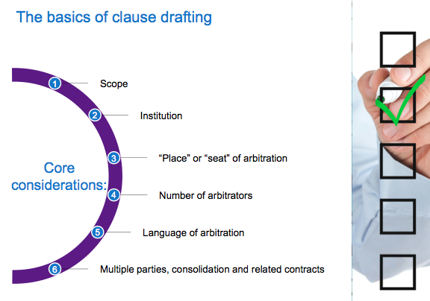

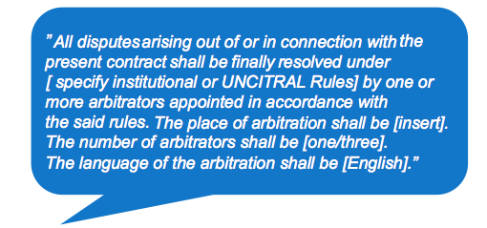

1. **Article: "How to Draft and Effective Arbitration Clause in an International Commercial Contract", by Holmes.**

**INTRODUCTION**

* When drafting any clause in a contract it is necessary to bear in mind what is to be achieved by that clause.
* Always bear in mind why arbitration is or is not the preferred process chosen by the parties.

**THE POSSIBLE BENEFITS ASSOCIATED WITH ARBITRATION**

* Possible **benefits:**
* More efficient
* Less expensive
* Faster and more likely to result in a more expeditious determination of the parties’ rights and obligations;
* 🡺Main benefits
* HOWEVER, it is heavily influenced by the particular persons involved in the process. Parties should choose their arbitrator wisely.
* Allows the parties to have a say in the choice of the decision maker*;*
* Therights of the parties are determined by a neutraldecision maker; 🡺clear advantage over the national courts of one of the parties to the transaction.
* Rights to challenge, generally no appeal, are restricted*;* This is a significant consideration which can be secured by a contractual provision whereby the parties agree that any award shall be final and binding and that there shall be no appeal of any nature from the award (Article 28(6) of the ICC).
* An arbitral award is relatively easy to enforcewhen compared to the enforcement of foreign court judgments; *readily (rapidement/immédiatement/sans hésiter)* enforced and recognised in over 140 countries around the world who are signatories to the NYC. (However, the national law to determine whether or not the arbitration clause is valid and binding.
* An arbitral award is likely to be enforceable in a far greater number of countriesthan would be a court judgment
* **Disadvantage**s:
* Not all disputes between the parties may not be covered by the arbitration clause (problems of scope), less likely to arise in view of the current judicial approach to the proper construction of an arbitration agreement which is that the arbitration agreement *“should not be construed narrowly”.*
* Not all relevant parties may bound by the arbitration clause (problems of joinder).

**WHAT PROCEDURAL RULES SHOULD BE USED?**

* The **procedural rules** may be found:
* In an *ad hoc* arbitration agreement *whereby (selon lequel)* the parties have agreed to arbitrate the particular dispute according to specific procedures which they agree upon or incorporate into their agreement.
  + Allows the parties to draft an arbitration clause which may be tailored to the meet the needs of the parties and their particular transaction.
  + Pb : the needs of the parties sometimes only become manifest when the disputes subsequently arise
* “Institutional *arbitration”* which requires the involvement of the arbitration institutions each of which has formulated and adopted a set of procedural rules regulating the conduct of the arbitration process and which also ensures that the arbitration is administered by the particular institution.
  + The arbitral institutions usually recommend use of a standard or template clause which has the effect of incorporating the particular institution’s arbitration rules.
  + Arbitral institutions will, if requested by the parties, generally administer and supervise arbitrations using the UNCITRAL Rules.
  + It has been said that these rules “are *in fact reflective of what actually transpires in international arbitration practice and provide a milestone for review in many arbitrations under other systems.”*
  + Procedures and practice which have been developed over time and have benefited from first hand experience accumulated over time. Reflect current best practice.
  + Advantage over ad hoc arbitration: institutional support and administrative services + unspoken advantage gained when it comes to enforcing the award.
  + When drafting the close, make sure that the institution still exists!
* Arbitration Rules adopted by the United Nations Commission on International Trade Law (UNCITRAL), not tied to any arbitration insitution.
  + The UNCITRAL Rules are a *“neutral set of arbitration rules suitable for use in ad hoc arbitrations ...* [which were] *intended to be acceptable in both capitalist and socialist, in developed and developing countries and in common law as well as civil law jurisdictions.”*
  + The UNCITRAL Rules contemplate an administering or appointing authority to act in default of agreement.

🡺 Most arbitration clauses are somewhere in between an ad hoc agreement and an arbitral institution’s recommended clause. EVEN in the case of institutional arbitration, parties tend to vary or modify the template clause.

🡺There is a threshold issue in the drafting exercise: should the parties adopt the procedural rules of an established arbitration institution or craft a set of rules tailored for the particular contract pb with that option, is that you don’t know what sort of disputes will arise in the future and how will they best be resolved)?

🡺 However, the opportunity to undertake this drafting exercise may not even arise or may be very limited. The drafting exercise may be cut short for reasons such as the dispute clause is often thrown into the negotiations at the last moment.

**THE FUNCTION OF THE ARBITRATION CLAUSE**

**They should be born in mind. They are *threefold (en trois parties/triple):***

* To produce mandatory consequences for the parties
* To exclude the intervention of State courts in the settlement
* To put in place a rapid and efficient procedure leading to an award susceptible of judicial enforcement.

**WHAT MATTERS SHOULD BE ADDRESSED OR INCORPORATED IN THE ARBITRATION CLAUSE?**

* It is necessary to specifically address in the arbitration clause:
* The number of arbitrators,
* The procedure for choosing the arbitral panel,
* What ethical rules control the arbitral panel and the parties’ representatives,
* The issue of pre-hearing discovery,
* Allowing pre-hearing dispositive motions, the issue of how costs and attorney’s fees will be awarded in the arbitration,
* Whether the award should be a reasoned award,
* What evidentiary rules will be applied and,
* Even, matters of minutiae such as whether the hearing will occur on consecutive days!
* Sometimes, desire to place the arbitration process under the contract in the form of the court processes most familiar to the legal representative engaged in drafting the clause.
* Risk to recreates the judicial process with which the advisor is most familiar.
* Where the parties are from different legal jurisdictions, this approach runs the risk of not achieving agreed result.
* It also risks not utilising current best international arbitration practice.

**THE SCOPE OF THE ARBITRATION CLAUSE**

* The scope of the clause determines the nature and extent of the disputes which the parties agree to be arbitrated.
* In order to avoid argument as to whether a particular dispute falls within the scope of the clause, it needs to be as wide as possible.
* Until recently it was generally accepted that a clause which stated that it covered all disputes “arising *out of”* the contract or all disputes “arising *under”* the contract might not be wide enough to include disputes between the same parties arising out of pre-contractual negotiations and any pre-contractual conduct.
  + A significant change in December 2006, Full Court of the Federal Court of Australia in *Comandate Marine Corp v Pan Australia Shipping Pty Ltd :* the Court rejected the assertion that the words "all *disputes arising out of”* also covers such matters as claims for misleading conduct occurring during the pre-contractual negotiations.
  + Because of the sensible commercial presumption that the parties did not intend the inconvenience of having possible disputes in their transaction being heard in two different places.

**THE NUMBER OF ARBITRATORS**

* Generally if the amount in dispute is below a certain level then costs considerations may lead to the appointment of a sole arbitrator:
* A clause may specify that if the amount in dispute is below a certain amount then it will be a sole arbitrator and if it is above a certain amount, it will be a panel of three.
* Most modern procedural rules will include a power by default for the institution to determine the appropriate number of arbitrators.

**APPOINTMENT OF ARBITRAL PANEL MEMBERS**

* A default mechanism may be found in the rules of the arbitration institution if chosen and it may also be found in the applicable arbitration law.

**THE LAW APPLICABLE TO THE MERITS OF THE DISPUTE**

* Generally this will be the proper law governing the main contract between the parties.
* Importantly it may affect a party’s decision as to which arbitrator to appoint:
* The process is more likely to be expeditious if the arbitrator is familiar with the applicable legal principles.

**THE LANGUAGE OF THE ARBITRATION**

* Consider the situation where the language of the arbitration has not been considered or agreed:
* What is to happen when there is a contract between a Chinese party and an Australian party governed by English law and the notice of dispute is served in Chinese or vice versa?
* The language used in an international arbitration can lead to significant additional translation costs for a party and can delay the hearing.
* The language to be used will also limit or influence a party’s choice of arbitrator.
* Most arbitral institutions suggest that the language be agreed by the parties and their model arbitration clause usually addresses this issue.(Under the CIETAC Rules where the arbitration is taking place in China, the language used will be Chinese, see Article 67 of the CIETAC Rules).
* Under some institutional rules the language of the arbitration is left to the tribunal to decide. This can lead to uncertainty
* Bilingual arbitration may be more expensive and time consuming.
* + Be CAREFUL: if a less common language is specified then the pool of experienced international arbitrators fluent in the language will be greatly reduced.

**CONFIDENTIALITY AND PRIVACY**

* Questions arise as to the confidentiality of any documents produced in the arbitration and of the evidence given by the contracting parties and by third party witnesses.
* Again most institutional rules address these issues.
* EX: ACICA Rules. Article 18.

**THE QUALIFICATIONS OF THE ARBITRATORS**

* Where specific qualifications or expertise is a matter which has led to the choice of arbitration as the means to settle the disputes, then the requisite criteria should be addressed and specified in the arbitration clause.
* Most dispute clauses omit any reference to qualifications.
* BE CAREFUL to avoid making the definition of the qualifications required too narrow as such persons may be hard to come by if and when a dispute arises.

**SOVEREIGN STATE PARTY TO THE CONTRACT**

* Where a sovereign state or a *state instrumentality (agence governementale)* is a party to the arbitration agreement, the nationality of the arbitrators is a relevant consideration:
* It is advisable to adopt a negative qualification for any arbitrator, i.e. an arbitrator may not be of the same nationality as any party to the contract.
* By agreeing to arbitration, a sovereign state is *thereby (ainsi)* taken to have waived any sovereign immunity
* HOWEVER, written consent by a state to a dispute being arbitrated does not also amount to consent to the enforcement of any award or waiver of state immunity on the execution of the award against particular state owned assets. ??????

**SERVICE ON THE PARTIES**

* Recognition and enforcement of an award may be refused under the NYC where the party against whom the award is sought to be enforced “*was not given proper notice of the appointment of the arbitrator or of the arbitration proceedings or was otherwise unable to present its case*.”
* This should be borne in mind not only when drafting the clause but at all times during the arbitral process so as to not provide a basis for non enforcement of the award.
* Again the rules of most arbitration institutions address this issue and prescribe what is required for effective service during the course of the arbitration.

**THE PLACE [SEAT] OF THE ARBITRATION**

* Very important it determines *“the* rules of the game”.
* Where is the international arbitration taking place as a matter of legal theory?
* An international arbitration frequently takes place by videoconferencing involving people in a range of different jurisdictions. It is necessary in such circumstances for the parties to choose which arbitration law will regulate the procedural aspects of the arbitration as the common law “does *not recognize the concept of arbitral procedures floating in the transnational firmament unconnected with any municipal system of law.”*
* The choice of the seat will have a major effect on any enforcement as the award is generally regarded as being made at the seat of the arbitration and the courts of that place as having primary supervisory responsibility for the arbitration and any award.
* The law of the seat selected by the parties may be a different law to that chosen by the parties as the law governing the merits of their dispute.
* Any challenge to the award is likely to be made under the laws of the seat except where the challenge arises on an application for enforcement of the award under the New York Convention. *“It is the curial law which governs the validity of the award and challenges to it.” ?????*
* When selecting the location in which the arbitration is to take place, it is necessary to considerm :
* A neutral place
* A modern, national legislation dealing with arbitration;
* A minimal interference by domestic laws and the courts;
* A broad interpretation of what disputes can be arbitrated;
* The validity of the arbitration clause (Article V.1 (a) NYC);
* A respect of the parties’ autonomy to allow the parties the flexibility to vary  the arbitral process as the need arises. ;
* Allows the parties the freedom to use lawyers of choice who may not be admitted in that jurisdiction.
* Provides the parties with assistance from the local courts in aid of the arbitration e.g. on substantive matters such as granting and assisting with interim measures, and on procedural matters such as compelling the attendance of third persons to attend as witnesses and produce documents.
* Ensures as far as is possible the enforceability of the award outside the country of origin.
* Once the seat has been chosen, additional care should be taken to express this choice precisely where the place or seat is in a country which does not have a unitary system of law such as a federation.

**A COMBINED OR STAGED DISPUTE RESOLUTION PROCESS ENDING IN ARBITRATION**

* Most modern dispute clauses provide for a *staged ( ???)* dispute resolution process involving possibly consultation, mediation or expert determination and ultimately, arbitration.
* When drafting an arbitration clause a question arises as to whether these more informal and less compulsive processes should be addressed and included
* parties are free at any time to talk and try to mediate their dispute.
* HOWEVER, when the parties have reached the stage of a formal dispute, either party may be reticent to suggest mediation (can be seen as a sign of weakness).
* 🡺It is generally advisable to include specific and enforceable provisions to mediate with strict time limits.
* An agreement to mediate as a pre-condition to arbitration may be indirectly enforced by the stay or adjournment of the arbitration proceedings.
* Where there is a staged resolution process there is an increased risk that there may be a need for urgent *interim relief* *( ???)* pending the ultimate resolution of the dispute by arbitration ?????
* (To meet any such concerns the parties may wish to consider including a provision expressly stating that pending any such process, any party shall be at liberty to apply to the court for injunctive, provisional, conservatory, or other interim or emergency relief.)
* To avoid any response that such an application amount to a waiver of a party’s right to enforce an arbitration clause it would be advisable to state that any such application shall not amount to a waiver of a party’s rights under the arbitration clause.
* Care should also be taken not to avoid such a provision does not conflict with or alter the meaning of other provisions in the arbitration clause as occurred in *Seeley International Pty Ltd v Electra Air Conditioning.* In that case the provision which apparently was intended to preserve the right to seek interim relief from the courts, was held to amount to a complete carve out of the dispute from the scope of the arbitration clause with the result that the court held that the parties had not agreed to submit the particular dispute to arbitration.

**CONSOLIDATION OF ARBITRATIONS**

* Those drafting the clause should consider whether if the parties were to find themselves in a future arbitration, they may benefit from consolidation with other arbitration proceedings or even holding concurrent hearings with other arbitrations.
* For example, in a construction project a main contractor may make a number of sub-contracts each of which contains an arbitration clause. A dispute arises in which a claim is made against a sub-contractor who seeks to blame another. In these circumstances, consolidation or concurrent hearings may be desirable in avoiding conflicting awards and the time and costs of duplicated hearings.
* The problem is easily solved if all parties agree but this may not be achievable at a time when the parties are locked in dispute.
  + If this is likely to arise, a clause (or clauses) permitting the arbitral tribunal (or tribunals) to consolidate or order concurrent hearings in appropriate cases, should be considered and if appropriate, incorporated into the contract (or contracts). (Ex: London Maritime Arbitrators Association Rules, R14),

**CONCLUSION**

* Sometimes in an effort to deal with every possible consequence, a *bespoke (fait sur mesure)* arbitration clause may become too sophisticated and itself be a source of disputes.
* “Simple, *clearly drafted arbitration clauses will avoid uncertainty and disputes as to their meaning and effect”.*
* A modern institutional template clause may **be a good starting point.**

Cours 5 – Arbitral jurisdiction - Préparation

**The chapter 5 of the book Greenberg, Kee and Weeramantry**

1. **Introduction**

* Chapter addresses **procedural issues** that can arise when a party wishes to contest an arbitral tribunal’s jurisdiction.
  + also considers the link between :
    - an arbitral tribunal’s authority to rule on its own jurisdiction and
    - the control of that authority by domestic courts
* An arbitral tribunal’s jurisdiction is far from automatic.
  + It derives from the disputing parties’ free will, i.e. their agreement to arbitrate.
  + The consensual nature of arbitral jurisdiction must be contrasted with the jurisdiction of domestic courts, which is established by the domestic law of the forum and any applicable treaties dealing with international judicial competence.
* The consensual basis means that a respondent party can attempt to contest or deny arbitral jurisdiction.
  + The objecting party might never have agreed to arbitrate or,
  + even if it previously agreed, may now prefer to litigate the dispute in a domestic court.
    - In this case the objecting party may seek to escape its obligation to arbitrate by denying its previous agreement.
    - Alternatively, that party might raise jurisdictional objections in an attempt to delay and frustrate the resolution of the dispute.

1. **Overview and summary of jurisdictional objections**

* Jurisdictional objections generally raised at the outset of an arbitration.
* If completion, a party may also deny arbitral jurisdiction at the end, during a procedure
  + to challenge the award or
  + to resist enforcement of the award.
* a party’s failure to raise jurisdictional objections promptly may give rise to a finding that the party is deemed to have waived those objections.
* Overall, a party (typically the respondent) wanting to contest jurisdiction has several options
  + - * 1. First, the respondent **may challenge jurisdiction** by making its objections **directly** to the arbitral tribunal
* (as AT is empowered to decide on their own jurisdiction)
  + ‘Competence-competence’ rule.
    - Feature of the competence-competence rule: an arbitral tribunal’s decision that it possesses jurisdiction is not final: can be reviewed by a domestic court during proceedings to set aside the decision.
      * the only domestic court with jurisdiction to set aside an arbitral tribunal’s jurisdictional decision is a court at the seat of arbitration.
* **However, while a court at the seat of arbitration can always hear an action to set aside an arbitral tribunal’s decision that the arbitral tribunal possesses jurisdiction, this is not true when an arbitral tribunal decides that it lacks jurisdiction**.
  + only some legal systems expressly empower their courts to review an arbitral tribunal’s negative jurisdictional decision.
    - * 1. Second, the respondent party may **refuse to participate** in the arbitration, wait for the arbitral tribunal’s final award and then

Seek to have that award set aside (i.e. challenge it) at the seat of arbitration on the basis that the arbitral tribunal did not have jurisdiction to make the award or

Wait for the claimant to commence proceedings to enforce the award and then resist enforcement for the same reason.

* Either of these strategies raises significant risks for the respondent.
  + Failure to participate in the arbitration: respondent’s views, arguments and position not heard by the arbitral tribunal.
    - If its jurisdictional plea before the domestic court fails (whether in the seat of arbitration or before the court where the opposing side is trying to enforce the award), it will be faced with and bound by an award made in circumstances where its position was never argued before the AT.
      * Sometimes: the respondent’s failure to participate will be considered as a waiver of its right to object to the AT’s jurisdiction.
* If the respondent **participates** in the arbitration **without raising an objection** to the arbitral tribunal’s jurisdiction **but subsequently contests that jurisdiction before a court**,
  + The respondent considered by the court to have waived its right to object AT’s jurisdiction.
    - Waiver: can also be basis for invocation of estoppel or abandonment (?).
      * 1. Third, the respondent **may seek from the arbitration’s outset a ruling directly from a domestic court at the seat of arbitration** that the arbitral tribunal lacks jurisdiction.
* Competence of the court of the seat of arbitration to decide an issue of arbitral jurisdiction before the AT has ruled on its own jurisdiction depends on the local law and practice of the courts.
* A respondent sometimes seeks a similar ruling from a court **outside the seat of arbitration**
  + As a general rule, a decision from a court outside the seat of arbitration should not affect the arbitral tribunal’s jurisdiction => the court would not be competent under the law of the seat of arbitration to make such a decision.
    - * 1. Fourth, another alternative is for the respondent **to commence court litigation proceedings against the claimant on the substance of the dispute**.
* If it does so, the other side **could accept** – expressly or implicitly – the domestic court’s competence,
  + thereby waiving its right to invoke the arbitration agreement in connection with that dispute.
* If, however, the opposing party **contests** the court’s jurisdiction on the basis of the arbitration agreement
  + then that court will, depending on its law:
    - either rule on the arbitral tribunal’s jurisdiction or
    - order the parties to arbitrate their dispute.

1. **Preliminary issues relating to arbitral jurisdiction**
2. ***Partial and absolute jurisdictional objections***

* An objection to an arbitral tribunal’s jurisdiction can be:
  + absolute (i.e. contesting 5.9 arbitral jurisdiction per se, or over a particular party per se)
  + or partial (i.e. only with respect to certain of the claims or issues submitted to arbitration).
* Absolute jurisdictional objections: the most common.
  + Usually raised on the ground that one of the alleged parties to the arbitration **is not a proper party** to the arbitration agreement.
  + may also be raised on grounds that the respondent did not have capacity to enter into the arbitration agreement,
  + that the arbitration agreement is illegal, void or incapable of being performed,
  + or that the claimant has waived its right to invoke the arbitration agreement (**Art 6.2 ICC Rules**)
* Partial jurisdictional objections arise primarily
  + as a consequence of the “scope of arbitration” : concept that an arbitral tribunal has jurisdiction to decide only those matters which the parties have agreed that it can decide.
    - Terms of Reference for instance
  + Could arise from the language of the Arbitration agreement (difficult argument to sustain)
    - “*All disputes*”
    - “*All disputes arising out of or in connection with the contract*”
  + Partial jurisdictional objections can also arise by virtue of the law governing the arbitration agreement or the law governing the arbitration proceedings.
    - some subject matters being considered inarbitrable for instance
* Finally, a distinction needs to be drawn between:
  + an arbitral tribunal’s *jurisdiction* and
  + the scope of its *powers*.
* It is sometimes argued that an arbitral tribunal does not possess the power, legally speaking, to make certain orders.
  + For example, there has historically been debate about the extent of arbitrators’ powers to order certain preliminary injunctive relief, and in particular interim injunctions that affect a party’s ability to deal with immovable property.
    - Such issues concern an arbitral tribunal’s powers rather than its jurisdiction over the claims or parties involved and should be clearly distinguished.

1. ***Jurisdictional objections raised by a party***

* The most common scenario in which a jurisdictional issue will arise is where the respondent objects to the arbitral tribunal’s jurisdiction at the beginning of the arbitration.
  + Arbitration laws and rules usually require a party to raise any jurisdictional objections early,
    - generally prior to that party’s first submission on the substance of the dispute.
    - Failure to do so can mean irrevocable waiver of that party’s right to raise jurisdictional objections.
* **Article 16(2) of the ML** 
  + “*A plea that the arbitral tribunal does not have jurisdiction shall be raised not later than the submission of the statement of defence. A party is not precluded from raising such a plea by the fact that he has appointed, or participated in the appointment of, an arbitrator. A plea that the arbitral tribunal is exceeding the scope of its authority shall be raised as soon as the matter alleged to be beyond the scope of its authority is raised during the arbitral proceedings. The arbitral tribunal may, in either case, admit a later plea if it considers the delay justified*”.
* **Article 21(3) of the 1976 UNCITRAL Arbitration rules** 
  + “*a plea that the AT does not have jurisdiction shall be raised not later than in the statement of defence or, with respect to a counter claim, in the reply to the counter claim*”

|  |
| --- |
| Actualisation: **Article 23 of the 2010 UNCITRAL Arbitration Rules** “Pleas as to the jurisdiction of the arbitral tribunal”  *1. The arbitral tribunal shall have the power to rule on its own jurisdiction, including any objections with respect to the existence or validity of the arbitration agreement. For that purpose, an arbitration clause that forms part of a contract shall be treated as an agreement independent of the other terms of the contract. A decision by the arbitral tribunal that the contract is null shall not entail automatically the invalidity of the arbitration clause.*  *2. A plea that the arbitral tribunal does not have jurisdiction shall be raised no later than in the statement of defence or, with respect to a counterclaim or a claim for the purpose of a set-off, in the reply to the counterclaim or to the claim for the purpose of a set-off. A party is not precluded from raising such a plea by the fact that it has appointed, or participated in the appointment of, an arbitrator. A plea that the arbitral tribunal is exceeding the scope of its authority shall be raised as soon as the matter alleged to be beyond the scope of its authority is raised during the arbitral proceedings. The arbitral tribunal may, in either case, admit a later plea if it considers the delay justified.*  *3. The arbitral tribunal may rule on a plea referred to in paragraph 2 either as a preliminary question or in an award on the merits. The arbitral tribunal may continue the arbitral proceedings and make an award, notwithstanding any pending challenge to its jurisdiction before a court.* |

* Both Articles provide that if a respondent wants to raise jurisdictional objections, it must do so not later than when filing its statement of defence.
  + The Model Law expressly provides, that mere participation in the constitution of an arbitral tribunal will not preclude the respondent from later objecting to jurisdiction.
  + In contrast: UNCITRAL Arbitration Rules deal expressly with objections regarding arbitral jurisdiction over counterclaims.
  + Model Law: objection to the arbitral tribunal’s exercise of authority must be brought as soon as the matter is raised in the arbitration.
    - Finally, only the Model Law expressly empowers the arbitral tribunal to admit a later plea if it considers the delay justified.
* If a party participates in the arbitration **but fails to raise a jurisdictional objection within the time limit specified by the applicable law,** its silence may amount to entering into an arbitration agreement.
  + **Article 7(2) of the Model Law** refers to an arbitration agreement being in writing :
    - ‘*if it is contained in . . . an exchange of statements of claim and defence in which the existence of an agreement is alleged by one party and not denied by another’*.

1. ***Arbitral Tribunal’s ex-officio examination of jurisdiction***

* Jurisdictional objections can only be raised by an entity named as a party to arbitration proceedings.
  + However, regardless of whether jurisdictional issues are raised by one or more parties,
    - it is prudent for all arbitral tribunals to consider on their own initiative whether they have jurisdiction, both absolute and with respect to each claim on which they have been asked to rule.
* An arbitral tribunal should always comment on jurisdiction in its award(s), even if it is only to cite the arbitration agreement and confirm that neither party objected to jurisdiction.
* An express decision on jurisdiction must also be made if one or more parties to the arbitration proceedings do not participate at all.
  + Unlike domestic court proceedings, **‘default judgments’** cannot be issued simply because a party fails to appear in an arbitration.
    - If a party does not participate, the arbitration continues without the defaulting party or parties
* The arbitral tribunal should examine and take an express decision on its own jurisdiction.
  + Before doing so, it should ask the participating party or parties to file submissions on jurisdiction **and expressly provide an opportunity for the non-participating parties to do so as well**.
    - Each non-participating party should be kept informed of and invited to participate in all steps in the arbitration.
* It is essential for an arbitral tribunal to examine and rule on jurisdiction where the respondent is not participating because the respondent may subsequently raise its objections in court proceedings challenging the award or resisting its enforcement.
  + Arbitrators must also ensure that parties do not use arbitration to avoid certain mandatory provisions of a domestic law

1. ***Appropriate time to decide jurisdiction***

* When an arbitral tribunal is faced with a challenge to its jurisdiction: **two broad options as to when it will decide that challenge**.
  + First: it can **bifurcate** the proceedings
    - hearing arguments on jurisdiction separately and
    - then rendering a decision on jurisdiction before proceeding to examine the merits.
  + Second: it can decide to **join** the issue of jurisdiction to the merits and decide both in one single award.
* The advantage of deciding jurisdiction separately from the merits:
  + it saves a long and costly proceeding on the merits **when it is uncertain whether or not the arbitral tribunal possesses jurisdiction**. T
    - ime and costs could have been wasted if the arbitral tribunal later rules that it does not have jurisdiction.
* Advantages of combining jurisdiction and the merits are twofold.
  + First, bifurcating the proceedings will almost always **add time and, as a consequence, costs** to the overall procedure if the arbitral tribunal finds that it has jurisdiction.
  + Second, if the jurisdictional objections are in any way intertwined with the substantive issues in dispute **there may be a degree of overlap**.
    - A classic example is where a respondent argues that it is not a proper party to either the contract or the arbitration agreement.
      * S. Jarvin ‘*the best course for an arbitral tribunal to take is . . . where possible, it should hear arguments on the issue of jurisdiction as a preliminary matter and render an interim award on the point. This enables the parties to know where they stand at a relatively early stage*’.
* However, authors consider that there are often very good reasons not to hear jurisdiction separately.
  + In many cases, bifurcation will only cause delay and additional costs and may pose risks where the issues are intertwined with the merits.

1. ***Waiver of the right to invoke an arbitration agreement***

* A party that has waived an arbitration agreement loses its right to rely on the arbitration agreement.
  + Waiver may either be express (e.g. the party expressly states that it waives the arbitration agreement) or
  + implied by a party’s conduct.
* In practice, disputes about express waiver are rare.
* Implied waiver: on the other hand is sometimes alleged by a party contesting arbitral jurisdiction or resisting the stay of a court action.
  + Ultimately, the requirements for establishing that waiver has occurred will depend on the law governing the arbitration agreement.
* Implied waiver cannot be based on mere assumption
  + it occurs where the parties’ conduct amounts to the expression of a clear intention to relinquish their contractual rights to arbitrate
    - **French Cour de Cassation 18 February1999, Iglac/Société Soulier et autres** has clearly held that a party will be deemed to have implicitly waived its right to arbitrate only if it has performed unequivocal acts establishing a clear intention to abandon such rights
* As a general proposition a defendant to a court proceeding who wants the dispute to be determined by arbitration must raise the arbitration agreement (or object to the court’s jurisdiction) ‘not later than when submitting his first statement on the substance of the dispute’ or it will be too late.
  + In Hong Kong, this phrase from the Model Law has been interpreted fairly liberally by courts: in favour of arbitration.
* A party participating in any court proceeding where an arbitration agreement may cover the same dispute should be very cautious about implicitly waiving the arbitration agreement.
  + Whether as plaintiff or defendant, it is prudent expressly to mention in each submission to the court that by making that submission the party does not intend to waive its right to invoke the arbitration agreement

1. **Arbitral tribunal’s determination of jurisdiction: competence-competence rule**

* There are various facets to the competence-competence rule.
  + At its simplest, it empowers an arbitral tribunal to decide on any and all objections as to its own jurisdiction.
  + A more thorough consideration of the competence-competence rule reveals close links to the courts, and in particular the circumstances under which a court will allow an arbitral tribunal to rule on its jurisdiction prior to a court examining that jurisdiction.

1. ***Introduction to competence-competence rule***

* **The competence-competence rule means that an arbitral tribunal may be authorised to determine its own jurisdiction.** 
  + As explained by Fouchard, Gaillard and Goldman, ‘*the competence-competence principle also allows arbitrators to deter- mine that an arbitration agreement is invalid and to make an award declaring that they lack jurisdiction without contradicting themselves*’.
    - In order to overcome the apparent contradiction of an arbitral tribunal deciding that it does not have jurisdiction, the competence-competence rule must exist above and beyond the agreement to arbitrate.
    - Arbitration experts therefore tend to agree that the source of an arbitral tribunal’s power to determine its own jurisdiction is not the agreement to arbitrate but rather the law governing the arbitration proceedings
* The competence-competence rule is almost universally recognized in arbitration laws,
  + varying degrees and in different ways.
  + And if not recognized: sometimes implied into laws and applied as a general principle of international arbitration law and/or practice.
* In addition to its recognition the rule is reiterated in most arbitration institutional rules
  + However : they are generally not considered to be the ultimate source of its authority, because they apply only by virtue of the parties’ agreement.
* The competence-competence rule is sometimes said to have a negative and a positive effect.
  + The positive effect: parties gain a right to have their jurisdictional dispute determined by an arbitral tribunal, at least in the first instance
  + The negative effect: is that the parties lose their right to have the jurisdictional dispute determined by a court.
* **An essential component of the competence- competence rule : arbitral tribunal’s decision that it has jurisdiction is not final.**
* can be considered as a rule of **temporal priority**, empowering the arbitral tribunal to rule on its jurisdiction in the first instance.

1. ***Competence-competence rule and extent of domestic court intervention***

* Domestic courts can be called on to decide, or at least consider, arbitral jurisdiction in several circumstances before an arbitral tribunal has ruled on jurisdiction.
  + The most common is when a party has commenced an action on the merits of the dispute in a domestic court and the opposing side contests the court’s jurisdiction on the basis of the arbitration agreement
  + In these circumstances, the domestic court should refer the parties to arbitration provided that there is a binding arbitration agreement.
* Vast majority of courts (including most Asia-Pacific courts): hybrid and will examine only **the prima facie existence of an arbitration agreement**
  + **Article 8 of the Model Law** mirrors **Article II of the New York Convention** in relation to stays of domestic court proceedings when there is an arbitration agreement.
  + Both provisions aim to ensure that when there is an arbitration agreement and a party objects to the domestic court’s jurisdiction, the court immediately refers the parties to arbitration.
    - The extent of a court’s authority to rule on jurisdiction before an arbitral tribunal has had the opportunity to do so is a subject of **judicial and academic debate**.
      * Frederic Bachand argues strongly in favour of the prima facie approach. After observing that there is conflicting case law, Bachand goes on to consider the drafting history of the Model Law.
        + His analysis leads him to conclude that the Model Law’s travaux preparatoires, basic structure and underlying principles reveals that the drafters considered the prevention of dilatory jurisdictional objections to be a more important objective and, consequently, that Article 8(1) ought to be interpreted as requiring courts seized of referral applications to apply a prima facie standard while reviewing the tribunal’s jurisdiction.
      * Bachand’s reasoning is compelling but it is to be contrasted with numerous authors who consider that examining the drafting history of the Model Law would lead to the opposite conclusion
* In certain jurisdictions, the law takes a different approach.
  + The parties may agree to derogate from the competence-competence rule and empower the courts with exclusive jurisdiction to decide on arbitral jurisdiction
  + It is very unusual for an arbitration law not to recognize the competence-competence rule at all, but one example is China.
    - Jingzhou Tao explains that there can sometimes be overlapping involvement of domestic courts and the arbitration commission in determining jurisdiction.
    - The arbitration commission ordinarily takes the lead role unless a party has commenced a court action prior to the arbitration proceedings.
    - A court may revise the arbitration commission’s decision upon an application to set aside the award or enforce the award.
      * If so, the court should inform the arbitration commission of its decision so that the latter, if it has already taken a decision on jurisdiction, can suspend or even terminate the arbitration.
    - Tao also explains that whenever there is a dispute between parties about which arbitration commission has been chosen, the competent Intermediate People’s Court decides.
      * An example in point was where the arbitration agreement provided for disputes to be submitted to the ‘**Beijing arbitration organisation**’
        + The clause was pathological because there are two arbitration commissions in Beijing, CIETAC and the BAC (Beijing Arbitration Commission),

neither of which was correctly named in the arbitration agreement.

* + - * + When the claimant filed for arbitration with the BAC, the respondent reacted by seeking a declaration about the validity of the arbitration agreement from the Beijing Intermediate People’s Court.
        + The court, applying a **1996 ruling from the Supreme People’s Court,** held that the clause was valid and that the claimant was at liberty to choose one of the arbitration commissions in Beijing.
        + The court also confirmed that the court was the appropriate forum to determine jurisdiction given the lack of clarity about which arbitration commission was designated.
* the trend in the Asia-Pacific Model Law jurisdictions is, overall, now strongly in favour of a prima facie limitation on the scope of court examination of jurisdiction.
  + This approach is also favoured by most continental European jurisdictions, and in the US more and more

1. ***Conclusions on competence-competence***

* The importance of the competence-competence rule is obvious.
  + Without it, only the courts could decide disputes about arbitral jurisdiction.
    - any time a party raises a jurisdictional objection an arbitral tribunal would either have to wait for the courts to decide the matter before proceeding, or proceed without knowing whether it has jurisdiction.
      * Certain arbitration laws under which the parties may derogate from the competence-competence rule and empower the courts with exclusive jurisdiction to decide on arbitral jurisdiction: efficiency and underlying principle of arbitration: party autonomy
      * But the strongest argument in favour of competence-competence is the need to avoid dilatory tactics, because jurisdiction is often contested by a respondent wanting to cause delay and disruption in the arbitral proceedings.
        + (over-burdened and disinterested courts from having to deal with arbitration matters)
        + In addition, **expertise of experienced international arbitrators** generally means that they are far better placed than domestic courts to examine most questions of jurisdiction arising in international arbitrations

First, international arbitrators will apply – within the limitations and framework of the law governing the arbitration agreement – concepts of international arbitral practice which are widely accepted by the international legal and business communities.

Second, in applying this international approach, wise international arbitrators may give great weight to the character of the underlying transaction and the broad commercial context leading to the conclusion of the arbitration agreement.

* Limiting the scope of the competence-competence rule would deny the parties the benefit of having a neutral, experienced, international arbitral tribunal decide what can be a key issue, i.e. jurisdiction.
* Furthermore, the competence-competence rule means that a court which is later required to review an arbitral tribunal’s decision on jurisdiction will benefit from having the arbitral tribunal rule on jurisdiction in the first instance.
* In sum, we strongly support the competence-competence rule and believe that a court’s initial role should be nothing more than a prima facie examination of jurisdiction. If the court considers that there is an arguable case for jurisdiction, it should refer the parties to arbitration

1. **Arbitral institution’s examination of jurisdiction**

* The rules of some arbitral institutions expressly permit the institution to examine the prima facie existence of an arbitration agreement before the arbitral tribunal does so.
* If there is clearly no arbitration agreement, the case is dismissed.
* Best know example : Article 6(2) ICC rules :
  + The ICC Court does not analyse *sua sponte (de son propre gré)* whether an arbitration agreement under the ICC Rules exists. Article 6(2) is triggered only when the respondent does not file an answer to the request for arbitration and/or objects to the arbitration clause.
  + Here, the ICC Court’s analysis is limited to a mere prima facie review of the existence of an arbitration agreement under the ICC Rules
  + 🡺Permit to save time and cost
* ICSID Convention art.36 (3)

1. ***Examples in multiparty arbitrations***

* The ICC Court is often confronted with situations where a claimant has identified in the request for arbitration several respondents, one or all of which have not signed the arbitration agreement.
* Normally, the ICC Court is prima facie satisfied that a non-signatory respondent can be included in the arbitration if there is evidence that it has been closely involved with the contract containing the arbitral clause, e.g. if it participated in the negotiations, performance and/or termination of the contract. Two examples :
  + Two claimants introduced a request for arbitration against four respondents, only two of which had signed the contract containing the relevant arbitration agreement. The claimants argued that since all four potential respondents were part of the same group of companies, they should all be parties to the proceedings, even though some of them had not signed the contract. On the basis of the information submitted, the ICC Court decided that the arbitration proceedings could be initiated against all four respondents because the claimants had satisfied the prima facie test by showing that all respondents had participated in the negotiations and performance of the agreement.
  + By contrast, in the second example, a request for arbitration was introduced by the claimant against one respondent on the basis of a sales agency contract. The claimant later sought to raise claims against two other companies, arguing that they formed part of the same group of companies. Unlike in the previous example, the claimant contended that the burden was on the respondents to show that they did not share the same duties and responsibilities as the first respondent. The ICC Court decided that the matter could not proceed against the two additional respondents.
* Same issue when : the respondent admits that it is subject to an arbitration agreement with one of the claimants, but denies that an arbitration agreement exists between it and another claimant. Examples
  + A case in which two claimants commenced arbitration against a single respondent. Only the first claimant had signed the contract containing the arbitration agreement and the second claimant was its corporate parent. The ICC Court found that there was a prima facie arbitration agreement between the respondent and the first claimant, but not between the respondent and the second claimant as there was no evidence that it could be a party to the arbitration agreement.
  + Another example involved a case commenced by four claimants against six respondents. Several respondents argued that there was no prima facie arbitration agreement between them and the third and fourth claimants. The ICC Court agreed. The matter went forward with the first two claimants only, the second two being dismissed.
  + In a construction case, the first claimant was the contractor and a party to the contract with the respondent owner. The second claimant, a party related to the first, had not signed the contract containing the arbitration clause but had provided in a separate document a guarantee to secure the first claimant’s performance. The respondent contended that there was no arbitration agreement between it and the second claimant. The ICC Court took into account inter alia that the document containing the guarantee did not have its own dispute resolution clause and decided that the matter would proceed with both claimants. It would be for the arbitral tribunal to determine whether it had jurisdiction over the second claimant.

1. ***Examples in multi-contract arbitrations (=*** where a request for arbitration is filed based on more than one distinct agreement)

* The ICC Court has generally allowed such arbitrations to proceed under Article 6(2) of its Rules only when the following conditions have been met:

1. All contracts are signed by the same parties;
2. All contracts are related to the same economic transaction and
3. The dispute resolution clauses in the contracts are compatible (e.g. reference to the ICC, choice of the same seat of arbitration, referral to the same domestic court of jurisdiction, and the same method for constituting the arbitral tribunal).
4. **Effects of jurisdictional decisions**
5. ***Effects of a court or arbitral institution’s prima facie examination of jurisdiction***

* If a competent domestic court at the seat of arbitration decides that there is no arbitration agreement (i.e. in most jurisdictions, that the arbitration agreement is ‘null and void, inoperative or incapable of being performed’) before the arbitral tribunal has ruled on jurisdiction, then the competence-competence rule does not come into effect.
* However, a ruling by a court that is not competent, which will ordinarily be the case of a foreign court outside the seat of arbitration, that there is no arbitration agreement **does not bind** an arbitral tribunal sitting abroad.
* It is not uncommon that arbitration proceedings continue despite a foreign court’s ruling that there is no arbitration agreement.
* If an arbitral institution, such as the ICC Court, decides that there is no prima facie arbitration agreement, the last sentence of Article 6(2) of its Rules provides that any party retains the right to ask any court having jurisdiction whether or not there is a binding arbitration agreement.

1. ***Recourse against an arbitral tribunal’s jurisdictional decision***

* It should be noted that in investor-state arbitration conducted under the ICSID Convention there is no scope whatsoever for court review of jurisdictional decisions.
  1. *Positive jurisdictional decisions*
* The Model Law provides two possibilities for court review of an arbitral tribunal’s decision that it has jurisdiction :
* A mechanism to seek **immediate review** under Article 16(3)
* Article 16(3), creates a different form of recourse : the arbitration proceedings will continue during the domestic court’s review of the arbitral tribunal’s decision that it has jurisdiction
* Article 34, dealing with setting aside proceedings :
* There is doubt about whether decisions on jurisdiction are in fact awards. As they are not generally considered to be awards, Article 34 should not be available to set aside a decision dealing exclusively with jurisdiction, but could be used to set aside an award on the merits on the ground that the arbitral tribunal lacked jurisdiction.
* Art. V, NYC : lack of jurisdiction under.
  1. *Negative jurisdictional decisions*
* Article 16(3) of the Model Law does not specify whether there is any recourse against a negative jurisdictional decision
* Similarly, if jurisdictional decisions are not awards then review would not be available under Article 34 of the Model Law.
* Most arbitration laws do not provide for recourse against an arbitral tribunal’s decision that it *lacks* jurisdiction.
* Exceptions :
* The New Zealand Arbitration Act art. 16 (3). specifically amends the Model Law in this respect
* Section 37 of the Indian Arbitration and Conciliation Act
* Why such an omission of express recourse against negative jurisdictional decisions ?
* Because negative jurisdictional decisions certainly do not constitute awards : because the arbitral tribunal had no jurisdiction to make it in the first place
  + *PT Asuransi Jasa Idonesia (Persero) v Dexia Bank SA : « the word award* does not include a negative determination on jurisdiction ».
* Because negative jurisdictional decisions are not awards, they cannot in principle be treated as reviewable under provisions of arbitration laws which deal with recourse against or enforcement of awards.
* While negative jurisdictional decisions are not awards, recourse against them could be expressly provided for in the law. Yet the Model Law is silent.
* 🡺 legal vacuum
* For Greenberg : the key underlying reason for different treatment relates to the fundamental difference between the effects of a positive as opposed to negative jurisdictional decision.
  + A positive jurisdictional ruling means a finding that the party objecting to jurisdiction has waived or opted out of its right to go to court. Considering that access to justice is a basic human right, it follows that positive jurisdictional rulings **must be reviewable**.
  + When an arbitral tribunal decides that it does not have jurisdiction, however, the right to bring the claim to a domestic court is rejuvenated : There is only a denial of a right to access arbitral justice which has traditionally not been considered a fundamental human right.
* Other reasons relates to the grounds for establishing domestic court jurisdiction in international matters :
  + Where an arbitral tribunal has rejected jurisdiction, the putatively agreed seat of arbitration is usually rejected as well. As a consequence, the local court’s international jurisdiction rules may not pro- vide it with any ground on which to assert jurisdiction to review a negative jurisdictional ruling short of specific legislative recognition.
* In practice, the absence in most jurisdictions of a means of recourse from negative jurisdictional decisions is very unfortunate and frustrating.
* Options left to the parties :
* Start an action in some domestic court with all of the disadvantages that it sought to avoid by choosing arbitration
* Attempt to constitute a new arbitral tribunal :
  + Theoretically, it is possible that a party could continue to constitute arbitral tribunals until one decided that it had jurisdiction since negative jurisdictional decisions have no recognised legal authority.
  + In practice, however, an arbitral tribunal would be reluctant to overrule a prior arbitral tribunal’s decision on the same jurisdictional question.

1. ***Scope of court interview of arbitral tribunal’s jurisdictional decisions***

* When a court at the seat of arbitration reviews an arbitral tribunal’s decision on jurisdiction, the scope of that review is normally de novo.
* Article 16(3) of the Model Law which empowers the court simply ‘to decide the matter’ of jurisdiction
* The possibility for a de novo re-hearing results from the fact that domestic courts have the final say on jurisdiction and may need to hear new arguments and evidence in order to make their determination.
* Singapore High Court in *Insigma Technology Co Ltd v Alsthom Technology Ltd (2008)*
* *Dallah Estate and Tourism Holding Company v The Ministry of Religious Affairs, Government of Pakistan (2009) :* English court of appeal confirms that, in England, de novo review of an arbitral tribunal’s jurisdictional decision is alternatively available when resisting the enforcement of an award
* While rarely, if ever, done, in some jurisdictions parties may effectively be able to exclude the ability of courts to review certain jurisdictional issues.
* After the jurisdictional dispute arises, the parties could enter into a new arbitration agreement, which empowers the arbitral tribunal to decide *finally* a disputed issue of jurisdiction relating to their initial arbitration agreement.

1. ***6.4 Subsidiary orders with negative jurisdictional decisions***

* If an arbitral tribunal decides that it does not have jurisdiction over a party, and/or rejects *absolute* jurisdiction, then it ceases from that moment to have any authority with respect to that party.
* It logically follows that an arbitral tribunal in these circumstances has no power to make a subsidiary order, such as an order for costs.
* Case of *CDC v Montague* in Queensland, Australia

Cours 6 – Préparation

**The chapter 3 of the book Greenberg, Kee and Weeramantry : Applicable substantive law**

1. **Introduction**

* This chapter concerns the identification of the law that applies in an international arbitration.
* Various laws may apply to different aspects of the dispute.

1. **Types of conflict of law issues in international arbitration**

* Determining the applicable law in an international litigation matter : ‘conflict of laws rules’ or ‘private international law rules’.
* Resolving conflict of laws issues in international arbitration is certainly more flexible than in international litigation, however there is arguably an additional complication which does not exist in state courts: in international commercial arbitration there is no **fallback legal forum or the *lex fori****.* 
  + *Lex fori* means literally the law of the forum; it is the law of the jurisdiction where a domestic court proceeding is taking place.
  + The *lex fori* should be distinguished from the *lex arbitri*
  + International arbitration proceedings have no *lex fori*
  + Although the *lex arbitri* provides the legal backbone of the arbitration it does not provide a system of conflict of laws rules.
    - So when an arbitral tribunal has to decide a question of applicable law, it does not have a fixed conflict of laws regime at its disposal.
* In international litigation, there are primarily two types of conflict of laws questions:
  + First which law governs the procedure? Necessarily the lex fori and the applicable rules of procedure are those of the court hearing the case.
    - 🡺 Once a litigant brings court proceedings, the litigant usually has no choice as to the applicable procedural law or rules.
* Second, which law governs the parties’ substantive rights? The substantive law of the *lex fori* unless there is a foreign element in the case and the conflict of laws rules of the *lex fori* otherwise direct the judge.
* 🡺Conflict of laws rules are essentially part of the *lex fori* and will be applied accordingly.
* In international arbitration, many more choice of law issues can arise than in international litigation. It is possible that a different law will govern each issue :

***(i) Which law governs the arbitral procedure?***

See chapter 2, the international arbitration procedural law at the seat of arbitration normally applies. Alternatively, the parties may be free to choose a different procedural law.

(***ii) Which law governs the individual reference to or instance of arbitration?***

* It is the procedural law that governs a particular dispute which has been referred to arbitration.
* *A contract could lead to several separate disputes that might in turn give rise to several separate referrals to arbitration.*

***(iii) Which law governs the arbitration agreement?***

See chapter 4.

***(iv) Which law governs supervisory, supportive, and enforcement measures?***

Ordinarily take place before domestic courts

***(v) Which law governs a party’s legal capacity?***

* A party’s capacity (for example to enter into a contract and/or an arbitration agreement) will generally be governed by its *lex personum* (personal law), that is the law of its nationality.
* BUT, when entering into a contract with a foreign party, it cannot be assumed that a state possesses capacity that is limited by its own law. Whether a party has validly entered into a contract or arbitration agreement may alternatively be determined by the law governing that contract or arbitration agreement.

***(vi) Which law governs the parties’ substantive rights? See 3.***

1. **Determining the law applicable to the substance of the dispute**

* In some international arbitrations, the parties and arbitrators never actually refer to the substantive law at all.
  + Even where there is a choice of law clause in the contract providing for the application of a specified law, the arbitral tribunal might not find it necessary to refer expressly to the law because the case can be decided directly by reading the contract clauses, perhaps supplemented by **‘trade usages’** of the particular industry.
  + Nonetheless, even if the law is not specifically referred to, every contract has to be governed by some law or rules of law.
  + Which law?
    - Example : article 28 of the Model Law
  1. **Freedom of parties to choose the law**
* The most important rule: **the parties are free to choose the law!!** Model Law Article 28(1)
  + The parties’ choice of law is usually made in the contract itself, but can be made at any time, even after a dispute arises.
  + In 2009 parties chose the applicable law in 88% of arbitrations before the ICC International Court of Arbitration.
* The parties are generally not restricted in their choice of applicable law. There is no requirement, for example, that the chosen law has some connection to the parties or to the dispute
  + However restricted in China!
  + Domestic arbitration laws also sometimes contain restrictions. For example, Section 28(1)(a) of the Indian Conciliation and Arbitration Act 1996 provides that where the arbitration is ‘other than an international commercial arbitration’ Indian law will be the substantive law irrespective of party choice.
  + The other limitation on the parties’ choice of law is ‘**mandatory laws’**, which apply regardless of the parties’ chosen law.

🡺Apart from the exceptions just mentioned, it follows that if the parties have chosen the law, **the arbitral tribunal must respect that choice**, whatever it may be.

* 1. **Applicable law where there is no choice of law by the parties**

The arbitral tribunal has to determine the law by some form of conflict of laws analysis.

* + 1. ***Arbitration laws and institutional rules regarding applicable law in the absence of party choice***

There are several categories of approaches among the laws and rules in the Asia-Pacific region.

* + - 1. ***‘Conflict of laws rules’ and ‘direct’ approaches***
* **The first** and most common approach among Asia-Pacific arbitration laws is that used in Article 28(2) of the Model Law, which empowers the arbitral tribunal to select the ‘conflict of laws rules it considers appropriate’
* **A second approach** (direct approach), which is very common in arbitral institutional rules in the region, allows the arbitral tribunal to choose an ‘**appropriate’ law:**
  + Arbitral tribunals applying the direct approach will undoubtedly have conscious or unconscious recourse to their knowledge and experience of private international law.
  + HOWEVER, It would not be at all satisfactory if arbitrators could directly choose a law without due consideration and justification, they have to apply conflict of laws rules.
  + Gary Born is highly critical of the suggestion that the direct approach could be understood as to relieve the arbitrators from applying any conflict of laws analysis. He says it ‘leaves the parties’ substantive rights to turn on subjective, unarticulated instincts of individual arbitrators and does little to further interests of predictability or fairness’.
    - 1. ***Requiring the application of the substantive law of seat of arbitration***

Indonesia and Sri Lanka

* + - 1. ***Requiring the application of the conflict of laws rules of the seat of arbitration***

China and Malaysia

* + - 1. ***Requiring the application of the law with the closest connection* *to the dispute***

Japan and South Korea

* + 1. ***Conflict of laws methodology adopted by international arbitrators***
* How the arbitral tribunal will determine the applicable law within the scope of its broad discretion?
* A decision about which law applies may have a direct impact on the parties’ substantive rights.
* Surprisingly, however, there is notable diversity in approaches adopted by arbitrators.
  + - 1. ***Absence of court interference in arbitral tribunal’s conflict of* *laws decisions***
* There is nothing in either the grounds for setting aside awards or the grounds for resisting their enforcement that empowers a court to review an arbitral tribunal’s decision as to the applicable law.
  + As a result, such decisions can be considered like those relating to the substance of the dispute, meaning that they are not subject to any review by the courts.
* In practice, courts tend not to interfere in the power of arbitrators to decide the law even where the determination of law could affect the court’s jurisdiction to decide claims under mandatory domestic laws.
  + For example, in *Transfield Philippines Inc v Pacific Hydro Ltd,* an ICC arbitral tribunal sitting in Singapore decided that Transfield’s claims for misleading and deceptive conduct and negligent misrepresentation were governed by the laws of the Philippines, thus rejecting Transfield’s contention that those claims were governed by Australian trade practices legislation. Transfield later sought to bring those claims in the Supreme Court of Victoria, Australia, contending that the claims were no longer capable of settlement by arbitration because the arbitral tribunal had declined to hear them : « it would not be appropriate for an Australian court to adjudicate claims once the arbitral tribunal had determined, that such claims are governed by the law of the Philippines. »
    - 1. ***Substantive law of the seat of arbitration***
* A now very outdated approach was for arbitrators to apply the substantive law of the seat of arbitration.
  + This solution is simple and predictable.
  + However, parties choose the seat of arbitration for a variety of reasons, such as its international arbitration (procedural) laws, its neutrality, the quality of its courts, geographic convenience, and relevant infrastructure.
    - The seat of arbitration often has no further connection whatsoever with the underlying transaction. It would therefore be artificial to presume either
    - (i) that the parties implicitly wanted the seat’s law to be the substantive law or
    - (ii) that it would be an appropriate law to apply by virtue only of the fact that it is the law of the seat of arbitration.
      1. ***Conflict of laws rules of the seat of arbitration***
* This has historically been one of the most commonly used methods for resolving conflict of laws questions in international arbitration.
  + HOWEVER, applying delocalisation theory, the conflict of laws rules of the seat of arbitration would be considered inappropriate.
* *Another more practical problem is that domestic conflict of laws rules are developed with national and sometimes political interests in mind. They may not be well suited for use in a truly international dispute.*
* However, Most contemporary commentators consider this method is outdated (E. Gaillard), because this approach is out of touch with the truly transnational character of international arbitration, ignores the fact that domestic conflict of laws rules may not be well suited or adapted to international arbitrations
  + - 1. ***Cumulative application of the conflict of laws rules connected to the dispute***
* It involves applying all of the domestic conflict of laws rules connected to a particular dispute to see whether they converge and result in the application of one substantive law.
  + For example, consider a dispute between a party from India and a party from Thailand in relation to a project that took place in the Philippines. Applying the cumulative method, the arbitral tribunal would need to examine the conflict of laws rules of India, Thailand and the Philippines to see whether, in the circumstances of the case, they would all lead to the application of the same substantive law.
  + Surprisingly enough, it is not uncommon for the cumulative method to result in convergence.
  + Successful application of it means that the interests of the states connected to the case are respected. This may in turn increase the enforceability of the resulting award.
  + It also removes any perceived subjectivity or arbitrariness arising from the flexibility left to international arbitrators to decide which law applies.
    - 1. ***General principles of private international law***
* There is no universally accepted set of conflict of laws rules. This means that the exact nature of these general principles is often debated.
* An arbitral tribunal using this method has several alternatives.
  + It might compare the conflict of laws rules of the domestic legal systems connected to the dispute to establish common themes.
  + Another possibility is to extract general principles from international or regional conventions on private international law.
  + Finally, some arbitral tribunals simply announce what they consider to be a general principle of private international law based on their own experience (in reality, nothing more than a veiled attempt to allow the arbitrators to choose any substantive law they wish’ SJToope?)
    - 1. ***Law with the closest connection to the dispute***
* This rule is often found in domestic legal systems for determining the law applicable to contracts and is one of the few general principles of private international law (Rome Convention).
  + Although this method may seem straightforward, it is not always easy to determine which law has the closest connection to a dispute.
  + An arbitral tribunal that decides to apply (or is required to apply) the law with the closest connection to the dispute might well have to refer to general principles of private international law in any event, in order to apply the closest connection rule
    - 1. ***Implied intent***
* International arbitrators should attempt to discern the par ties’ implicit choice of law.
  + The ‘**implied negative choice’** theory according to which if parties from different states have not agreed on the applicable law in their contract, it is presumed that each party specifically rejected the national law of the opposing party.
  + This implied negative choice theory is dubious because the absence of a contractual choice of law does not necessarily mean the parties could not agree
  + What is more, applying this theory would often rule out the law that should naturally apply.
    - In a sale of goods case, for example, it would be artificial to rule out the law of both parties’ places of business simply because neither was specified as the applicable law in the contract.
      1. ***Selecting a set of conflict of laws rules***
* If an arbitral tribunal must choose a set of domestic conflict of laws rules, there are several which could logically be considered:
  + The one of the seat of arbitration
  + Of the place where the award is likely to be enforced
  + *Of the jurisdiction that would have been competent but for the arbitration clause.* 
    - But too complex and strongly rejected + one reason parties choose arbitration is to find a more neutral dispute resolution forum than the one that would ordinarily be competent.
  + Of the place of contractual performance
  + Of a jurisdiction with some element common to the parties
  + Of the jurisdiction with the closest connection to the dispute
    - 1. ***Conclusions on methods adopted by international arbitrators; a preferred approach***
* The **cumulative method**, if it works, is the most rigorous and acceptable approach.
* The next best option is debatable:
  + In our view, the preferred approach failing successful application of the cumulative method is to apply the general principles of private international law, established by eliciting common themes from the conflict of laws rules of the jurisdictions connected to the substance of the dispute.
  1. **The law applicable to non-contractual claims**
* Normally, arbitration clauses are drafted broadly enough to include non-contractual claims within the jurisdiction of the arbitral tribunal.
* Contractual choice of law clauses are often narrower, referring expressly to the contract.
  + For example, a typical choice of law clause might be drafted in the following terms: ‘this contract shall be governed by and construed in accordance with the laws of X’, while a typical arbitration clause is broader, such as: ‘all disputes arising out of or relating to this contract shall be decided by arbitration . . . ’.
* 🡺Thus, read literally, a choice of law clause generally does not cover all claims that potentially fall within the scope of an arbitration agreement.
  + Furthermore, there is no guidance on this in arbitration rules or laws.
* Which law applies to non-contractual claims that are raised in an arbitration?
* It certainly should not be assumed that the contractual law will govern non-contractual claims simply because those claims are somehow connected to the contractual relationship.
  + 1. ***Characterization of claims as contractual or not***
* The first step in determining whether a different law might apply to a given claim is to characterise the claim as contractual or otherwise.
  + If it is a contractual claim, the applicable contractual law should apply.
  + If not, the issue of applicable law needs to be considered separately.
* It is not always evident whether a particular claim is based in contract, tort or otherwise.
  + Domestic legal systems (lex fori) generally provide established rules enabling the judge to characterise claims.
  + But an international arbitrator have no lex fori must therefore decide which characterisation rules to use, if any, in order to characterise the claims.
  + To ensure consistency and eliminate overlap, the chosen characterisation system must be consistent with the law governing the contract.
  + In our view, the best characterisation rules to ensure harmony with the contractual law are those of the law governing the contract.
    1. ***Parties’ choice of law applicable to non-contractual claims***
* It is not clear whether the party autonomy principle applies to empower the parties to choose the law to govern non-contractual claims.
* There are logical reasons why party autonomy may be restricted in relation to the law governing non-contractual claims.
  + Contracts regulate the relationship between private, consenting parties. Tort law is mandatory and formulated by legislators in order to attribute responsibility and provide compensation specifically outside contractual relationships.
  + HOWEVER, arbitration laws tend not to prohibit – at least expressly – parties from choosing the law to govern tort claims. For example, Article 28(1) of the Model Law (Dispute’ is broad enough to cover tort claims, but it is possible that some courts will interpret it narrowly).
  + Support for the view that parties can choose the law governing non- contractual claims, in Rome II.
    - Nonetheless, Articles 14(2) and 14(3) of the Rome II Regulation ensure that, despite such freedom of choices, mandatory domestic laws and European Community laws cannot be avoided.
* It could be considered that contractual choice of law clauses should be read broadly, with a presumption that the parties intended to choose the same law for all claims relating in any way to the contract:
  + The contractual law will be practical, convenient and closely connected to the dispute.
    1. ***Law applicable to torts claims in the absence of choice***
* A convenient approach is to invoke the conflict of laws rules applicable under the contract’s governing law to determine the law governing the non-contractual claims, which ensures perfect harmony of legal solutions.
* One problem in cases where the contractual law has been chosen by the parties.
  + Contractual choice of law clauses generally exclude the conflict of laws rules of the jurisdiction designated.
  + They often say, for example: ‘This Agreement shall be governed by and construed in accordance with the laws of X without regard, however, to its conflict of laws rules . . . .’
  + Article 28(1) of the Model Law gives the same effect to any contractual choice of law clause to which the Model Law applies
  + 🡺The exclusion of local conflict of laws rules is designed to prevent the frustration of the parties’ agreement on the applicable law because those rules may, in contrast to the agreement, designate another law.
* Other methods: the arbitral tribunal could establish the applicable law using a method analogous to any of those described above for establishing the law governing contracts where the parties have not chosen it.
* An example of an arbitral tribunal determining the law applicable to non-contractual claims in this region occurred in *Transfield Philippines Inc v Luzon Hydro Corporation Ltd (ICC’s case) :* The arbitral tribunal did not appear to ground its decision on the fact that TPI’s 3.95 non-contractual claims were covered by the contractual choice of law clause. Rather, it held that Philippines law governed the claims because it was the appropriate law or, alternatively, by virtue of a general principle of private international law because it was the law most closely connected to the claims.

🡺 Given the uncertainty of using the cumulative approach or trying to establish 3.96 general principles of private international law applicable to non-contractual claims, in our view, as a general rule it is best to use the contractual law’s conflict of laws rules. That legal system will not only provide characterisation rules, but also a system of conflict of laws rules that can be applied to any and all conflict of laws issues that may arise. Alternatively, an arbitral tribunal might use the Rome II Regulation for guidance as to the general principles of private international law for torts.

1. **Limitations on choice of law: Mandatory laws and public policy**

Mandatory laws are imperative provisions of law that are imposed on arbitrating parties regardless of their choice of law. They constitute a limitation on the general principle that parties are free to choose the applicable law. It is rare in practice that a mandatory law will apply. One may apply only if the legal system to which the mandatory law belongs cannot be ignored by virtue of some close connection that legal system has to the facts of the underlying dispute and the mandatory law itself was intended to be applied in the circumstances of the case, including, where relevant, extraterritorially.

Pierre Mayer says :

* *a mandatory rule (loi de police in French) is an imperative provision of law which must be applied to an international relationship irrespective of the law that governs that relationship. To put it another way: mandatory rules of law are a matter of public policy (ordre public), and moreover reflect a public policy so commanding that they must be applied even if the general body of law to which they belong is not competent by application of the relevant rule of conflict of laws. It is the imperative nature per se of such rules that make them applicable.*

Mandatory laws only exist when there is a fundamental and unavoidable public policy objective at stake. A classic example that could interfere with a commercial relationship is anti-trust or competition laws. States enact anti-trust laws to encourage competition for the protection of consumers.

That said, a mandatory competition law (or any other mandatory law) will not apply simply because the dispute is somehow related to the legal system which enacts that law. There must be a real connection to the underlying transaction that would trigger the law’s application. Thus, for example, if an arbitration between parties from China and Singapore in relation to the acquisition of a company in the Philippines happens to have its seat of arbitration in Australia, there is no ground whatsoever to apply mandatory Australian competition or trade practices laws. On the facts given, there would be no connection between those laws and the underlying transaction.

Other classic examples of mandatory laws relate to criminal law, corruption, money-laundering, racial or gender discrimination, environmental protection, and employment law.

While it is not uncommon that mandatory laws are asserted in the context of international arbitrations, they are rarely applied. Examples of how arbitral tribunals have dealt with these issues can be found in ICC jurisprudence:

* *ICC Case No. 4132 (1983)* – A supply and purchase agreement was governed by Korean law but European antitrust law was considered. The arbitral tribunal recognised that antitrust and fair trade laws possessed a public policy character. It ultimately held, however, that since the agreement did not affect trade between EU Member states, only Korean law was relevant.
* *ICC Case No. 6320 (1992)* – The arbitrators accepted that US mandatory laws prohibiting corruption could apply extraterritorially to a contract governed by Brazilian law. However, a condition (which was not met in this case due to lack of factual, geographic proximity to the US) would be that the particular rule relating to corruption reflected ‘an important and legitimate interest’ of the US.
* *ICC Case No. 7047 (1994)* – The parties entered into a contract governed by Swiss law for sales assistance in support of various products. In an attempt to avoid liability for non-performance of its obligations, the defendant relied on regulations in the country where the contract was to be performed, which prohibited the use of intermediaries in that field of activity. The arbitral tribunal rejected the defendant’s argument on the grounds that ‘the parties are entitled to submit their legal relations to whatever law they choose, and to exclude national laws which would apply in the absence of a choice. Consequently the provision of the law thus excluded can only prevail over the chosen law in so far as they are matters of public policy’.90 The asserted laws were not, according to the arbitral tribunal, matters of public policy.

The above examples demonstrate the high burden of a connection to the under- lying dispute that a party seeking to assert the application of a mandatory law must establish. Mandatory laws are not, and should not be, applied readily, but only where there is a real connection to the dispute and real public policy issues at stake.

It is sometimes said that there are two kinds of mandatory laws, those of a domestic nature and those of an international nature. We do not find the distinction especially useful because the real question should be whether a particular mandatory law is in fact mandatory in the given circumstances, particularly taking into account the location of the conduct (i.e. the relevant aspect of performance of the contract) which potentially offends the law. If the distinction is made, however, it will be important91 because only international mandatory laws should affect international arbitrations. As Voser notes, ‘a domestic mandatory rule can only have the quality of an international mandatory rule if the enacting state itself wants it to be applied in international situations’.

A question arises as to whether an arbitral tribunal should apply a mandatory law only when a party has requested its application or whether it may do so of its own initiative, i.e. ex officio. It is one thing for an arbitral tribunal to go beyond the parties’ choice of law agreement and apply, on one party’s request, a mandatory law, the application of which is disputed by the opposing party. An even more delicate question is whether arbitrators should consider applying a mandatory law on the arbitral tribunal’s own initiative when neither party has requested the application of that law.

Professor Mayer focuses on when and to what extent arbitrators (i) may apply mandatory laws, (ii) are obliged to do so and (iii) if so, which mandatory laws. He says that if a party invokes the mandatory law, the arbitral tribunal would at least be required to consider applying it. If, however, neither party has referred to the mandatory law, but its existence nonetheless comes to the arbitral tribunal’s attention, or is simply obvious, the tension between the judicial and contrac- tual nature of arbitration intensifies. If arbitration is characterized as purely contractual, then the arbitral tribunal should do nothing that the parties have not requested of it.

* But **if the nature of arbitration is considered to be quasi-judicial, then arbitrators owe duties to the state**. In that latter scenario, one may ask to which state(s) an arbitral tribunal owes a duty; the state of the seat of arbitration, the applicable substantive law, the parties’ nationalities, or another?

Case : European Court of Justice *Eco Swiss v Benetton*

n the famous *Eco Swiss v Benetton96* case, the contract contained a choice of law clause selecting Dutch law to govern the contract and an arbitration clause providing for arbitration of all disputes or differences under the rules of the Netherlands Arbitration Institute. Eco Swiss obtained an award in its favour of just over US$26 million. Benetton sought to set aside the award in the Netherlands on the basis that the underlying agreement was contrary to EC competition law. The competition law in question had not been raised by either party during the arbitration. The Dutch court submit- ted several questions to the ECJ, one being whether an arbitral tribunal had a duty ex officio to apply EC competition laws. The ECJ avoided answering that question directly, but held that a Dutch court could, during setting aside proceedings, examine whether EC competition law had been respected. This means that if mandatory competition laws are not dealt with by the arbitral tribunal, an award can still be set aside if it contravenes such laws. Following this decision, a prudent arbitral tribunal, in the interests of increasing the enforceability of its award, ought to consider raising and addressing such mandatory competition laws during the arbitration.

Lawyers and international arbitrators should be alert to any jurisdictions where mandatory laws may be relevant. It is obvious that if a party asserts an international mandatory law that is part of the *lex contractus,* the arbitral tribunal must apply it. But if the mandatory law arises from some other legal system connected to the dispute, the matter is more complex. Potential mandatory laws arise from any jurisdiction which has a close factual connection to the transaction at the heart of the dispute.

Authors Barraclough and Waincymer contend that there are four categories of mandatory laws which are not (or should not be) controversial. These are:

* (i) laws which legitimately create a force majeure for one of the parties,
* (ii) laws implementing transnational public policy,
* (iii) mandatory rules of the *lex contractus,* and
* (iv) mandatory procedural rules of the *lex arbitri* that are applicable to international arbitrations.

As should be clear from this section so far, we tend to agree with Voser. The point is whether or not the mandatory law has a genuine factual connection to the issue it seeks to regulate. The *lex arbitri’s* mandatory laws should always be kept in mind because there is a risk that a judge in subsequent setting aside proceedings will see his own mandatory laws as prevailing and apply them as international public policy. Nonetheless, the mere fact that an arbitral award could possibly be set aside is insufficient for an arbitral tribunal to decide to apply a law that it otherwise determines to be irrelevant, if doing so would affect a party’s substantive rights. An arbitral tribunal should do what it finds to be correct as a matter of law in the circumstances. It should not be excessively constrained by hypothetical predictions as to future decisions of state courts.

5) Content of the applicable law

Once the law is established, an arbitral tribunal has to determine its content. Lawyers and arbitrators may not be specialists of this law, a question therefore arises as to how international arbitrator should establish the content of the law.

Arbitrators therefore have considerable freedom to establish it in the manner they deem fit, provided always that the parties’ fundamental due process rights are respected.

Taskforce of the ILA’s International Commercial Arbitration Committee summarized questions relating tho this issue :

* How should arbitrators acquire information about the contents of the applicable law?
* Howshouldarbitratorsinteractwiththepartiesaboutthecontentsoftheapplicable law?
* Howshouldarbitratorsmakeuseoftheinformationtheyreceiveaboutthecontents of the applicable law?
* How should arbitrators address situations that may call for special treatment regarding the contents of the applicable law?

According to the task force, *a balanced approach is the most acceptable general approach to the determination of the contents of the applicable law in international commercial arbitration. Arbitrators should primarily rely on the parties to articulate legal issues and to present the law, and disputed legal issues. They should give parties appropriate directions in relation thereto and should give appropriate weight to information so obtained*.

The point made here about the arbitrators relying principally on the parties to articulate legal issues is important. While arbitral tribunals may be permitted some limited scope to apply provisions of the governing law that have not been specifically plead by a party (the ‘jura *novit curia’* principle, well known in civil law countries), they cannot stray too far from the pleadings and apply statutes, cases or principles of law that the parties would not reasonably have expected them to apply.

The task force also produced a list of recommendations for arbitrators faced with the rask of determining the content of the applicable law :

* *1) Arbitrators should identify the potentially applicable laws and rules and ascertain their contents insofar as it is necessary.*
* *2) In ascertaining the contents of the applicable law and rules, arbitrators should respect due process and public policy and avoid bias or appearance of bias.*
* *3) When it appears to the arbitrators that the contents of the applicable law might be significant, they should promptly raise that topic with the parties and establish appropriate procedures as to how the contents of the law will be ascertained.*
* *4) Rules governing the ascertainment of the contents of law by national courts are not necessarily suitable for arbitration given the fundamental differences between international arbitration and litigation before national courts.*
* *5) Arbitrators should primarily receive information about the contents of the applicable law from the parties.*
* *6) Arbitrators should not introduce legal issues – propositions of law that may bear on the outcome of the dispute – that the parties have not raised.*
* *7) Arbitrators are not confined to the parties’ submissions about the contents  of the applicable law but may question the parties about legal issues and about their submissions and evidence on the contents of the applicable law. They may also review sources not invoked by the parties relating to those legal issues and may, in a transparent manner, rely on their own knowledge as to the applicable law.*
* *8) Before rendering a decision or an award, arbitrators should give parties a reasonable opportunity to be heard on all legal issues. They should not give decisions that might reasonably be expected to surprise the parties, or that are based on legal issues not raised by or with the parties.*
* *9) In ascertaining the contents of a potentially applicable law or rule, arbitrators may consider and give appropriate weight to any reliable source, including statutes, case law, submissions of the parties’ advocates, opinions and cross-examination of experts, scholarly writings and the like.*
* *10) If arbitrators intend to rely on sources not invoked by the parties, they should bring those sources to the attention of the parties and invite their comments.*
* *11) If in the course of deliberations arbitrators consider that further information about the contents of the applicable law is necessary to the disposition of the case, they should consider reopening the proceedings to enable the parties to make further submissions*
* *12) In disputes implicating rules of public policy or other mandatory rules, arbitrators may be justified in taking measures appropriate to determine the applicability and contents of such rules, including by independent research.*

The usual approach is for the parties’ lawyers to plead the content of that law with or without the assistance of a legal expert.

6) Trade usages

The term ‘trade usages’ refers to the way that business is conducted in a particular trade or industry. Regardless of what the applicable law is and whether or not it has been determined, an arbitral tribunal may need to consider relevant trade usages to give appropriate context to the facts, contract and applicable law.

Most arbitration rules and laws require arbitral tribunals to take into account trade usages in reaching their decisions. For example, Article 28(4) of the Model Law provides that ‘*In all cases, the arbitral tribunal shall decide in accordance with the terms of the contract and shall* ***take into account the usages of the trade applicable*** *to the transaction’*.109 Applying trade usages is also a general principle of international commercial law.110

An abundance of ICC and other arbitral case law confirms that industry specific trade usages must be used to complement the content of the applicable law and the contract. In some instances, arbitral awards have gone further by holding that, in addition to industry specific trade usages, there are general trade usages in international commerce which are analogous to general principles of international commercial law. Such usages may be considered relevant in addition to the applicable law. A few examples may be cited from ICC jurisprudence:

* In *ICC Case No. 5721* (1990), the arbitral tribunal found that: ‘Article 13(5) of the [1975] ICC Arbitration Rules invites the Tribunal to take account of trade usages and the contractual stipulations. From that perspective, the Tribunal is allowed to make reference to the lex mercatoria . . . the Tribunal therefore bases its decision on the general notion of good faith in business and the usages of international trade.
* Finally, in *ICC Case No. 1472,* the arbitral tribunal noted: ‘considering that, in the case under consideration, the contracts were signed in Paris, French national law should apply, supplemented, if necessary, by international custom and practice governing international contracts

these awards suggest a fairly broad interpretation of the term ‘trade usage’, as noted above it is normally limited to customs specific to a particular trade or industry, or specific to a course of dealing between the disputing parties. Provided that the *lex arbitri* permits the arbitral tribunal to use trade usages, such usages are often considered more important than the applicable law itself. The arbitral tribunal must take them into account.

7) Non-national rules of law and the *lex mercatoria*

7.1 – Choice of the lex mercatoria by the parties

Parties to international arbitration proceedings are generally permitted to select a non-national system of law to govern their dispute. This possibility is implicitly recognized in the Model Law. The language of Article 28(1) should be recalled:

* *The arbitral tribunal shall decide the dispute in accordance with such rules of law as are chosen by the parties as applicable to the substance of the dispute. Any designation of the law or legal system of a given State shall be construed, unless otherwise expressed, as directly referring to the substantive law of that State and not to its conflict of laws rules.*

The reference to ‘rules of law’ in the first sentence should be distinguished from ‘the law or legal system of a given State’ in the second sentence. The former logically includes any rules of law, state-based or otherwise, while the latter concerns the situation where the parties have chosen a domestic legal system.

A party agreement on a non-national system of law to govern a contract can be made in a countless number of ways, including references to the *lex mercatoria,* general principles of international trade law, etc. A typical example is the following clause which was contained in a contract relating to the supply of energy between an Asian state-owned energy provider and a foreign private company, which stipulated that:

* *Any questions relating to this contract which are not expressly or implicitly settled by the provisions contained in this contract shall be governed by the principles of law generally recognized in international trade as applicable to international distribution contracts, with the exclusion of national laws.*

A non-national system of law should not be agreed to without careful consideration : issues of certainty and predictability.

* Where do we find the principles of law recognized by civilized nations ? What is the impact of *normally*?

For these reasons, parties rarely choose a non-national system of law. Between 2004 and 2008, only 19 cases at the ICC (total more than 2000). But it also shows that the lex mercatoria is not an esoteric concept that is never used.

7.2 – Choice of the lex mercatoria by the arbitral tribunal

Aside from the ability of parties to choose a non-national system of law, it is theoretically possible for an arbitral tribunal to decide to apply non-national law where the parties have failed to choose the governing law. This is not considered to be permitted in Model Law jurisdictions.

It is more acceptable for arbitral tribunals to apply – but still with considerable caution – non-national rules of law or general principles of international commercial law to substitute, fill gaps in or even occasionally to interpret domestic laws.

7.3 – Discussion of the lex mercatoria

There is a rich and romantic academic debate about the content and even existence of so-called bodies of law such as the *lex mercatoria.* It is certain that – if it exists – the *lex mercatoria* is a law. An arbitrator applying it is not somehow authorized to apply his own view on the general principles of law. Nor can he apply general notions of fairness and justice without reference to law. He must rather search out and determine the content of the *lex* on a particular point and then apply it, just as he would apply a domestic law.

Various attempts to codify the lex mercatoria like the UNDROIT Principles of International Commercial Contracts.

* Like most soft law in international arbitration, the UNIDROIT Principles have no independent force of law unless parties expressly select them, in which case they apply quasi-contractually. They are also occasionally applied by arbitrators as a restatement of the *lex mercatoria.*

While these attempts at codification are truly impressive, one may wonder about their global utility. It is quite possible that the content of the lex mercatoria varies according to the peculiarities of the parties.

* *It seems to me that [the lex mercatoria] equates universality with only the European world. This alleged universal law merchant held no sway in India, or China and even less in the less developed or undiscovered parts of the world. Thus, the cry of universality must surely ring hollow.* A former Chief Justice of Australia

The main drawback of the *lex mercatoria* is uncertainty in the determination of its content. If it exists, then its content could not possibly be temporally, geographically or circumstantially stagnant, but should rather be considered as dynamic, depending, among other factors, on the parties’ backgrounds and the peculiarities of their commercial relationship. Given the almost infinitely diverse combination of these variants, once the appropriate principles of law are established, it would be surprising if their depth to resolve complex commercial questions is really adequate. In other words, while it might set forth general principles, trying to establish the content of detailed, technical provisions of the *lex mercatoria* seems futile.

The main perceived benefit of using the *lex mercatoria* must be to guarantee *pacta sunt servada* and to ensure that international dealings are resolved in a way that recognizes their international character, rather than by applying potentially rigid and occasion- ally ill-suited domestic laws. But the goal is achieved in any event because wise inter- national arbitration lawyers and arbitrators focus on the contract and the par- ties’ relationship and will apply domestic laws in an internationally sensible way.

8) Deciding cases without law : *Ex æquo et bono* and *amiable compositeur*

Both the Model Law and most institutional arbitration rules permit an arbitral tribunal to decide a case as ‘ex *aequo et bono or as amiable compositeur’.139* In brief, this means deciding a case based on principles of fairness and justice without necessarily following the law.

Deciding disputes *ex aequo et bono* is very rarely permitted in domestic courts. Courts must apply the law. The possibility for parties to empower an arbitral tribunal to decide *ex aequo et bono* is therefore an advantage of arbitration over litigation. *Ex aequo et bono* may be preferable where the parties consider that the law is not well suited or is insufficiently evolved to meet their particular needs and/or where a key priority is to preserve their long-term busi- ness relationship. Agreements on *ex aequo et bono* are therefore more common in long-term contracts than short-term contracts.

Several arbitration laws in this region go against the norm and do not permit arbitral tribunals to decide based on *ex æquo et bono*.

Where the law or arbitration rules allow decisions based on *ex aequo et bono,* the parties must expressly request and authorise the arbitral tribunal to proceed in this manner. Thus Article 28(3) Model Law provides that ‘the arbitral tribunal shall decide ex aequo et bono or as amiable compositeur **only if the parties have expressly authorized it to do so**’.

One may wonder what *ex æquo et bono* actually means for the arbitrator’s decision-making process. Deciding a case *ex aequo et bono* is certainly not the same as applying a law or even ‘gap filling’ mechanisms for contracts. It is also not the same as applying principles of ‘equity’ in the sense of the common law doctrine and remedy. Making a determination *ex aequo et bono* is a distinct approach to dispute resolution which must be separated from the law and any mechanisms that might be contained in it. Thus Lord Mustill has noted that ‘*the essence of amiable composition is to dispense the arbitrator from the duty of enforcing any system of law*’.

When deciding *ex aequo et bono,* an arbitrator is thus relieved from applying the law. Rather than turning to the law, the arbitral tribunal should apply common commercial sense, making its decisions based on what it deems to be fair and reasonable, taking into account the peculiarities of the parties’ relationship.

While the arbitral tribunal is still required to provide reasons for its decisions, the reasoning need not be legal reasoning but should rather be based on principles of fairness and justice. It has been said that if an arbitrator acting as *ex aequo et bono* wishes to rely on and apply the law, he must explain and justify why he is doing so.

While arbitrators deciding *ex aequo et bono* need not apply the law, there is some debate as to whether they should apply the terms of the parties’ contract literally, or whether they may digress from those terms. One expert contends that ‘the better view, adopted by a majority of commentators and other authorities, is that arbitrators may depart from the terms of the parties’ contract in fashioning a fair and equitable result, provided that they do not rewrite the structure of the agreement’. However, this does not seem to sit comfortably with the Model Law. Article 28(4) of the Model Law provides that ‘*in all cases’ the arbitral tribunal must decide in accordance with the contract and trade usage*s. The positioning of Article 28(4) numerically *after* Article 28(3) suggests that Article 28(4) applies to and limits Article 28(3).

Case : Court of Appeal of Quebec, *Coderre v. Coderre* 2008

The main issue was whether the arbitrator, under Article 944.10(3) of the Code of Civil Procedure, had exceeded his mandate of *amiable compositeur* when he decided to ignore two provisions of the parties’ contractual accounting formula. The court affirmed that the arbitrator had indeed exceeded his powers. As such, it found that Article 944.10(3) applies both to an ‘ordinary’ arbitrator as well as one acting as *amiable compositeur.* Although an arbitrator is entitled to a certain degree of discretion155 when acting as *amiable compositeur,* he cannot remove or rewrite provisions in the parties’ contract, unless the parties have explicitly authorised him to do so.

The Court of Appeal’s approach seems sensible. First, it conforms with the plain language of Article 28(4) of the Model Law. Second, it is legally logical. International arbitration is essentially contractual so arbitrators should, so far as possible, limit themselves to what the parties have agreed. That is true regard- less of the applicable law or whether the arbitral tribunal has been authorised to decide *ex aequo et bono.* An arbitrator deciding as *ex aequo et bono* can do. He or she is of course still limited by public policy and mandatory rules of law, just as an arbitrator applying the law is so limited.

In practice, parties very rarely expressly empower an arbitral tribunal to decide *ex aequo et bono* or similar. Perhaps parties and their legal advisors prefer the structure and perceived predictability of the law and are comforted by the fact that international arbitrators will generally strive to ensure that the outcomes of their decisions are fair.

Cours 7 – Préparation

1. **Introduction**

* The procedure governing the conduct of an arbitration
  + Temporal scope: commences from the claimant’s initiation of the arbitration and extends up to the closure of the arbitral proceedings
  + International arbitration: freedom of the parties to choose and individually tailor the procedure
* Arbitral procedure may be conducted in flexible, cost-efficient and innovative ways that are attractive to the business community
* Flexibility as the most widely recognized advantage of international commercial arbitration
* Study of 2006: ‘active participation of the parties in determining and shaping the procedure inspires confidence in the process’

1. **Party Autonomy**
2. ***The principle***

* A foundation stone on which the entire edifice of international commercial arbi- tration rests is the principle of party autonomy. A major component of this prin- ciple involves the parties’ freedom to choose the procedure to be applied in their arbitration.
* Model Law embodied this principle in Article 19(1), which has since been referred to as ‘the Magna Carta for party autonomy in all modern laws on international commercial arbitration’
  + Further confirmation of the party autonomy principle is found in:
    - **Article V(1)(d) of the New York Convention** and
    - **Article 34(2)(a)(iv) of the Model Law**,
    - which empower a court to refuse enforcement or set aside an award if the party resisting enforcement establishes that ‘the arbitral procedure was not in accordance with the agreement of the parties’.

1. ***Limits to party autonomy***

* Despite its importance, the autonomy of parties to determine the procedure is **not absolute**. In a number of circumstances, their freedom is controlled or limited by law.
* Reason contained in the preparatory work of the Model Law
  + *“. . . To give parties the greatest possible freedom does not mean, however, to leave everything to them by not regulating it in the model law. Apart from the desirability of providing ‘supplementary’ rules . . . what is needed is a positive confirmation or guarantee of their freedom. Thus, the model law should provide a ‘constitutional framework’ which would recognize the parties’ free will and the validity and effect of their agreements based thereon.*
  + *. . . Yet . . . it is not suggested to accord absolute priority to the parties’ wishes over any provision of the law. Their freedom should be limited by mandatory provisions designed to prevent or to remedy certain major defects in the procedure, any instance of denial of justice or violation of due process. Such restrictions would not be contrary to the interest of the parties, at least not of the weaker and disadvantaged one in a given case. They would also meet the legitimate interest of the State concerned which could hardly be expected to issue the above guarantee without its fundamental ideas of justice being implemented*.”
* The main limits or constraints on party autonomy are

1. *Parties’ failure to agree* 
   * specific default provisions in the chosen set of rules or the *lex arbitri* may be triggered or the arbitral tribunal may be empowered to make the relevant  determination.
2. *Fundamental, mandatory due process principles* (also known as natural-justice principles)
   * principles are essential requirements akin to basic human rights that cannot be overridden by private agreement. An award might be set aside or be unenforceable if tainted by transgressions of such due process requirements.
3. *Other mandatory procedural laws* 
   * If the procedural rules agreed by the parties conflict with any non-derogable provisions of the lex arbitri, then the latter will usually prevail.
   * A noteworthy mandatory law in mainland China is the requirement of institutional arbitration, i.e. parties cannot choose ad hoc arbitration.
4. *Institutional requirements* 
   * may occasionally constrain party autonomy. For example, under some institutional rules parties are not free to exclude the supervision that is part of that institution’s procedure
5. *Third parties* 
   * No matter what the parties to the arbitration agree, their agreement by itself cannot legally bind a third party.
   * however, assistance may be sought from the national courts of a competent jurisdiction to issue an order that legally obliges a third party to act.
6. *Arbitral tribunal discretion*
   * If the arbitral tribunal cannot accept the parties’ agreement on a matter of procedure, it should ordinarily offer its resignation. However, in practice an experienced arbitral tribunal may effectively require the parties to abide by certain procedural rules and decisions despite a reluctance by both parties.
7. *The role of domestic courts*
   * Court decisions concerning a given arbitration are often not fully consistent with what the parties originally agreed in relation to that arbitration.
8. **Rules procedural law and guidelines**
9. ***Arbitration rules***
10. Choice of arbitration rules

* The parties may, but are not required to, agree on a set of institutional or ad hoc arbitration rules to apply to their arbitration.
  + If they don’t : none will apply.
  + Alternatively, they may simply formulate their own rules or rely on the procedural law at the seat of arbitration.
* Should the procedural rules chosen by the parties be silent as to any matter:
  + the necessary procedure may be chosen by further agreement between the parties
  + or it may be determined by the arbitral tribunal
  + or the lex arbitri.
* Consistent with the party autonomy principle, parties are free to choose the procedural rules of any arbitral institution
* If an arbitration is ad hoc, the rules typically adopted by the parties are the UNCITRAL Arbitration Rules. However, an arbitration can be entirely ad hoc, with no set of arbitration rules involved.
* The procedural rules chosen never cover all the procedural issues that may arise. Usually, once an arbitral tribunal has been appointed, it will hold a preliminary meeting with the party representatives in which many points of procedure will be finalised.
* It is rare that parties do not indicate (through an express choice or by implicitly incorporating institutional rules) what rules will govern their arbitration.
  + But if they do not agree on any rules => the law of the seat of arbitration will govern the arbitral procedure.

1. Differences between institutional and ad hoc arbitration procedure

* The degree of supervision or administration offered by arbitral institutions varies.
  + While the policy of most arbitral institutions **is to leave the arbitral tribunal as free as possible**,
  + **some are more proactive** in ensuring that the arbitration proceeds smoothly and efficiently and complies with its own rules.
    - The ICC Rules, Article 18 : while being very flexible on procedure generally, require an arbitral tribunal to draw up **‘terms of reference’** that identify the issues to be determined
* It follows that ad hoc arbitrations are generally more flexible in the procedure that they may adopt because they are not constrained by the requirements set by arbitral institutions.
  + But the lack of an arbitral institution may in fact be a drawback because:
    - such institutions perform important administrative functions
    - employ counsel with the relevant legal experience, who are available to advise the arbitral tribunal and parties on day-to-day issues.
    - Also : where a party is recalcitrant or otherwise difficult, the support of a supervisory institution will help to minimise that party’s misconduct.
    - Arbitrators also find comfort with the support of an experienced institution that offers a neutral sounding-board for complicated aspects of arbitration practice

1. Failure to object to non-compliance with procedural rules

* A party that does not object to a failure to comply with an applicable procedural rule may be deemed to have waived its right to object subsequently.
  + waiver and estoppel

1. Applicable version of the rules

* A question as to the applicable version of any arbitration rules can arise when the rules are revised or otherwise amended between the time the arbitration agreement is concluded and the time the arbitration is commenced.
  + **Black and Veatch Singapore Pte Ltd v Jurong Engineering Ltd**
    - would be bound to the most appropriate SIAC Rules available at the time of their submission to arbitration.
      * Consequently, because the arbitration was domestic, it was held that the domestic rules of SIAC were applicable even though they did not exist at the time the arbitration agreement was concluded. This decision is consistent with international practice

1. ***IBA Rules of Evidence***

* The International Bar Association Rules on the Taking of Evidence in International Commercial Arbitration (‘IBA Rules of Evidence’).
* These Rules, as indicated in their Preamble, are designed not to supplant but ‘to supplement the legal provisions and the international or ad hoc rules according to which the Parties are conducting their arbitration’.
  + David Rivkin : the Rules ‘reflect procedures in use in many different legal systems, and they may be particularly useful when the parties come from different legal cultures’.
* However, they have not been immune to the criticism that they are more oriented towards a common law approach
* Parties agree that the arbitral tribunal may refer to them for guidance without being bound by them
  + A Rules of Evidence could play many roles in an arbitration
    - arbitrators consider themselves to be ‘inspired though not bound’ by the IBA Rules of Evidence while others prefer to adopt them as binding

1. **Core procedural rights and duties**

* State courts exercise supervisory jurisdiction over arbitrations that are seated in that state.
  + A major aim of this supervisory function is to ensure that the fundamental procedural rights of parties are protected.

1. ***Right to present case***

* A fundamental right accorded to all parties to an arbitration is that each party be given a reasonable opportunity to present its case
  + Latin maxim audi alteram partem (hear the other side).
* To enable the presentation of each party’s case:
  + all documents or information supplied to the arbitral tribunal by one party should at the same time be communicated to the other parties
    - The Working Group considered that while this contemporaneous communication generally reflected an important principle,
      * there would be circumstances where it would be inappropriate and have the potential to create procedural inequality.
    - this obligation was a matter of minor controversy during the revision of the UNICTRAL Arbitration Rules.
* The Working Group therefore recommended giving the arbitral tribunal a discretion to vary the rule.
* The issue was further discussed by the Commission with the result that the **2010 UNCITRAL Rules** give the arbitral tribunal discretion only where it is permitted by applicable law.
  + A related requirement is that any expert report or evidentiary document relied on by the arbitral tribunal must be communicated to the parties
  + ‘reasonable’ opportunity to each party to present its case.
    - The term ‘reasonable’ avoids reference to a ‘full’ opportunity to present a party’s case, as is the terminology used in Article 18 of the Model Law.
      * the 2010 UNCITRAL Arbitration Rules now use the word ‘reasonable’
* **Dadras International v Islamic Republic of Iran, (1995)**
  + the Tribunal is unpersuaded that any Party can credibly claim that it has been denied a ‘full opportunity of presenting [its] case’ given the procedural history of these Cases. The key word is **‘opportunity’**: the Tribunal is obliged to provide the framework within which the parties may present their cases, but is by no means obliged to acquiesce in a party’s desire for a particular sequence of proceedings or to permit repetitious proceedings.
* Finally, it should be noted that a party’s right to present its case does not neces- 7.32 sarily include the right to an oral hearing.

1. ***Right to equal treatment***

* The rights to present one’s case and to be treated equally overlap significantly.46 7.33 However, it is helpful to keep the two separate as each also possesses distinctive features.
  + The requirement that parties be treated with equality is well established and 7.34 constitutes a cardinal principle of arbitral procedure
  + **Article 15(2) of the ICC Rules**:
    - ‘*the Arbitral Tribunal shall act fairly and impartially and ensure that each party has a reasonable opportunity to present its case’*
  + ‘**fairly and impartially’** rather than **‘equal treatment’** has been said to be that ‘in some cases, treating the parties in precisely the same manner may lead to unfair results’

1. ***Arbitrators’ duty to avoid delay and expense***

* Related to arbitral procedure and to some extent procedural rights is an emerging duty on arbitrators to avoid unnecessary costs and delay
  + a fair means for resolving the dispute to which the proceedings relate
* A number of institutional rules impose a time limit within which the arbitral tribunal should render its award
  + **Under the ICC Rules**
    - the failure of the arbitral tribunal to complete the arbitration in a timely manner may lead to a reduction in its fees, which are fixed by the ICC Court,
    - or in an extreme case one or more members of the arbitral tribunal may be replaced
* Growing concern about time and costs in arbitration prompted the ICC Commission on Arbitration to set up a special Task Force in 2004 dedicated to the issue.
  + As a result of its research the **ICC published in 2007** a guide called *Techniques for Controlling Time and Costs in Arbitration*
    - a practical tool designed to stimulate the conscious choice of arbitral procedures with a view to organising an arbitration that is efficient and appropriately tailor-made.
      * It is intended to encourage arbitrators and parties to create a new dynamic

1. **Balancing common law and civil law procedure**

* International commercial arbitration frequently involves two or more parties based in jurisdictions whose legal traditions are different.
  + balance between these traditions in terms of procedure is one of international arbitration’s key advantages.
* A traditional characterization of these two legal systems is that:
  + the common law is said to be adversarial (i.e. the judge largely leaves the presentation of the case to the parties),
  + whereas civil law procedure is described as inquisitorial (i.e. the judge tends to play a more active role in ascertaining the truth and is less dependent on the arguments put forward by the parties).
* This difference between various Asia-Pacific legal systems is sometimes overlooked by practitioners trained solely in common law jurisdictions.
* Then arbitrators from both the civil law and the common law sit together,
  + **cross-cultural influences may lead to the adoption of the better aspects from each tradition and the avoidance of weaker aspects**.

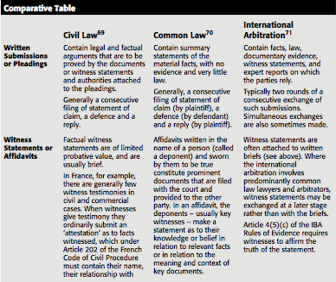

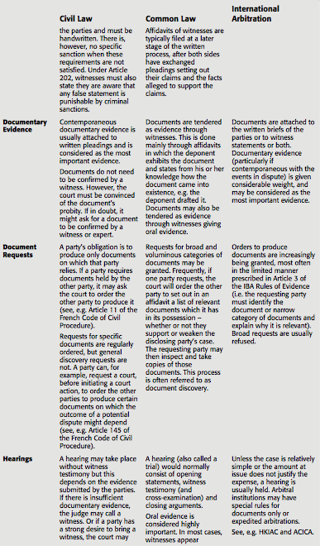

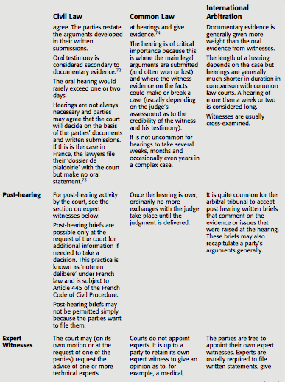

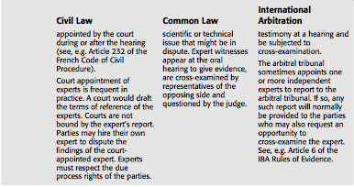

1. **Arbitral proceedings**
2. ***Overview of typical procedural steps***

Again, at the risk of oversimplification, the following list sets out in sequential order many of the most typical procedural steps from the commencement to the closure of an international arbitration:

1. notice of arbitration;
2. response to the notice of arbitration;
3. appointment of arbitrators;
4. preliminary meeting between the arbitral tribunal and the parties at which procedural timetables and documents such as terms of reference might be prepared (this meeting may be in person, by telephone, video-link, or dispensed with altogether);
5. exchange of written submissions (witness statements may instead be attached to pre-hearing briefs);
6. disclosure of documentary evidence (requests to produce);
7. oral hearing (with witnesses of fact and expert witnesses);
8. post-hearing submissions;
9. deliberations of the arbitrators;
10. issuance of the award; and
11. setting aside or enforcement of the award in domestic courts.

* As a consequence of the flexible character of arbitral procedure and party autonomy,
  + these steps may not feature in an arbitration and other steps not mentioned may also be adopted.
  + it should be borne in mind that the arbitration procedure may sometimes be split into different phases.
* However, vesting the arbitral tribunal with an overly wide discretion may have a negative side effect.

1. ***Initiating the arbitration***

* The notice of arbitration (or request for arbitration) initiates the arbitration process.
  + It typically includes :
    - details of the parties,
    - the arbitration clause or agreement invoked,
    - the nature of the claim and remedy sought,
    - and proposals for the appointment of arbitrators.
* Institutional arbitration rules often require that the respondent submit an answer (or response) to the notice or request,
  + a brief document responding to the notice of arbitration.
  + Later provisions of those rules may require parties to file more detailed written submissions, such as a statement of claim (or case) or a statement of defence.

1. ***Representation***

* Arbitration rules and laws generally do not require that a person representing a party in an arbitration be a lawyer.
* In practice, however, lawyers virtually always represent the parties in large international commercial arbitrations.
  + The situation in China also requires specific note. The position of the Chinese 7.58 Ministry of Justice has been said to be that ‘Foreign law firms are not prohibited from representing clients in arbitration cases in China; however, when Chinese law is applied or Chinese law issues are concerned, they should refrain from providing legal advice or comments, but assist clients in engaging local lawyers to do so’.
    - The practical impact of this is restrictive. It has been observed that on its face this appears to permit ‘foreign law firms to practice arbitration in China; however, since Chinese law is applied or otherwise implicated in almost every arbitration case in China, the prohibition on providing advice or commenting on relevant China law issues constitutes a restriction’
* Institutional rules and domestic laws may also need to empower arbitral tribunals to refuse a party’s chosen representative in appropriate cases

1. ***Preliminary meeting***

* Once an arbitral tribunal has been appointed, the arbitrators may confer by teleconference or email and discuss issues relating to the organization and conduct of the proceedings.
* Thereafter, the arbitral tribunal might hold a preliminary meeting with the parties.
  + At this preliminary meeting the arbitral tribunal, in consultation with the parties, will decide a number of procedural issues

1. ***Terms of reference***

* The ICC is well known for requiring ‘terms of reference’ to be drawn up by the arbitral tribunal as soon as it receives the arbitration file from the ICC Secretariat.
  + **Article 18(1) of the ICC Rules** requires that those terms include a summary of the parties’ claims and the particulars of the applicable procedural rules.
    - They may also include a list of issues to be determined. The terms of reference must be signed by the arbitral tribunal as well as the parties.
* In some instances, where an original arbitration agreement is defective, the terms of reference – because they are signed by the parties – may be considered as a substitute arbitration agreement

1. ***Witten submissions***

* Like virtually all aspects of arbitration procedure, the type, number and sequence of written submissions is flexible and varies greatly.
  + It is common for the exchange of written submissions to take place consecutively rather than simultaneously
  + After a statement of claim is served or submitted, the respondent is required to serve or submit a statement of defence, to which would ordinarily be attached supportive documentary evidence and witness statements.
* Although in practice it is relatively rare for arbitral proceedings to be based solely on documents, this may result in very fast and economical arbitrations
* Documentary evidence is often attached to pre-hearing written submissions.
  + in rare cases, a party might wish to withhold a document for a later stage of the proceedings.
    - This might be part of a strategy used to withhold the document until the cross-examination of a witness.
      * Caution should be applied in adopting such a technique because

(1) that document may be required to be disclosed in a document production request (2) it is highly probable that the other party will object to the document’s later inclusion on the grounds that

(i) it has been submitted out of time;

(ii) it is unfair to surprise the opposing party with such a document; and/or

(iii) extra time is needed to respond to it, with the costs of any adjournment

to be paid by the late-submitting party.

* As regards the filing or service of the written submissions, deadlines are usually set by the arbitral tribunal in consultation with the parties.
  + In the absence of agreement by the parties and subject to the arbitral tribunal’s (or arbitral institution’s) discretion, some institutional rules fix time periods for submission.
* Post-hearing written submissions are common in larger cases.
  + In these submissions, parties are typically permitted to comment on the evidence that was given during the hearing or they may be permitted to summarize in one final document all factual and legal arguments presented during the proceedings.

1. ***Amendment of claims***

* Many institutional rules and laws in the region provide for the amendment of the claim or defence.
  + The ICC Rules are different in this respect.
  + They are silent as to ‘amendments’ to claims but prohibit the introduction of ‘new claims’ falling outside the scope of the terms of reference without the arbitral tribunal’s permission. No definition of a ‘new claim’ is provided.
    - A mere amendment to, say, the quantum of the claim, or refining the language of a claim will not normally be considered as a new claim.
* Furthermore, if a new claim is not admitted, that does not amount to rejection of the claim. A claim not admitted, subject to jurisdictional requirements, may be reintroduced in a later proceeding.

1. ***On-site inspections***

* Colloquially, an on-site inspection may be referred to as a ‘see, touch and smell’ exercise.
  + It gives the arbitral tribunal an important impression of a place or object that is relevant to the arbitration and may provide the arbitrators with a deeper understanding of the factual issues in dispute.
    - The power to conduct on-site inspections is given to most courts and arbitral tribunals
* However:
  + **Article 24(2) of the Model Law** provides that for any meeting of the arbitral tribunal at which inspection of property is to take place, the parties should be given sufficient advance notice. Again, this is simply an application of due process principles.

1. ***Bifurcation and trifurcation***

* A procedural device that may increase efficiency in arbitration involves splitting the procedure into several phases.
  + Bifurcation and trifurcation, respectively, divide the proceedings into two or three phases,
    - for example,
      * one dealing with jurisdictional issues,
      * one dealing with liability
      * and a final one with quantum or costs.
  + Partial arbitral awards may be issued for each phase before the following one begins.
  + This division can save costs and time.

1. ***Party default and non-participating parties***

* Some international arbitrations involve a respondent that decides not to participate in the arbitration.
  + Less often, a claimant may file a notice of arbitration but thereafter it may fail to submit a statement of claim. The arbitration’s procedural laws and rules usually stipulate the consequences in these situations of party default.
    - In the context of ICC arbitration, in 2009 there was at least one non- participating party in 6.4% of ICC arbitration cases.
* Non-participation raises the question whether the arbitration should proceed **ex parte (i.e. without the respondent’s participation)**
  + In arbitration, however, refusal by the respondent to participate does not override the arbitral tribunal’s duty to examine and question the claimant’s position.
  + the claimant is still required to prove its case : according to **Article 25(b) of the Model Law**, if:
    - *the respondent fails to communicate his statement of defence . . . the arbitral tribunal shall continue the proceedings without treating such failure in itself as an admission of the claimant’s allegations.*
* Once an arbitral tribunal is satisfied that a well-founded case is made out, it must issue an award that is accompanied by reasons for its decisions and detailing the circumstances of the respondent’s failure to participate.
  + **Hainan Machinery Import & Export Corporation v Donald & McArthy Pte Ltd**
    - Hainan initiated CIETAC arbitration proceedings but some of the documents it relied on were in Chinese.
    - Although informed of the hearing Donald did not attend. After the hearing, Donald was informed that it had taken place and was given an opportunity to submit materials. Donald simply replied stating that it did not agree to the arbitration. An award was rendered in favour of Hainan. Enforcement of the award was sought and granted in Singapore. The decision of the Singapore High Court in granting enforcement noted that there were no errors of procedure made in the arbitration
* Not all laws or rules address a claimant’s failure to submit a statement of claim after it has made a request for arbitration.
  + The procedural laws or the arbitral rules that deal with such a circumstance generally require termination of the arbitral proceedings

1. ***Expedited arbitration procedures***

* In certain circumstances, the parties to arbitration may desire a swift resolution of their dispute.
  + The principle of party autonomy allows them to agree on **an expedited or fast-track procedure.**
    - Parties may prefer faster dispute resolution at the possible sacrifice of a better quality decision.
  + A more cost effective process is an important feature of expedited arbitration, particularly where the amount in dispute is relatively small.
  + The rapid determination of legal rights has also been considered positive in the sense that it reduces prolonged uncertainty.

1. ***Arb-Med***

* As its name suggests, arb-med is a fusion of arbitration and mediation.
* Under this process, arbitrating parties agree that their arbitrator may act as a mediator in the same dispute at some point during the arbitral proceedings.
  + The essential difference between arbitration and mediation is that the latter is facilitative.
  + It involves an impartial third party mediator who assists the parties to arrive at a settlement.
    - Unlike an arbitrator, a mediator lacks the power to impose a decision on the parties.
* In relation to China in particular,
  + Michael Moser that *‘[o]ne of the unique characteristics of arbitration in China is that proceedings before the international arbitration bodies frequently involve conciliation’*.
* It has been observed that ‘[m]any cases show that the party’s frank confidential chats with the arbitrator acting as a mediator [do] not make resumption of the arbitrator’s work as an adjudicator difficult’.
  + However, this may not always reflect the reality of the situation.
* Some of the attractive features of arb-med are reported to be that

(1) it provides a ‘gentler solution’ to arbitration,

(2) it facilitates a continuation of commercial relations, and

(3) arbitrators have the power to make binding decisions if the mediation attempted during the arbitration fails.

* + As regards the latter feature, it is considered that the decision-making power of arbitrators tends to increase the chances that the parties resolve their differences in the mediation because a failure to settle will result in a binding arbitral award that may not be satisfactory to one or even all of them
* Enforcement of an award may be jeopardised or the award may be set aside if such requirements are not present.
  + Given the potential risks, caution should be exercised before utilising arb-med procedures if the arbitrator may be expected to resume his or her arbitral role failing successful mediation.

1. ***Termination of the proceedings***

* Under **Article 32(1) of the Model Law** a final award terminates the arbitral proceedings. Other circumstances in which proceedings may be terminated include:

1. the claimant’s withdrawal or discontinuance of a claim, which is not objected to by the respondent;
2. an agreement by the parties to terminate or discontinue the proceedings;
3. a finding by the arbitral tribunal that continuation of the proceedings has  become unnecessary or impossible; or
4. the failure of the parties to act.

* Once the arbitral tribunal issues an award that leaves no more disputed issues between the parties to be determined, the arbitral proceedings are brought to a close and the arbitral tribunal becomes **functus officio**, i.e. it has discharged its duty.
  + However, this may not terminate the matter between the parties because they may be entitled to challenge the award before domestic courts.
    - the mandate of the arbitral tribunal may revive if there is a request by a party (or decision by the arbitral tribunal on its own initiative) to correct or interpret the award
    - or if a court hearing a setting aside application determines that the arbitral tribunal shall ‘resume the arbitral proceedings or
    - to take such other action as in the arbitral tribunal’s opinion will eliminate the grounds for setting aside’

1. **Evidence**

* More than half a century ago, Bin Cheng observed that the ‘conviction of the Tribunal as to the truth of the assertions of the parties is secured by means of evidence’
* Evidence is largely unregulated in international arbitration. Party autonomy dictates matters of evidence. Failing an agreement between the parties, the arbitral tribunal is usually empowered to decide on the admissibility, relevance, materiality and weight of evidence
  + **Municipal Corporation of Delhi v Jagan Nath Ashok Kumar**
    - *Appraisement of evidence by the arbitrator is ordinarily never a matter which the Court questions and considers. The arbitrator in our opinion is the sole judge of the quality as well as the quantity of evidence and it will not be for the Court to take upon itself the task of being a judge of the evidence before the arbitrator.*

1. ***Burden and standard of proof***

* Concerning the burden of proof in international commercial arbitration, each party must prove the facts on which it relies.However, the standard or degree of proof required is a matter for the arbitral tribunal to determine.
  + Redfern and Hunter: while acknowledging that the standard of proof in international arbitration is not precise, appear to distil generally from arbitral practice a ‘**balance of probability’** standard
  + Lew, Mistelis and Kro ̈ll observe that the standard of proof may be a matter of substantive law and may depend on the subjective views of the arbitrators in each case.
* exceptional cases:
  + ex: when a claimant produces prima facie evidence in a situation where proof of a fact is extremely difficult and there is an absence of rebuttal by the respondent.
    - In such cases, the arbitral tribunal might shift the burden of proof on relatively little evidence or it may not insist on very rigorous standards of proof.
* Proof would not usually be required in the event the fact or proposition is uncontroversial, common knowledge or obvious.

1. ***Documentary evidence***

* A particular feature of international arbitration that distinguishes it from proceedings in common law courts is its emphasis **on evidence in the form of contemporaneous documents created around the time the transaction or the events giving rise to the dispute took place**
* Bin Cheng
  + *‘Testimonial evidence’, it has been said, ‘due to the frailty of human contingencies is most liable to arouse distrust.’ On the other hand, documentary evidence stating, recording, or sometimes even incorporating the facts at issue, written or executed either contemporaneously or shortly after the events in question by persons having direct knowledge thereof, and for purposes other than the presentation of a claim or the support of a contention in a suit, is ordinarily free from this distrust and considered of higher probative value*.
* The consequence is that in international arbitration, documents are readily admitted without arguments as to whether they are admissible
  1. Document production – Domestic court practice
* At one end of the spectrum must be placed the US document discovery procedure, which is broad and extensive.
  + Next in line are the more temperate discovery procedures of English courts and former British colonies, which view discovery as integral but require or order document disclosure on a less extensive scale than in the US.
* And on the other end of the spectrum, one finds many civil law jurisdictions.
  + At this end of the spectrum, one may also find some Asia-Pacific countries with civil law systems
* Giorgio Bernini
  + “*the taking of evidence in international arbitrations is likely to present itself as the occasion in which the different approaches characterising the contribution of civil and common law attorneys and arbitrators may give rise to a serious cultural clash. Discovery, in particular, is bound to remain a very controversial issue in arbitration. Nonetheless, the actual practice of arbitration shows signs of adjustment, and, despite theoretical differences, a workable modus vivendi has emerged in the reality of arbitration practice at [the] international level*.”
  1. Document production – Arbitral practice
* Arbitration rules sometimes contain specific provisions that empower arbitral tribunals to order document production.
* Although it is impossible to generalise about the type of document discovery usually permitted by international commercial arbitral tribunals,
  + one thing is clear: extensive US style court discovery is rarely, if ever, practised.
* It is also clear that there is great variation in the extent of discovery or document production that is permitted in international arbitration.
  + It depends on the procedure agreed by the parties, the circumstances surrounding the request and on the preferences of the arbitrator(s), which might in turn depend on their legal background and experience.
    - Lawyers trained in common law systems should not assume that the practice of obtaining evidence through discovery that may be familiar to them will be appropriate or acceptable in an international commercial arbitration.
    - On the other hand, lawyers trained in civil law systems should be ready to accept at least some form of document production.
  1. Court assistance in document production

The Hong Kong Arbitration Ordinance serves as a good example of a domestic law that allows courts to assist arbitral tribunals in requesting the production of documents.

* Under Section 2GB, an arbitral tribunal is empowered to make orders or give directions in respect of the discovery of documents. However, the arbitral tribunal cannot compel a party to act. If a party refuses to so act, the assistance of the court may be sought. In such a case, Section 2GG(1) becomes relevant:
  + *An award, order or direction made or given in relation to arbitration proceedings by an arbitral tribunal is enforceable in the same way as a judgment, order or direction of the Court that has the same effect, but only with the leave of the Court or a judge of the Court. If that leave is given, the Court or judge may enter judgment in terms of the award, order or direction.*
  1. The IBA Rules of evidence and document production

The IBA Rules of Evidence have attempted to reconcile differences between common law and civil law practices in respect of document production.

* They are frequently used.

Article 3(1): a party must submit all documents on which it relies and which are available to it (except for documents already submitted by another party).197 In the event a party needs to request another party to the arbitration to produce documents, it must submit a request to the arbitral tribunal (Article 3(2)). That request must identify each document requested or a ‘narrow and specific’ category of documents reasonably believed to exist (Article 3(3)(a)). Additionally, the request must state :

* 1. how the documents are relevant and material to the outcome of the case,
* (2) that the documents are not in the possession, custody or control of the requesting party, and
* (3) why the requesting party assumes the other party has possession, custody or control of the documents (Article 3(3)(b) and (c)).

Pursuant to Article 3(5), the party to whom the request is made may object on the basis of the reasons set forth in Article 9(2). These reasons are:

* a)  lack of sufficient relevance or materiality;
* b)  legal impediment or privilege under the legal or ethical rules determined by the  Arbitral Tribunal to be applicable;
* c)  unreasonable burden to produce the requested evidence;
* d)  loss or destruction of the document that has been reasonably shown to have  occurred;
* e)  grounds of commercial or technical confidentiality that the Arbitral Tribunal determines to be compelling;
* f)  grounds of special political or institutional sensitivity (including evidence that has  been classified as secret by a government or a public international institution) that  the Arbitral Tribunal determines to be compelling;
* g)  considerations of fairness or equality of the Parties that the Arbitral Tribunal determines to be compelling.

Under Article 3(6), if the arbitral tribunal considers that the issues the requesting party seeks to prove are relevant and material and none of the Article 9(2) exceptions applies, the arbitral tribunal may order production of the requested documents.

* Note here that even if all the conditions in the Rules as to production are satisfied by the requesting party, the presence of the word ‘may’ in Article 3(6) still gives the arbitral tribunal a discretion to deny the production request.

If a request to produce is made and a requested party fails without satisfactory explanation to produce any document in contravention of an order to produce, the arbitral tribunal may infer that this document would be adverse to the interests of that party (Article 9(4)).

* However, this may be a relatively weak sanction in the event that a critical document is not disclosed, especially given that in practice **arbitral tribunals are generally reticent to rely on adverse inferences**.

In certain jurisdiction, the *lex arbitri* may assist the arbitral tribunal.

* However, while this might be effective against a party situated within the jurisdiction of the courts of the *lex arbitri,* it is unlikely to have any effect on a foreign party situated outside that jurisdiction.
  + P. Yang : «  *If a foreign party irrevocably says that it has no such document to disclose, it is usually the end of the matter in an international arbitration. There is no point in further pursuing the matter as it ultimately will be a waste of time. If the arbitrator does not accept the reason for non-disclosure and is confident of its existence, he or she can of course and should always forewarn the foreign party that an adverse inference may be drawn against him or her. »*

While arbitral tribunals are empowered to draw an **adverse inference**, rarely are such inferences made, even if the refusal to produce concerns a document of high relevance. One of the factors that may affect the apparent reticence of arbitral tribunals to draw an adverse inference is doubt that

* the document exists,
* (ii) is in the possession of the requested party and
* (iii) is essential for the disposition of the case. It has been suggested that if an adverse inference is incorrectly made, the award may be challenged or difficulties in its enforcement may be encountered.

Other significant document production features of the IBA Rules of Evidence include the appointment of an impartial expert to review documents and report on objections made to their production (Article 3(7)); the production of documents from persons or organisations not a party to the arbitration (Article 3(8)); a request to produce that is initiated by the arbitral tribunal itself (Article 3(9)); and the submission of documents that become relevant and material as a consequence of the documents previously submitted to the arbitral tribunal (Article 3(10)).

**Harmonization in practice, with the assistance of the IBA Rules of Evidence, is gradually starting to emerge.**

* **ATTENTION:** nouvelles règles de l’IBA en matière d’Evidence.

1. ***Witness evidence***
2. Witness evidence generally

This evidence may take the form of statements or affidavits written specifically for the purpose of the arbitration or oral testimony at the hearing.

* **Witnesses are called to give factual evidence.**
* Their role is not to give their opinion: role assigned to expert witnesses.

Domestic laws vary considerably as to witness evidence.

* It is important to bear in mind that most of national rules do not apply to international arbitrations.
* Nonetheless, these differences often mean that different individuals (party representatives, lawyers and arbitrators) involved in an arbitration bring different expectations as to the approach toward witnesses.

The IBA Rules of Evidence fill this gap between national rules by attempting to provide a neutral standard of universal application.

1. IBA Rules of Evidence and witnesses

The means by which witnesses provide written evidence under the 1999 IBA Rules of Evidence is by **witness statements that contain an affirmation by the witness of its truth.**

Article 4(5) of the IBA Rules sets out the written statement’s required contents. One of the more important Article 4(5) requirements is **the need to identify the source of the witness’s information** as to the facts described. Article 4(1) expresses the common practice that, prior to the hearing, parties give notice as to the identity of the witnesses on whose testimony they will rely and a summary of the subject matter of their testimony.

* Under the IBA Rules of Evidence, any person is permitted to present evidence, including a party, a party’s officer, employee or other representative (Article 4(2)).
* The Rules also enable a party, its officers, employees, legal advisors or other representatives to ‘interview’ witnesses (Article 4(3)).
  + It is now generally understood within the field of international commercial arbitration (contrary to the practice in certain domestic jurisdictions) that witnesses may be prepared by counsel or other persons before giving their oral evidence.
  + B. Horatiau advises : *Witness preparation should not become witness manipulation. The starting point for any witness preparation is to remind the witness to tell the truth. Moreover, a witness who has been ‘over-prepared’ may quickly lose credibility in the eyes of the arbitral tribunal.*
* Witnesses who have submitted witness statements are required to testify at a hearing unless the parties agree otherwise (Article 4(7)).
* A party may insist that a witness who has submitted a witness statement be present for cross-examination at a hearing. Should that witness fail to appear without a valid reason, the arbitral tribunal may be required to disregard that witness statement, unless the circumstances are exceptional (Article 4(8)).
* Additionally, the arbitral tribunal by its own motion may order that any person testify (Article 4(11)).

1. ***Expert evidence***

Experts are expected to possess specialized professional experience and/or academic credentials in the subject area in which they testify. Expert evidence may be given by party-appointed experts or tribunal-appointed experts.

* 1. Party-appointed experts

Article 5 of the 1999 IBA Rules of Evidence deals with party-appointed experts. They are required to submit an expert report.

* Unless otherwise agreed by the parties, the experts must appear for testimony (Article 5(4))

The arbitral tribunal also has the discretion to order any party-appointed experts who have submitted reports on the same or related issues to meet and attempt to reach agreement on those issues in respect of which they expressed differences of opinion (Article 5(3)).

* 1. Tribunal-appointed experts

In practice, party-appointed experts are far more common than arbitral tribunal-appointed experts. If an expert is appointed by the arbitral tribunal, it is prudent for the arbitral tribunal to draft terms of reference for the expert. The appointed expert must be independent.

* IBA Rules authorize arbitral tribunal-appointed experts to request from any party information or access to documents, goods, samples or property.

The expert report must describe the method, evidence and information used in arriving at its conclusion (Article 6(4)). Parties have a right to see that report, the correspondence between the arbitral tribunal’s appointed expert and the arbitral tribunal, and may examine any other document the expert examined (Article 6(5)). Parties may also respond to the report through a separate report prepared by a party-appointed expert (Article 6(5)).

The report of the arbitral tribunal’s expert does not bind the arbitral tribunal, which must assess the expert’s conclusions ‘with due regard to all the circumstances of the case’ (Article 6(7)).

Case: ***Luzon Hydro Corp v. Transfield Philippines*****(2004 Singapore High Court)**

**Decision:** the applicant challenged an arbitral award on the basis that the tribunal-appointed expert retained to assist it went much further than was agreed by the parties – allegedly the expert was actively involved in assessing the evidence. Additionally, the applicant alleged a breach of natural justice on the basis that the expert’s report to the arbitral tribunal was not provided to the parties for comments. The Singapore High Court rejected the application on a number of grounds, which included a finding that the arbitral tribunal adequately set out the expert’s tasks in a letter to the parties; that the expert communicated to the parties in his invoices descriptions of his activities; no compelling evidence indicated that the expert exceeded his role; what the expert said to the arbitral tribunal was confidential; and no party objected to the role of the expert until the award was issued.

**Commentary :** This decision differs from the rule in Article 6(5) of the IBA Rules of Evidence, which states that the parties may examine ‘any correspondence between the Arbitral Tribunal and the Tribunal-Appointed Expert’. This serves as a reminder that the IBA Rules of Evidence are certainly not used in every case, and even where they are used they are generally utilised only as guidelines rather than binding rules. The decision also underscores the wide degree of discretion arbitral tribunals are granted in determining the procedure in relation to experts.

* 1. Witness conferencing

Arbitral tribunals may create procedures for the assessment of evidence that are conducive to smoother and more efficient arbitrations. One of these is witness conferencing.

Definition: Witness conferencing consists of the simultaneous joint hearing of all fact witnesses, expert witnesses, and other experts involved in the arbitration. It is not an occasional confrontation of two fact witnesses or expert witnesses, but involves all witnesses and experts appearing simultaneously throughout the entire hearing. Witness conferencing is therefore not a ‘witness-by-witness’ hearing, but a team-versus-team hearing.

Witness conferencing is said to reduce with relative speed many of the divergences among experts and leaves only a few specific points of disagreement for the arbitral tribunal to determine.

1. **Hearings**

A hearing typically refers to a meeting at which counsel and the arbitrators are physically present for purposes such as the presentation of each party’s oral arguments, examination of witnesses, and for the arbitrators to question the parties’ counsel and/or their witnesses. A general feature of arbitration hearings is that they take place in private.

* Due process rules demand that parties are given adequate advance notice of the hearing. In the event that a party duly notified of the hearing fails to appear without showing sufficient cause for the failure, the arbitral tribunal may proceed to hear the party that appears, and ultimately issue a default award.
* The power to manage hearings rests with the arbitral tribunal and not the parties.

Example of the procedure followed during an evidentiary hearing :

* (i)  *Opening of the hearing* –The parties and their representatives will be introduced and organizational matters will be explained.
* (ii)  *Opening statements* (sometimes omitted) – A summary presentation of each party’s case, highlighting the respective merits and strengths
* (iii)  *Hearing of witnesses of fact* – Not all witnesses who have provided written statements are called to give oral evidence. If a party disputes the con- tent of a witness’ written statement, then that witness should normally be called for cross-examination. Witnesses in international arbitrations rarely testify under oath unless that is mandatory under the law of the seat. The three main phases of taking evidence are the examination in chief (or direct examination), the cross-examination and re-examination (or redirect examination). Examination in chief often does not take place – for the sake of efficiency, counsel for the parties frequently agree that the witness’s written state- ment constitutes the evidence in chief. The arbitral tribunal is usually free to question a witness at any time during these phases.

* (iv)  *Hearing of expert witnesses* – The presence of expert witnesses will ordinarily be required at the hearing to be examined and cross-examined much like witnesses of fact.
* (v)  *Closing arguments* – This stage is reserved for the parties’ lawyers to sum up their case on the basis of all the evidence presented to the arbitral tribunal, usually with a focus on the evidence adduced during the hearing.
* (vi)  *Closing of the hearing* – Before formally closing the hearing, the sole arbitrator or chairperson may address outstanding and/or future procedural .

1. **Interim measures**

Interim measures are court or arbitral tribunal orders designed to protect assets or maintain the status quo pending the outcome of legal proceedings. These measures are temporary and usually have effect only up to the time the final award is issued. Issues relating to interim measures can arise before an arbitral tribunal or before a competent domestic court.

1. ***Tribunal-ordered interim measures***

An international arbitral tribunal’s power to order interim measures is derived from the parties’ agreement, the applicable procedural rules, the law of the seat, and perhaps even from the arbitral tribunal’s inherent power to conduct the proceedings as it sees fit.

In many cases, parties comply voluntarily with interim measures ordered by the arbitral tribunal. The arbitral tribunal’s ruling ends the matter and no further steps on its part are necessary. A party that defies an interim measures order may face a range of negative consequences:

* (i)  it may expose itself to an action for breach of the arbitration agreement;
* (ii)  the arbitral tribunal may draw an adverse inference against it;
* (iii)  an award of costs may be made against it; and/or
* (iv)  if national courts are called on to assist in the enforcement process and  the defiant party still fails to comply, state-backed sanctions involving contempt proceedings, fines and, perhaps in extreme cases, imprisonment could follow.

1. National laws

The new 2006 Model Law Article 17 elaborates significantly on the meaning of interim measures. It provides :

* (1)  Unlessotherwiseagreedbytheparties,thearbitraltribunalmay,attherequestof a party, grant interim measures.
* (2)  Aninterimmeasureisanytemporarymeasure,whetherintheformofanawardor in another form, by which, at any time prior to the issuance of the award by which the dispute is finally decided, the arbitral tribunal orders a party to:
* (a)  Maintain or restore the status quo pending determination of the dispute;
* (b)  Takeactionthatwouldprevent,orrefrainfromtakingactionthatislikelyto cause, current or imminent harm or prejudice to the arbitral process itself;
* (c)  Provide a means of preserving assets out of which a subsequent award may  be satisfied; or
* (d)  Preserve evidence that may be relevant and material to the resolution of the  dispute.

The conditions necessary for interim measures to be granted are set out in Arti- cle 17A of the 2006 Model Law. Its first paragraph reads:

* *The party requesting an interim measure under article 17(2)(a), (b) and (c) shall satisfy the arbitral tribunal that:*
  + *(a) Harm not adequately reparable by an award of damages is likely to result if the  measure is not ordered, and such harm substantially outweighs the harm that is likely to result to the party against whom the measure is directed if the measure is granted; and*
  + *(b) There is a reasonable possibility that the requesting party will succeed on the merits of the claim. The determination on this possibility shall not affect the discretion of the arbitral tribunal in making any subsequent determination.*

The 2006 Model Law amendments also contain safeguards to prevent abuse of the interim measures regime:

* the arbitral tribunal may modify, suspend or terminate the interim measure at any time (Article 17D);
* it may require appropriate security to be provided (Article 17E);
* it may require the requesting party to make prompt disclosure of any material change in the basis on which the measure was requested or granted (Article 17F);
* and the party requesting the measure is to be liable for any costs or damages caused by the interim measure if the arbitral tribunal determines that the measure should not have been granted

1. Ex-parte preliminary orders

One of the most contentious subjects in the Model Law 2006 amendments concerned ex parte ‘preliminary orders’, which an arbitral tribunal is entitled to grant under Article 17B:

* (*1)  Unless otherwise agreed by the parties, a party may, without notice to any other party, make a request for an interim measure together with an application for a preliminary order directing a party not to frustrate the purpose of the interim measure requested.*
* *(2)  Thearbitraltribunalmaygrantapreliminaryorderprovideditconsidersthatprior disclosure of the request for the interim measure to the party against whom it is directed risks frustrating the purpose of the measure.*
* *(3)  Theconditionsdefinedunderarticle17Aapplytoanypreliminaryorder,provided that the harm to be assessed under article 17A(1)(a), is the harm likely to result from the order being granted or not.*

The procedure to be adopted subsequent to the granting of a preliminary order is set out in Article 17C. Its main features include

* providing notice of the order and related information to all parties immediately after the order is made ;
* granting the party against whom the preliminary order is made the opportunity to present its case ;
* and deciding promptly any objection to the order. The order has a life span of 20 days but this may be varied after hearing the party subject to the order.

Pros : an arbitral tribunal’s power to grant ex parte measures enhances the usefulness and efficiency of international arbitration by increasing its independence from state courts and that the element of surprise may be essential for certain interim measures to be effective. They also assert that because state courts regularly grant ex parte measures, there is no reason for arbitration to be any different.

Cons : the granting of ex parte relief by an arbitral tribunal violates fundamental due process principles of international arbitration and it is inconsistent with the consensual nature of arbitration; that the practice may lead arbitrators to prejudge the merits of the dispute without hearing the other party; and that parties always have the option to obtain ex parte interim relief from a court.

1. ***Court assistance***

There are a number of reasons why an arbitral tribunal might need the assistance of courts in issuing interim measures. Five situations identified :

* (i)  The arbitral tribunal may not have the powers, particularly if the national law limits powers of arbitrators to order interim measures.
* (ii)  A need for interim measures might arise (often urgently) before the arbitral tribunal is constituted.
* (iii)  An arbitral tribunal’s powers extend only to the parties involved in the arbitration whereas court orders may be enforced against third parties.
* (iv)  An interim measure may not be enforceable internationally under the New York Convention and therefore an interim measure may need to be requested directly from a court at the place of execution.
* (v)  Arbitrators by and large are not given powers to grant ex parte applications to restrain the conduct of another party and therefore the ex parte application will usually need to be determined by a court.

A key feature of the Model Law 2006 amendments is its provisions on the enforcement of interim measures. Article 17H provides:

* (1) *An interim measure issued by an arbitral tribunal shall be recognized as binding and, unless otherwise provided by the arbitral tribunal, enforced upon application to the competent court, irrespective of the country in which it was issued, subject to the provisions of article*.

This provision also contains certain safeguards such as imposing an obligation on the requesting party to inform the enforcing court of any changes to the interim measure and empowers the enforcing court to order appropriate security from the requesting party.

Some laws may specifically allow courts to determine interim measures without the need first to apply to an arbitral tribunal

Interim court orders may be made by courts located outside the seat of arbitration as is indicated by Article 17J of the 2006 Model Law. Such orders are particularly important where assets outside the seat need to be protected.

**Cases**

In ***Bhatia International v Bulk Trading SA,291*** **(2002 Indian Supreme Court)** even though France was the seat of arbitration, the Indian Supreme Court upheld a lower court’s interim order to preserve the subject matter of an ICC arbitration by preventing a party to the foreign arbitration from alienating or otherwise disposing of its business assets located in India. In this case, the Supreme Court controversially used the interim measures provision located in Part I of India’s Arbitration and Conciliation Act. Whether Part I actually applies to arbitrations seated outside India is open to some debate because, pursuant to Section 2(2) of the Act, that Part applies ‘where the place of arbitration is in India’.

In ***Swift-Fortune Ltd v Magnifica Marine SA* (2006)***,* the Singapore Court of Appeal upheld a first instance decision by Justice Judith Prakash that Singapore courts have no jurisdiction under Section 12(7) of its International Arbitration Act to grant injunctions in aid of a foreign arbitration and that this provision applied only to an arbitration seated in Singapore. The court left open the question whether Section 4(10) of the Singapore Civil Law Act could be applicable. That provision states that ‘an injunction may be granted . . . in all cases in which it appears to the court to be just or convenient that such order should be made’. The International Arbitration Act was amended in 2009 to give Singapore courts the power to issue interim measures in respect of foreign arbitrations.

In relation to overlapping interim measures powers of arbitral tribunals and courts, no settled international practice has developed as to how they should coexist. The Article 17 Model Law amendments of 2006 are silent as to the order of priority.

* Courts and arbitral tribunals are no longer jurisdictional competitors in connection with interim measures. This position is supported by Justice Baragwanath’s view of a court’s role in an interim measures application arising out of a dispute subject to arbitration :
  + *the purpose of interim measures is to complement and facilitate the arbitration, not to forestall or to substitute for it. The Court’s role is ancillary, to be exercised only to the extent that it is possible or practicable for the arbitrator to deal with the issue.*

1. **Security for costs**

Definition : orders make the right of a claimant or counter-claimant to proceed on his claim conditional on the raising of a bank guarantee or other forms of surety to guarantee, in the case of an unsuccessful claim, any eventual award of legal fees assessed against the claimant or counter-claimant by the arbitral tribunal.

Reason for it : Without security for costs, a respondent to a spurious arbitration claim filed against it by a claimant that has little or no assets finds itself in an undesirable situation. If it does not defend the claim, an adverse award may be issued that is enforceable against it. If it succeeds in defending the claim, it is likely to be left without a remedy for the costs of mounting a defence due to the impecuniosity of the claimant. Security for costs may be granted to cover, for example, fees and expenses of its lawyers, experts, interpreters, the institutional costs etc.

A number of recent arbitration rules specifically empower an arbitral tribunal to order security for costs. While other sets of arbitral rules do not expressly grant this power, it may be implied into their provisions dealing with interim measures (power non existant in many laws including 1885 Model Law).

The 2006 Model Law amendments have revised the relevant parts of Article 17. But this provision still does not necessarily clarify whether an arbitral tribunal can order security for costs.

An arbitral tribunal has an effective sanction for non-compliance with security for costs orders: it may simply stay the arbitration until compliance occurs.

* Section 2GB of the Hong Kong Arbitration Ordinance expressly provides that an arbitral tribunal may strike out a claim if the claiming party fails to provide security for costs.

1. **Privacy and confidentiality**

Privacy has not proved an overly controversial concept. On the other hand, considerable debate has taken place as to the precise scope of confidentiality in international commercial arbitration.

* Difference between the two : Privacy is concerned with the right of persons other than the arbitrators, parties and their necessary representatives and witnesses, to attend the arbitration hearing and to know about the arbitration. Confidentiality, by contrast, is concerned with the obligation on the arbitrators and the parties not to divulge or give out information relating to the content of the proceedings, evidence and documents, addresses, transcripts of the hearings or the award.

One of the objectives of privacy in arbitration has long ago been described as keeping ‘quarrels from the public eyes’. A more recent rationale justifying privacy has been that the agreement to arbitrate is between the parties and only between them.

In contrast, the duty of confidentiality in arbitration finds no generally accepted approach.

* Confidentiality issues often arise in parallel arbitrations (but with different parties) where one arbitration may be relevant to and possibly determine the outcome of another. The question therefore arises whether the transcripts, pleadings, witness evidence, submitted documents and award in the first arbitration may be disclosed in the second. The same situation arises between an arbitration and related court proceedings with different parties.

The English courts on the one hand take the view that there is an implicit duty to maintain confidentiality in arbitration proceedings.

* English courts still need to determine whether a given case falls within established exceptions.
* It was considered that this duty of confidentiality is derived from the privacy of hearings.
* *If it be correct that there is at least an implied term in every agreement to arbitrate that the hearing shall be held in private, the requirement of privacy must in principle extend to documents which are created for the purpose of that hearing.*

Other jurisdictions such as France, Germany and Switzerland also imply a duty of confidentiality of arbitral proceedings and documents submitted during them.

* In New Zealand, legislation has gone as far as stating that the parties to an arbitration agreement are deemed to have agreed that the parties shall not publish, disclose, or communicate any information relating to arbitral proceedings or to an award made in those proceedings. On the other hand, the Australian High Court has famously declined to imply a general duty of confidentiality.

Common law courts have introduced exceptions to confidentiality :

* (i)  where there is a public interest, e.g. where the public has a legitimate interest to know about health or environmental issues;
* (ii)  where a court is required to determine matters relating to the arbitration, which means details of the arbitration may be heard in an open court;
* (iii)  where the parties have consented to disclosure – this may be implied, e.g. from an application to court asking for the removal of an arbitrator, which implicitly gives consent to the arbitrator to reveal matters concerning the arbitration to the court;
* (iv)  by compulsion of law, e.g. pursuant to anti-money laundering legislation or a public authority’s statutory power to demand information;
* (v)  with the leave of court if one party to the arbitration does not consent to disclosure to a third party;
* (vi)  to protect the legitimate interests of an arbitrating party, e.g. to enforce rights established by an earlier arbitration award or to evidence a position taken in an earlier arbitration in support of an issue estoppel argument;
* (vii)  where the interests of justice require it, e.g. where inconsistent evidence has been given by a party in two separate arbitrations;
* (viii)  where there is an obligation to disclose, e.g. by corporations to shareholders, during a takeover due diligence, to an insurance company or by listed companies to a stock exchange;
* (ix)  everyday situations, e.g. accidentally leaving a document in a public place; and
* (x)  where disclosure has been made to professional or other advisers and per- sons assisting in the conduct of the arbitration, e.g. lawyers, in-house counsel and executives, potential witnesses, investigators, secretaries, tran- scribers, copy personnel, or interpreters.

This table provides a snapshot of the confidentiality provisions in different arbitration Rules :

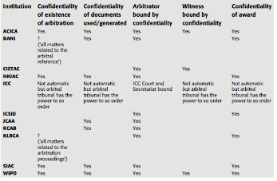

Some general observations may be made from this table. The ACICA, HKIAC and SIAC Rules offer significant protection in terms of confidentiality. Wide protections of confidentiality are also granted by the WIPO Rules particularly because of the sensitivity associated with the intellectual property disputes WIPO is called on to decide. On the other end of the spectrum is ICSID, which requires the publication of excerpts from ICSID awards.

In contrast, the ICC Rules do not explicitly address the issue of confidentiality. They grant, however, the right to privacy in hearings, enable the arbitral tribunal to take measures to protect trade secrets and confidential information, and to make any other orders as to confidentiality.

Cours 8 – Préparation

* **Simon Greenberg, José Ricardo Feris and Christian Albanesi, “Consolidation, Joinder, Cross-Claims, Multiparty and Multicontract Arbitrations: recent ICC Experience”, Chapter IX of the dossier VII of the ICC Institute of World Business Law, edited by Bernard Hanotiau and Eric Schwartz, 2010 (attached);**

1. **Introduction**

* Issues relating to multiparty and multicontract arbitrations arise within the ICC International Court of Arbitration (hereinafter, the ‘Court’) and its Secretariat (hereinafter, the ‘Secretariat’) in the process of constituting ICC arbitral tribunals and preparing files for transfer to those arbitral tribunals.
* The Court may take *prima facie* decisions on whether a case can proceed, fix the place of arbitration, decide on the number of arbitrators, confirm or appoint arbitrators and/or consolidate arbitration proceedings.
  + The Court’s supervisory role in these initial stages of arbitrations goes further than most arbitral institutions.
    - Expertise of its members and experience of the Secretariat: Court is able to be **pro-active** in identifying and taking steps to eliminate procedural irregularities that could, at worst, frustrate the enforceability of arbitrations or, at least, cause inefficiency, delays and wasted costs.
* The need for a pro-active approach: amplified in recent years by the ever-increasing complexity of the transactions behind the disputes that are submitted to ICC arbitration.
  + *For instance,*
    - *in each year from 2001-2009, at least 28.5% of ICC arbitrations involved more than two parties.*
    - *In 2009, 233 out of the 817 cases filed involved more than two parties; six of them involved more than ten parties.*
* Where an arbitration involves multiple parties or multiple contracts, it could be the case that

1. one of the respondents or the claimants has not signed the agreement on the basis of which the request for arbitration has been filed;
2. the arbitration clauses contained in the different contracts may not be compatible; and/or
3. the contracts may concern different, potentially unrelated economic transactions. Furthermore, a respondent could file cross- claims against another respondent or even request the joinder of an additional party, which could subsequently also file jurisdictional objections, cross-claims or make other requests.
4. **Consolidation**

* There are various interpretations of the meaning of the procedural mechanism ‘consolidation’, as it is known in international commercial arbitration.
* At its broadest, some practitioners include in this definition any arbitration where slightly unrelated claims are heard together.
* Others include any situation where there are claims arising from more than one contract, for example where: (i) a single arbitration is commenced on the basis of more than one contract; or (ii) a party to an existing arbitration makes a claim against another party based on a different contract from the one that forms the jurisdictional foundation for the arbitration.
* **For ICC purposes consolidation in the strict sense covers only one procedural situation.**
  + In this situation, there are at least two separate ICC arbitrations pending (i.e. with separate ICC case numbers) and one or more parties to one of the arbitrations wants them to be consolidated into a single proceeding.
    - Under the rules, consolidation is dealt with in Article 4(6) as follows:
      * *‘When a party submits a Request in connection with a legal relationship in respect of which arbitration proceedings between the same parties are already pending under these Rules, the Court may, at the request of a party, decide to include the claims contained in the Request in the pending proceedings provided that the Terms of Reference have not been signed or approved by the Court. Once the Terms of Reference have been signed or approved by the Court, claims may only be included in the pending proceedings subject to the provisions of Article 19.’*
* The Court’s practice under this article has been to follow its language strictly. This means that in order to consolidate two or more pending ICC arbitrations:
  + the legal relationships underlying the arbitrations must be connected;5
  + the parties to each arbitration must be the same;
  + a party to one of the arbitrations must request consolidation; and
  + the terms of reference must not have been signed or approved.
* In the three years from 1 january 2007 to 31 december 2009,
  + the Court dealt with 24 contested requests for consolidation,
  + eight of which were accepted and the remainder rejected.
    - These figures exclude those cases where all parties agreed to consolidate.
      * In those instances, a decision of the Court is unnecessary and the Secretariat proceeds to consolidate the matters administratively.
* By far the most common reason for the Court to reject an application for consolidation is non-satisfaction of the second criteria i.e. the parties are no identical.
* The Court has not been indifferent to the difficulties posed by the strict language of Article 4(6), particularly regarding inefficiency and potentially conflicting outcomes where consolidation is impossible.
* The Court, before deciding that it could not consolidate the cases, encouraged the parties to agree on consolidation and drew their attention to the financial consequences of conducting the three arbitrations separately.
* On other occasions, the Court has been pro-active by appointing the same arbitral tribunal in the related cases. Where identical arbitral tribunals are possible, the arbitrations can be run in parallel, thus achieving most of the benefits of consolidation without actually consolidating the matters.

1. **Multicontract arbitrations**

* As a matter of ICC internal practice, ‘multicontract’ arbitration means a single arbitration where claims have been brought on the basis of more than one contract.
  + some practitioners consider this a form of consolidation.
    - It is true that there is a close conceptual link between a request to consolidate two pending arbitrations that have been filed on the basis of different contracts, on the one hand, and a single arbitration that has been filed on the basis of more than one contract, on the other.
    - For ICC purposes, however, the two situations are considered procedurally distinct.
* The Court has developed a relatively well-established practice for determining whether a multicontract arbitration can proceed on a *prima facie* basis.
  + This means that, like all the Court’s decisions under Article 6(2) of the rules, it is for the arbitral tribunal to make a final decision on its jurisdiction.
  + In relation to multicontract disputes, an arbitral tribunal may take into account the criteria set forth by the Court’s practice, but is not necessarily required to do so
* According to the Court’s practice, a multicontract arbitration can proceed where the following three conditions are satisfied:
  + all contracts are signed by all of the parties;
  + the dispute resolution mechanisms in the different contracts are  compatible; and
  + all contracts are related to the same economic transaction.

It can be quickly observed here that the elements required for a multicontract arbitration to proceed are not dissimilar to the above-mentioned conditions for consolidation. Unlike consolidation, however, the Court’s practice for multicontract arbitrations includes limited exceptions to the element concerning the identity of the parties.

* With respect to this first element of the multicontract test set out above, the Court has, exceptionally, decided to allow a single arbitration on the basis of multiple contracts not signed by all of the parties in situations where:
  + the signatory parties belong to the same group of companies; or
  + at least one of the arbitration agreements has been signed by all of  the parties.

Two final comments must be made with respect to multicontract arbitration under the rules.

* First, a mere reference to multiple contracts by a party, or even the filing of claims arising from different contracts, may not necessarily prompt the Court to conduct its multicontract test. It can happen that a party filing claims related to more than one contract invokes only the arbitration clause contained in one of them. The question in such a case may be whether the arbitration clause relied upon is broad enough to encapsulate the claims as raised, but this is normally an issue that would be decided by the arbitral tribunal. A similar situation may also arise when a party commences arbitration based on one contract but later raises claims arising out of another contract.
* Second, the most common multicontract situation is when a claimant files principal claims on the basis of more than one contract. However, the Court has recently faced multicontract scenarios that were created either by the filing of counterclaims arising from a contract other than that upon which the claimant had based its claims or by virtue of a request for consolidation of two or more arbitrations involving different but related contracts. This situation could also potentially arise with respect to cross-claims.

1. **Joinder and third party intervention**
2. ***Joinder***

* Once again, there is some variation in the way that practitioners understand the procedural mechanism of ‘joinder’.
* For ICC purposes, it means the situation where there is an arbitration underway and a party to that arbitration seeks to add a new party, that is to say, a party that was not named as such in the original request for arbitration.
  + In practice, it is almost always the respondent side in an arbitration that seeks to name new parties, because the claimant side had the opportunity to do so in the request for arbitration.
  + The Court has, however, occasionally heard applications from a claimant to name an additional party at some stage after filing its request for arbitration.
* The current rules are silent as to whether a respondent can name additional parties, whether as claimants, respondents or counter-claim respondents. This silence follows the traditional principle in international arbitration that it is exclusively for the claimant to identify the parties
  + While it could be said that the rules imply (in Article 4(3)(a)) that it is for the claimant alone to determine the parties, the Court’s practice was clarified in the early years of the rules so as to allow a respondent to apply to join a new party in certain limited circumstances.
  + This development recognized that the traditional approach could create perceived procedural inequality by denying one side (i.e. the respondent side) the opportunity to name parties.
  + The new practice also recognized that multiple arbitrations concerning closely related matters could lead to inefficiency, increased costs and potentially conflicting outcomes.
* The practice that evolved does not put the claimant and the respondent entirely on an equal footing in relation to naming parties.
  + When a claimant names one or more respondents in the request for arbitration, the request for arbitration will be notified to the respondent(s) immediately upon compliance with the filing requirements.
  + on the other hand, when a respondent wishes to join an additional party not named in the request for arbitration, the Court will take a decision on whether to allow the joinder after consulting the other parties. This creates a hurdle for the respondent that does not exist for the claimant
* Upon the respondent’s joinder application, the parties agreed to the joinder on the condition that the new party:
  + ‘joins the procedure as a party on the defendant’s side;
  + accepts this arbitration procedure as it is in its current status; and
  + accepts that the [relevant arbitration agreement] is binding on it.’
* It is more common for one side (normally the claimant) to resist the joinder of a new party rather than agreeing to it. According to the Court’s joinder practice, the Court may nonetheless allow the joinder where these three conditions are met:
  + the third party must have signed the relevant arbitration agreement;
  + there must be claims raised against the new party; and
  + no steps have been taken towards the constitution of the arbitral  tribunal.
* With respect to the *first element*, the signature requirement, the practice was in principle strict, i.e. the Court would not join a party unless it had actually signed the contract containing the relevant arbitration agreement.
  + It was therefore sometimes felt that the signature requirement of the joinder test was inconsistent with the Court’s practice under Article 6(2) of the rules and gave rise to inequality.
  + In applying Article 6(2), the Court does not require all parties to have signed the arbitration agreement, provided that the Court is prima facie satisfied that any non-signatory may be a party to the arbitration agreement. Classic non-signatory scenarios include, inter alia, parent companies,guarantorsand subrogates.
  + Furthermore, the Court takes a slightly different approach where the respondent is an individual rather than a company.Thus, a claimant could simply name any respondent as a party (subject only to passing the Court’s Article 6(2) test), whereas a respondent’s request to join a new party would be subjected to the strict signature requirement.
  + The Court has adopted a more flexible case-by-case approach to joinder applications in recent years, albeit always proceeding with great caution. The last few years saw examples of cases where, in certain circumstances, the Court joined a party that had not signed the contract containing the arbitration clause.
* With respect to the *second element*, that there are claims made against the new party, it must be noted that merely reserving the right to raise a claim later, or raising a conditional claim, is generally insufficient.
  + The Court has indeed decided not to join a third party in a case where the respondent requesting the joinder merely reserved its right to file claims against the third party at a later stage, in the event that the arbitral tribunal decided against the respondent.
  + In certain circumstances, the Court has applied this condition more flexibly.
* The *third element* for joinder, that no steps have been taken towards the constitution of the arbitral tribunal, recognizes the *Dutco*principle that all parties to an arbitration should have equal rights with respect to the constitution of the arbitral tribunal.
  + Accordingly, in order for the Court to allow a new party to be joined, no arbitrator may have been confirmed or appointed by Court or Secretary General.

1. ***Third party intervention***

* A concept somewhat related to joinder is where a non-party to the arbitration learns of the existence of the arbitration and seeks to be joined to it.
  + This is quite rare and, like joinder, not provided for in the rules.
* On those occasions where a potential new party contacts the Secretariat with a request to be joined to an arbitration, the Secretariat informs the person that, due to the confidential nature of the Court and Secretariat’s work, the Secretariat is not in a position even to acknowledge the existence of the arbitration, much less entertain a request for intervention.

1. **Cross-claims**

* For ICC purposes, a cross-claim means a claim filed between parties on the same side of an arbitration, for example a claim made between claimants or between respondents.
  + The rules are silent as to whether such claims are permitted and, if so, how they are dealt with. While cross-claims are relatively rare, there have been a number of cases where they were introduced.
* In the past, cross-claims have been a decisive factor for the Court to appoint the whole arbitral tribunal pursuant to Article 10(2) of the rules, which is what occurred in the case described above. The Court has considered cross-claims as clear evidence that the parties between which such claims exist have opposing interests and thus cannot be expected to jointly nominate an arbitrator as required by Article 10(1) of the rules.

1. **Conclusion**

* The situations covered by the present article are an illustrative sample of the diversity of the Court’s caseload. The examples demonstrate that the seemingly infinite number of combinations of factual scenarios that can arise out of that caseload can only be managed under modern yet very flexible arbitration rules and reliable institutional support.
* Throughout their existence, the rules have been able to meet the challenges of the ever-evolving circumstances and demands of their users. This is mainly due to their flexible and universal nature. It is also due in great part to the practices developed by the Court in order to adapt the rules to the needs of particular circumstances.
* In revising the rules, the Commission is currently facing the challenge of preserving the flexible and universal nature of the rules while adapting them to the most current needs. The increasing complexity of cases demonstrates that the rules will probably need to deal head on with the onset of multiparty and multicontract arbitration.
* Fortunately, in conducting its revision process, the Commission will have the advantage of drawing from the rich experience and practices developed by the Court as set out in this article.
* **Bernard Hanotiau, “May an Arbitration Clause Be Extended to Non-Signatories: Individuals, States or Other Companies of the Group?” in Bernard Hanotiau, Complex Arbitrations: Multiparty, Multicontract, Multi-Issue and Class Actions, Kluwer Law International, pp. 49-99, 2005 (attached);**

**Chapter II : May an arbitration Clause be Extended to Non-signatories : Individuals, States or Other Companies of the Group ?**

**Section I**

**Introdution. The so-called group of companies doctrine :**

There is not always an identity between the individuals/companies that have signed the agreement and those that perform it. So should the agreement extended ?

* The issue of extension does not only arise in relation to companies, also individuals and states.
* The sole existence of a group of companies is not per se a sufficient element to allow extension
* To allow extension the Courts require existence of consent or a conduct amounting to consent (implied consent). The fact that the signatory and the non-signatory belong to the same group is only one factual element (un indice) to be taken into consideration to determine the existence of consent.

🡺 Thus non-recognition by the applicable law of the legal existence of groups of companies is not decisive: it is an issue of facts not of law. 🡺 Not relevant to refer to the “group of companies ‘doctrine”

The group of companies’ doctrine:

* Issue of arbitration special dimension when you have a group of companies
* The consent of the company (of a group) can be implied from its implication
* The affiliation to the group of companies is not per se a sufficient element for extension.

Issue of extension regarded as procedural sometimes can be handle in a partial award during a preliminary phase. But not always possible: often depends on the facts of the case.

Why one want to join non-signatory companies as additional claimants or respondents?

Various reasons that pertain to strategy: the company that signed is insolvent the others subsidiaries are not.

🡺 CAREFUL: don’t forget that consent is the fundamental pillar of international arbitration!

Section II

The impact of the requirement that the arbitration clause be in writing.

To give jurisdiction to an arbitral tribunal must have an arbitration clause in writing. So what about a non-signatory, by definition did not sign a writing agreement? 🡺The formal issue.

**Swiss Federal Supreme Court, 16 oct 2003**: no need of written agreement, from the moment there is an arbitration clause, the issue of extension to a non-signatory may be considered, no formal bar to extension.

In the US too it is accepted that even though there must be an agreement in writing to arbitrate, there is no requirement that this **agreement be signed**.

**Section III**

**Analysis of case law**

**Sub-section I: the factual schemes**

 

**Sub-section II:**

**Extension to One or More Non-signatories as Additional defendant(s)**

1. **Extension to the parent company**

CA Pau, 1986 Société Sponsor A.B. v. Lestrade.

Facts: a company Sponr AB the parent company of the Swedish group Sponsor had started negotiations with the French group Lestrade with a view to acquiring the control of two companies of this group. A protocol was signed between Lestrade and Sponsor AB which provided for the setting up of a French subsidiary Sponsor SA that would hold the shares of the two target companies.

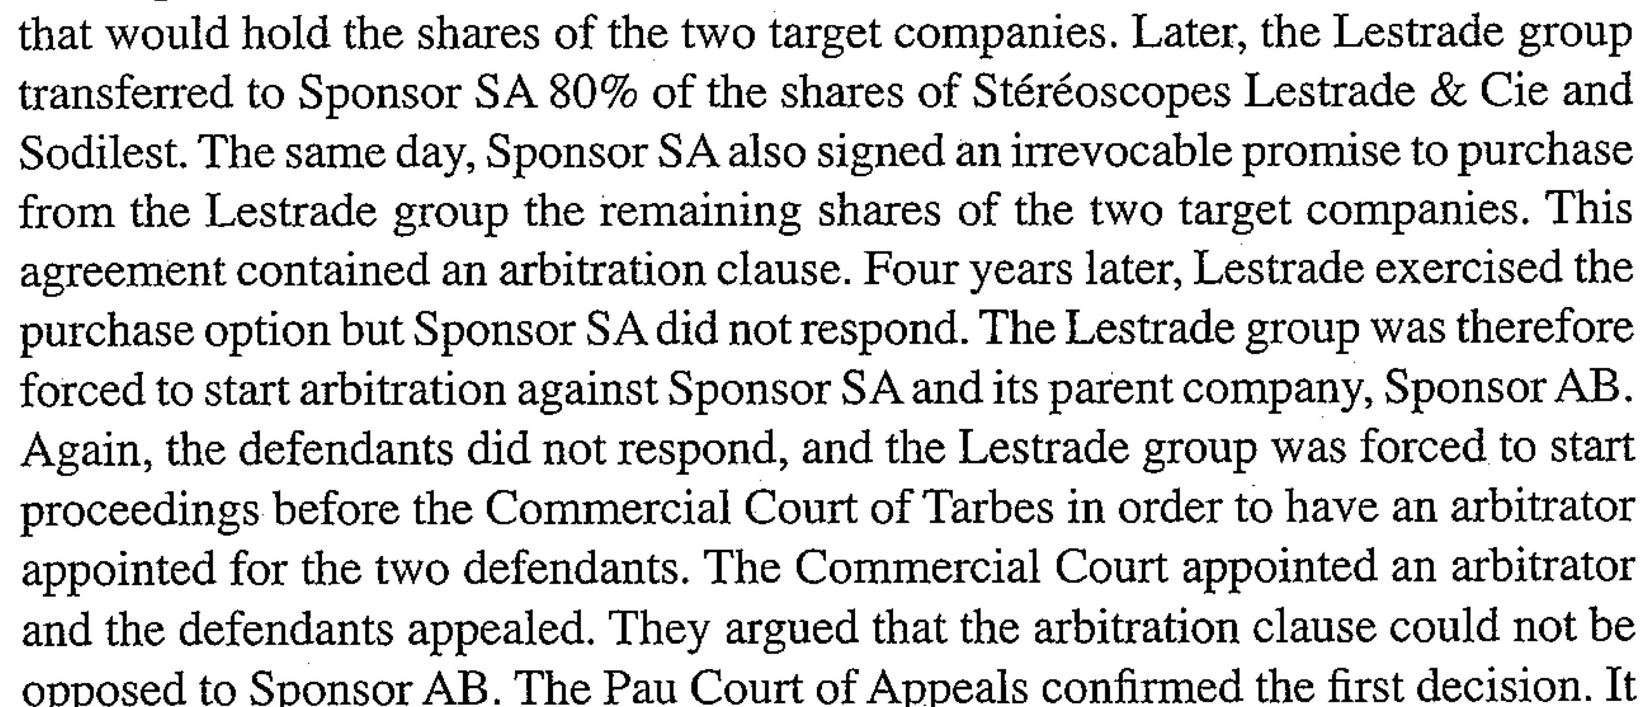

CA Pau said:

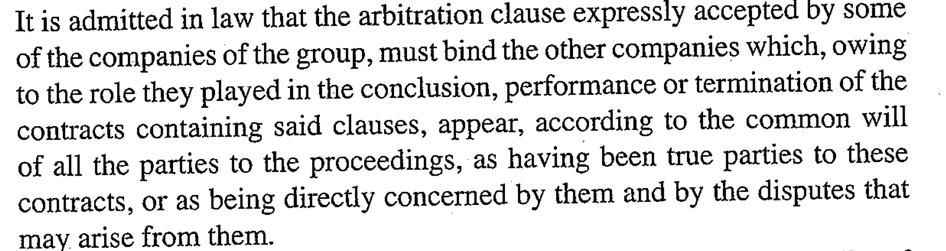

🡺 Which has to be taken into account is the single economic reality and not the separate legal personality of each!

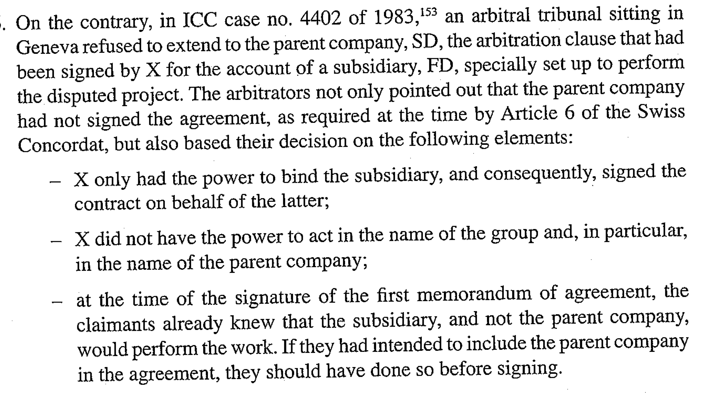

🡺Contradiction between French courts liberalism and reluctance of some arbitrators.

Under the same factual pattern the requirements in American courts to extend an arbitration clause to a parent company are much less stringent : the requirement of intent to be bound bu the clause is not necessary. A close relationship between the entities or evidence that they are inherently inseparable seem to suffice to permit an extension to the parent company.

Ex: Sunkist soft drinks, Inc v. Sunkist Growers, Inc

Ryan and Sons v. Rhone poulenc Textile SA “*when the charges against a parent company and its subsidiary are based on the same facts and are inherently inseparable, a court may refer claims against the parent to arbitration even though the parent is not formally a party to the arbitration agreement”.*

Also see Metalclad and the In re Currency conversion fee antitrust litigation cases.

Finally there are exceptional cases where the extension was granted on the basis of the position taken by the non-signatory in parallel proceedings:

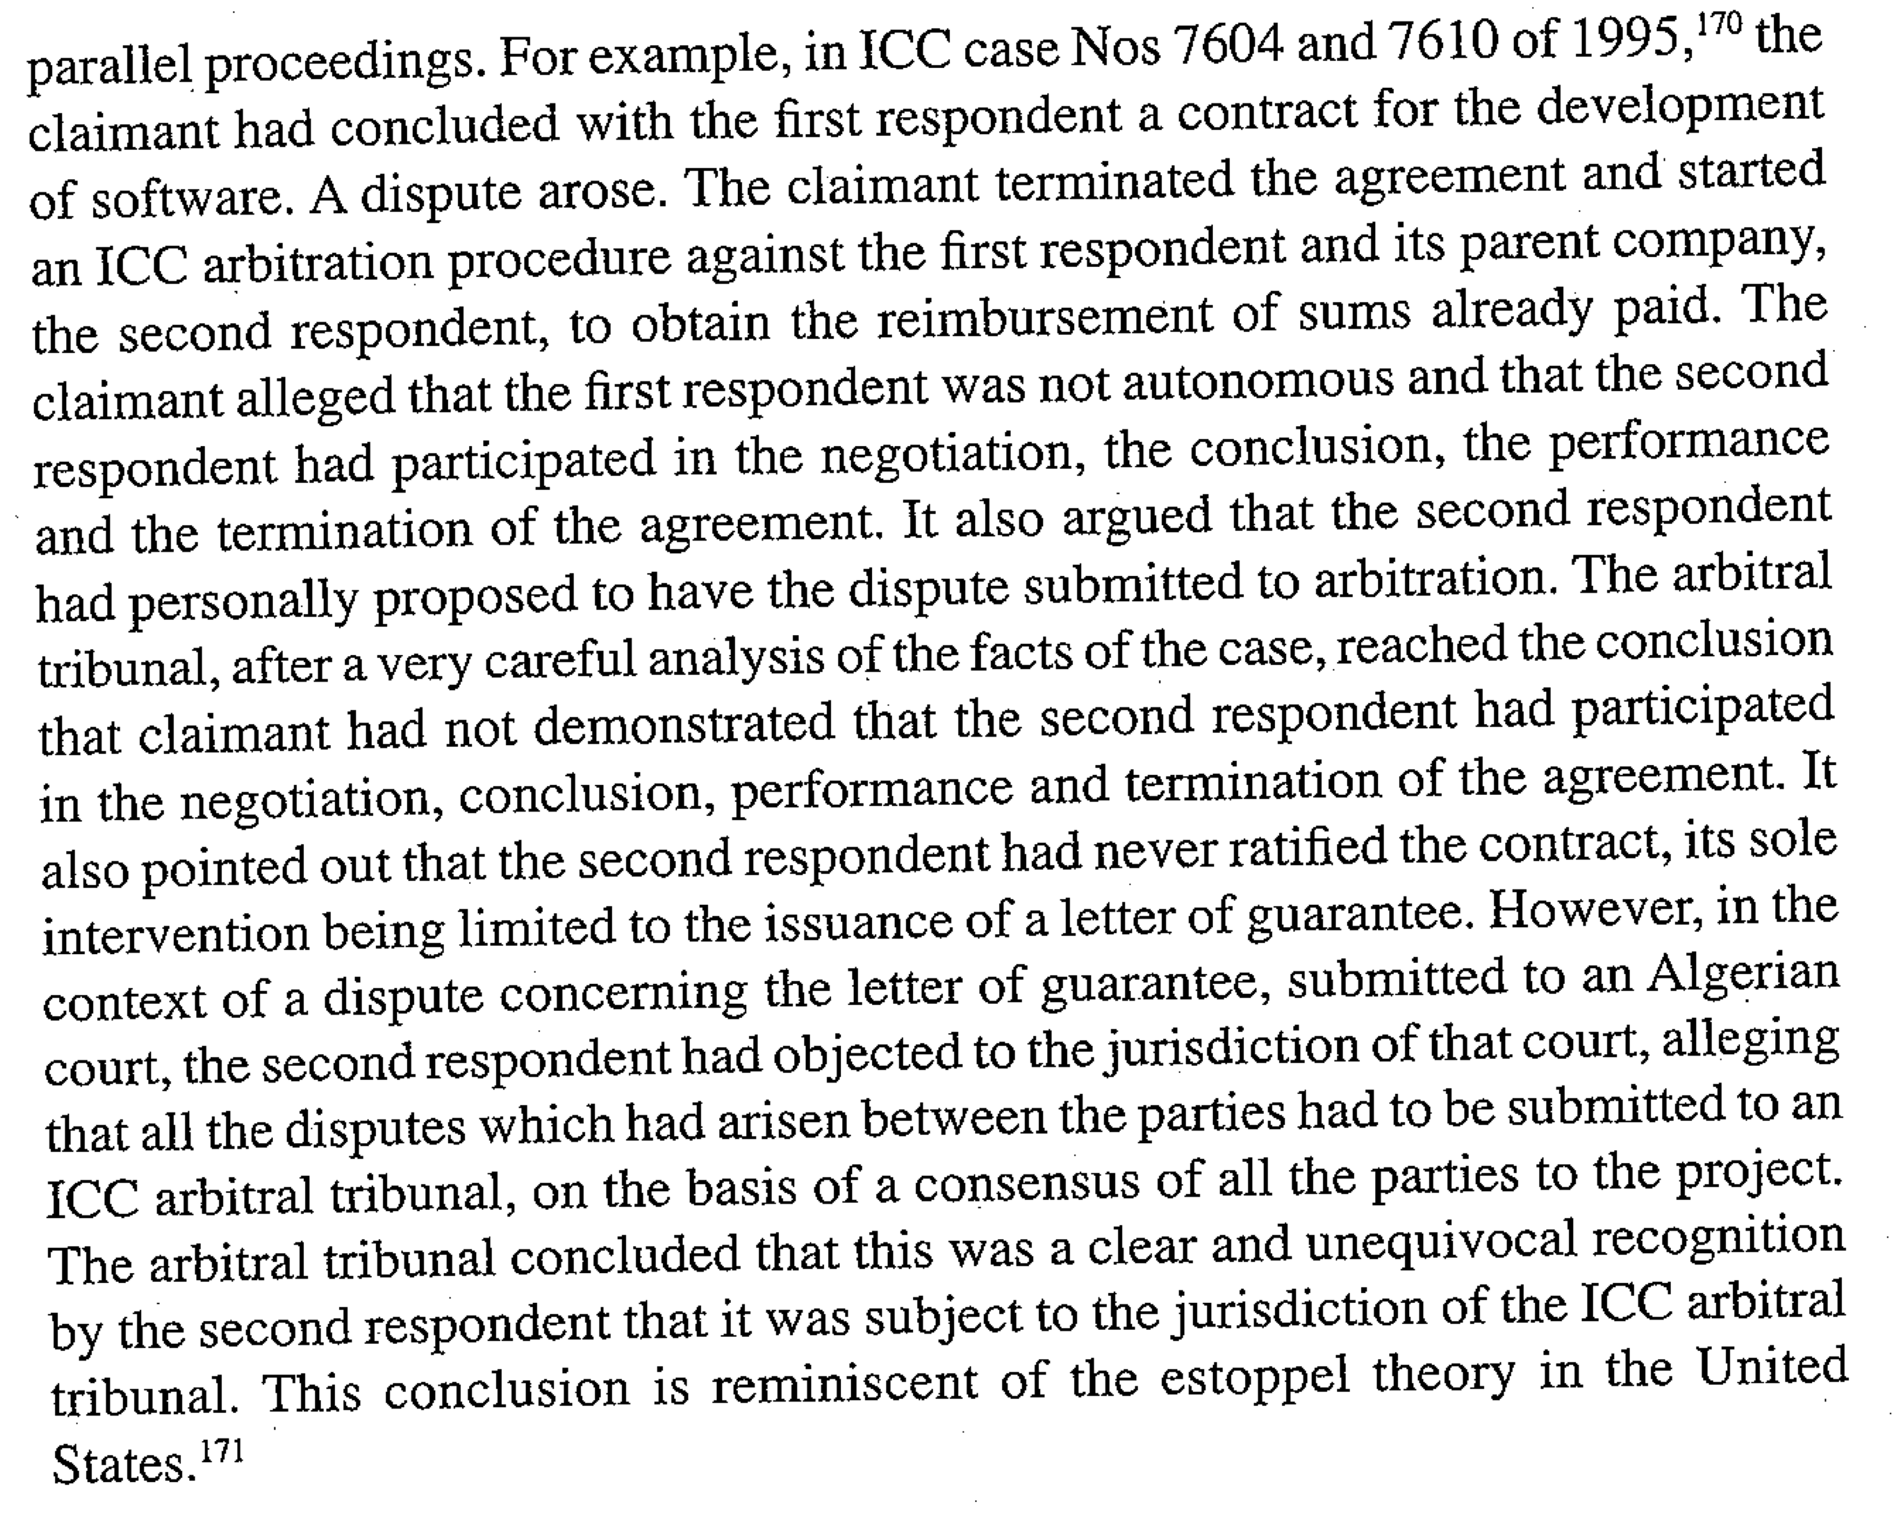

1. **Extension to a state**

When a contract is signed by a state-owned company or a state entity it is not unusual that claimant tries to extend the arbitration clause contained therein to the state itself.

🡺 Same legal issue as for a group of companies: in both cases it **is the INTENTION** of the parties that is the main criterion to determine the scope **rationae personae.**

ICC case: Pyramids 1983

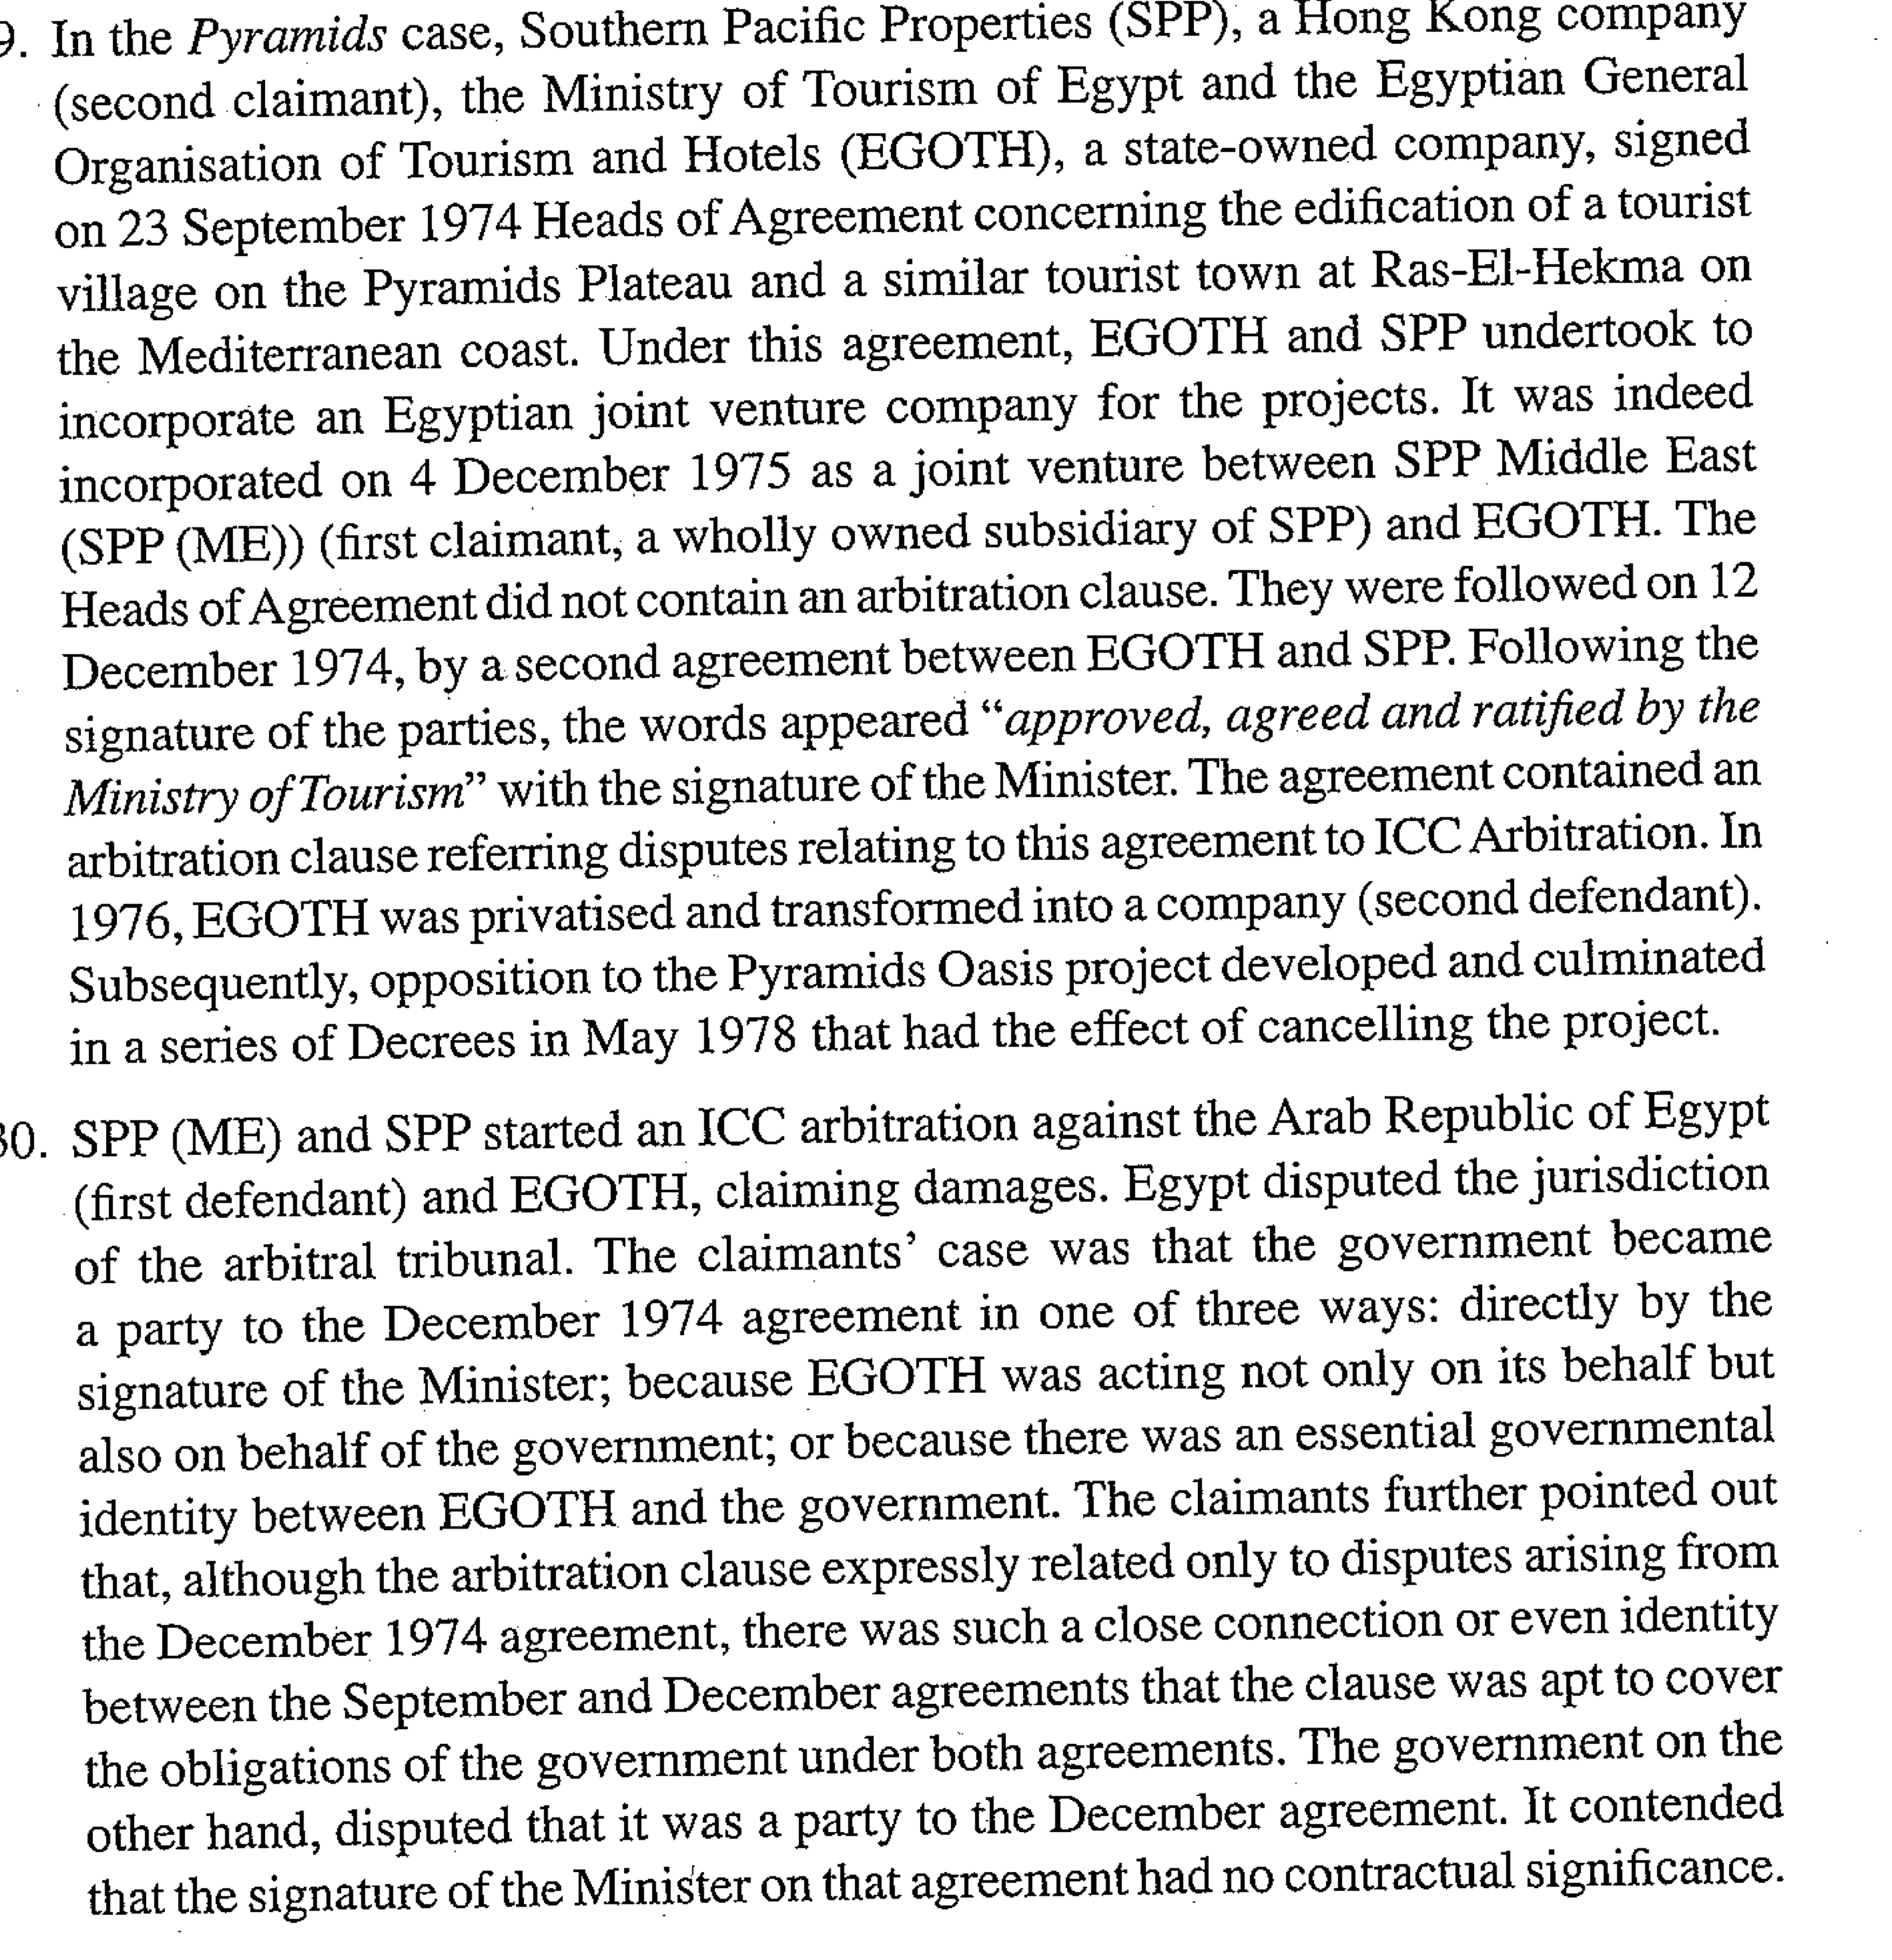



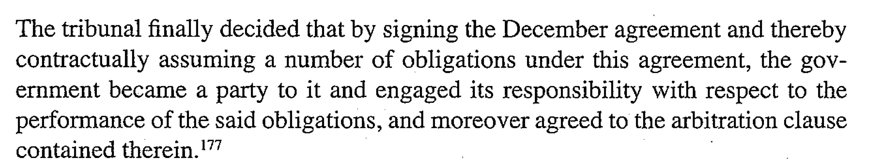

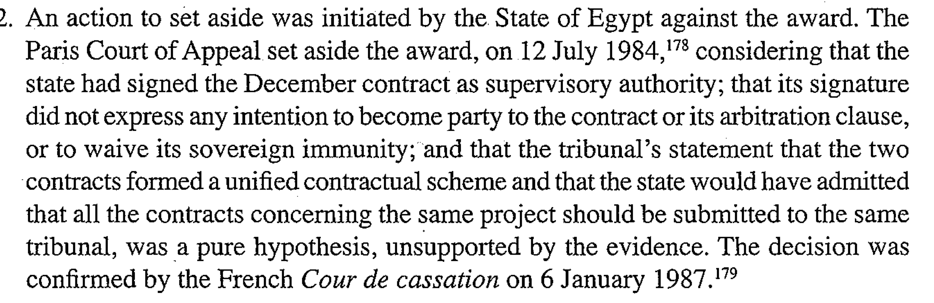

Bridas v. Government or Turkmensitan also of great interest

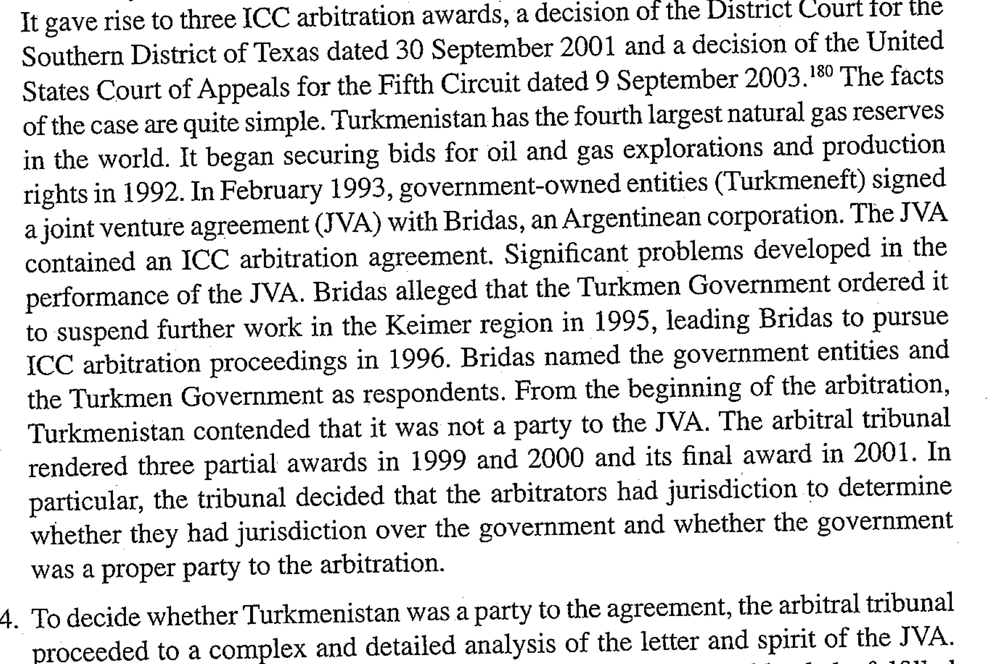

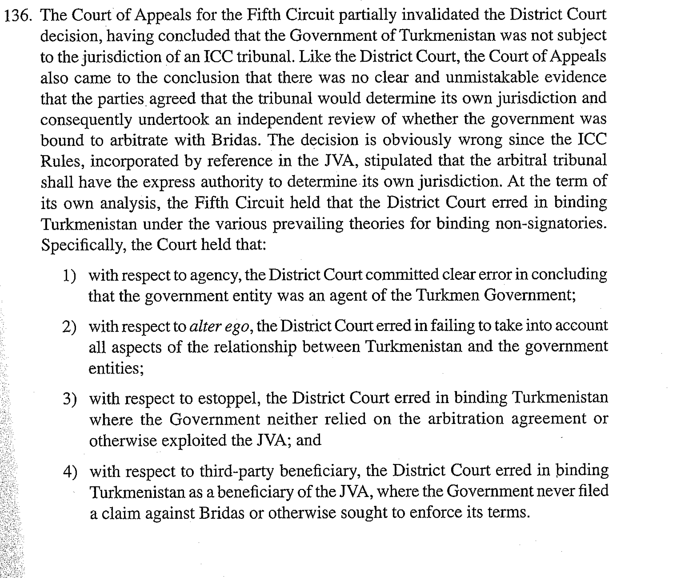

1. **Extension to one or More Subsidiaries or One or more companies of the group that are not subsidiaries.**

ICC case, n°4504 of 1985-86

Arbitration took place in Geneva

Arg raised by the claimant to try to justify the jurisdiction of the arbitral tribunal vis-à-vis the second defendant:

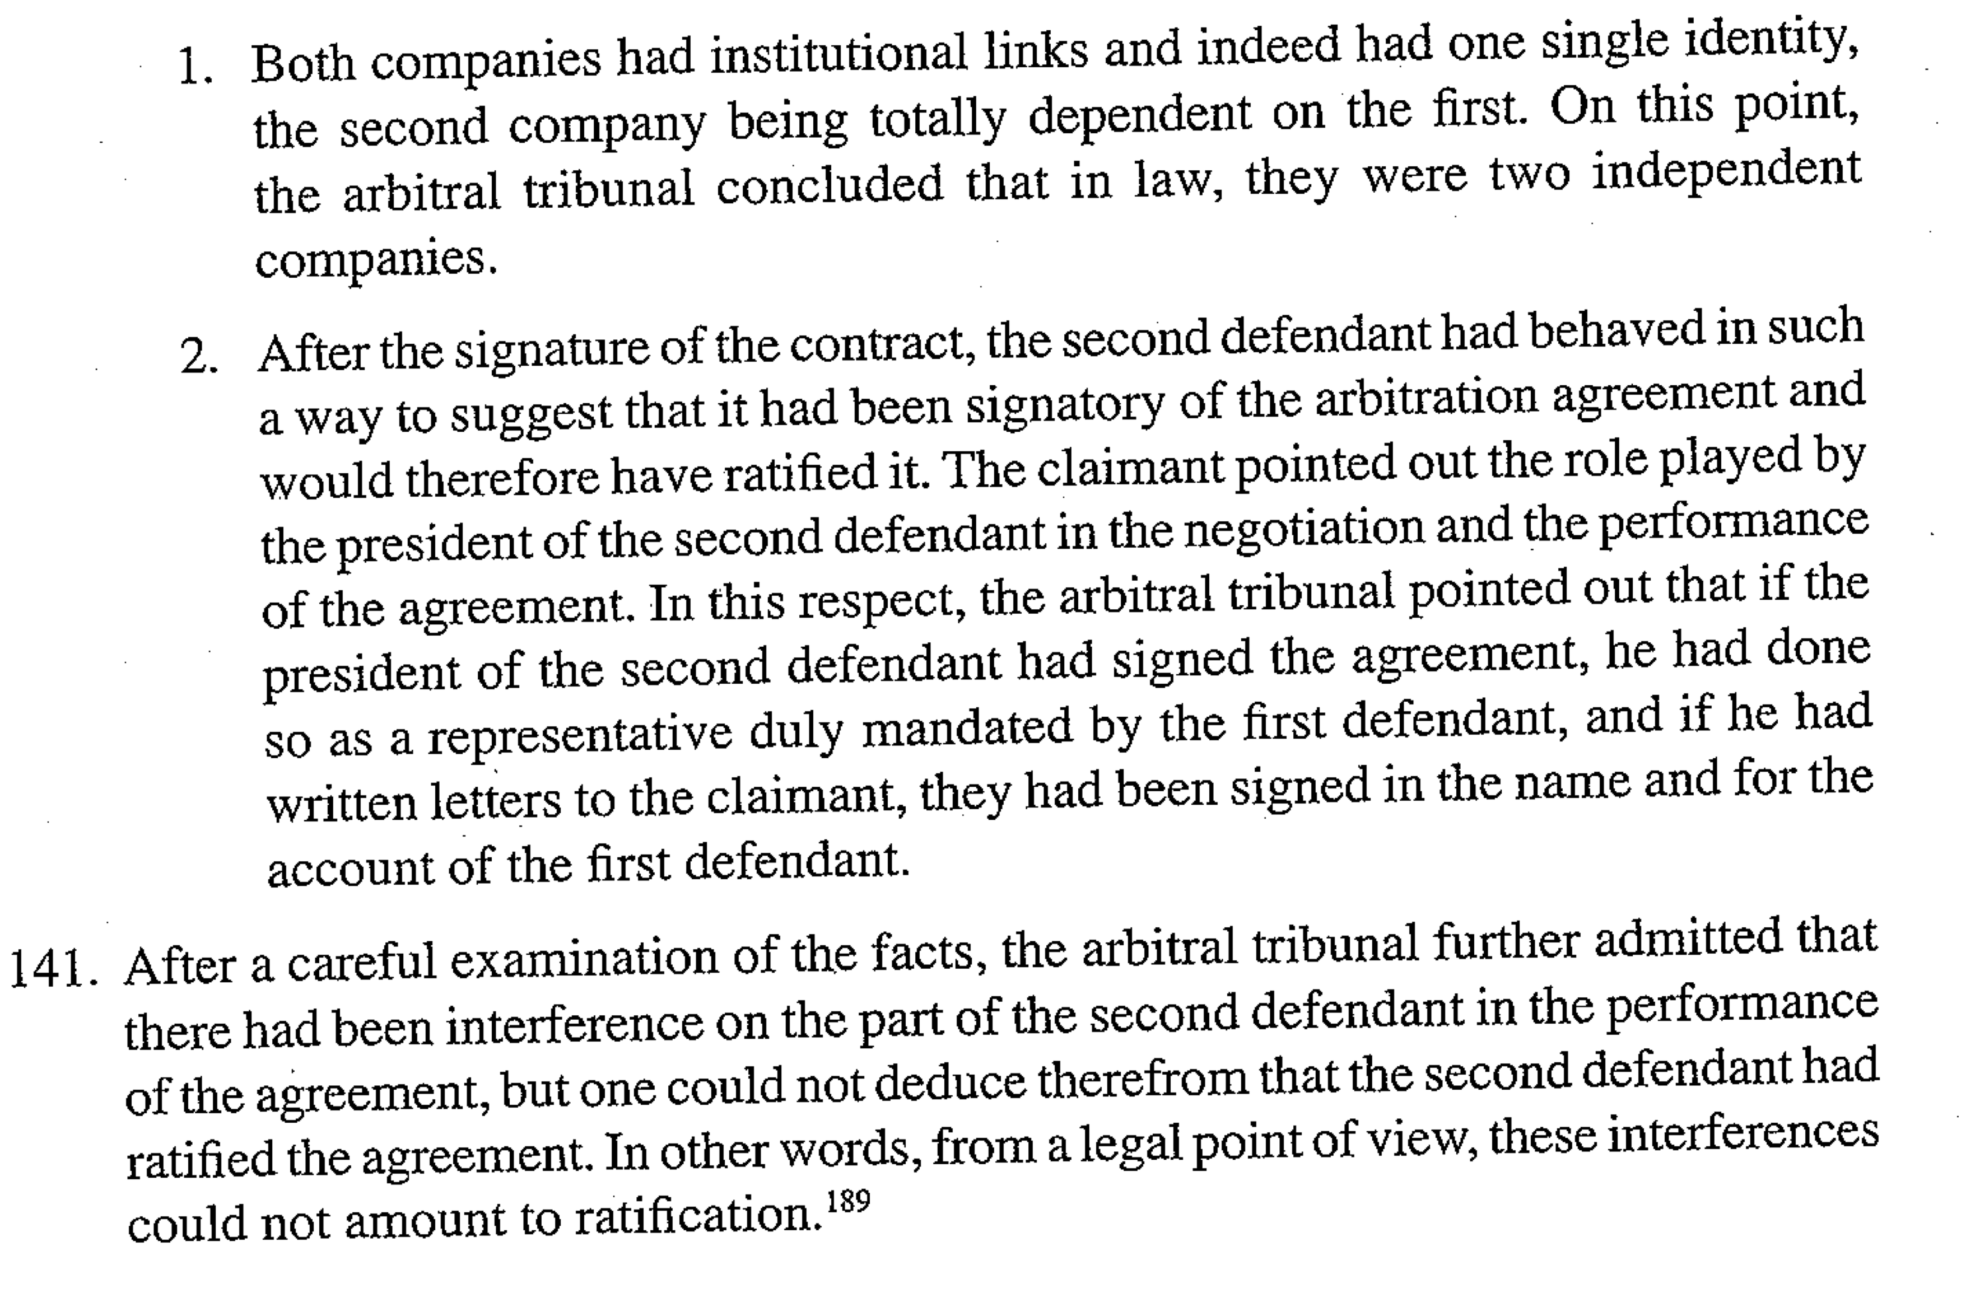

The **doctrine of “piercing the corporate veil**”: the central question is the legal independence of the juridical person. This means that the controlling company may be liable instead of its subsidiary, while in the case of an application of the **“group of companies” doctrine, the** existence of a subsidiary as a separate legal entity is beyond dispute and the problem arises in relation to the exclusive legal capacity of the subsidiary.

For the Swiss tribunal the existence of a group is not sufficient also need:

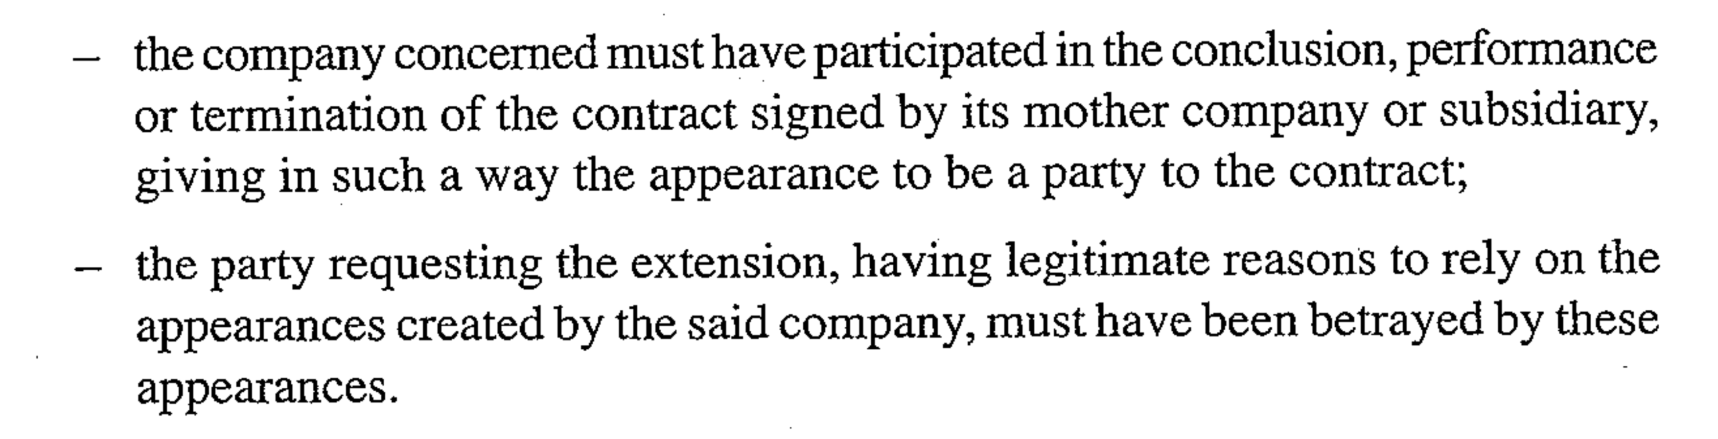

USA: United International Holdings inc. v. Wharf Holding ltd

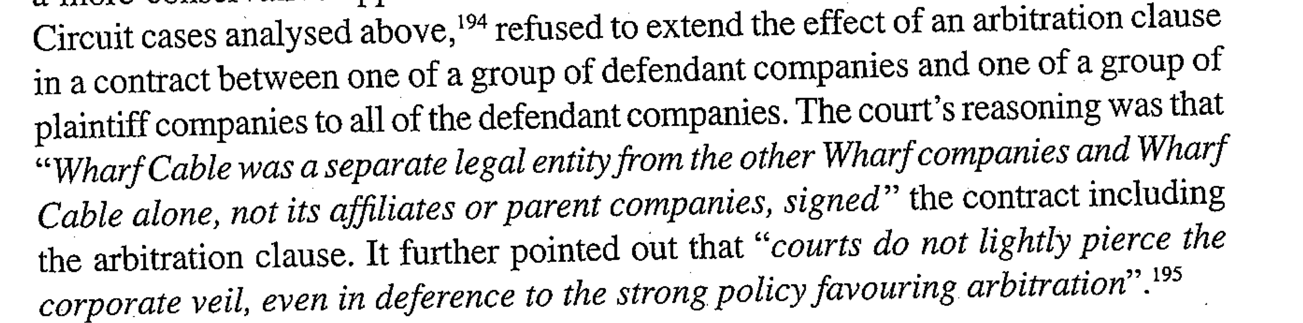

On the other hand in ICC case n°1434 of 1975

The arbitral tribunal accepted the extension on the following grounds:

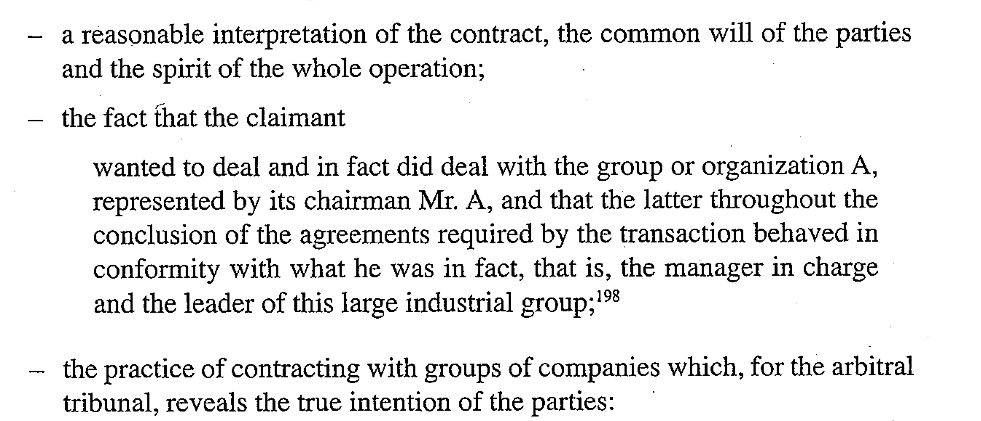

USA: Smith/Enron Cogenerational Ltd Partnership v. Smith Cogeneration

Enforcement of an arbitration agreement by requiring a party to the agreement to arbitrate with companies that were no longer parties to the agreement.

🡺The Court based its conclusion on an identity of interest between petitioners and the current Enron signatories to the disputed agreement and on estoppel.

1. **Extension to as Sister Corporation and an Employee**

USA: Pritzker v. Merrill Lynch, Pierce, Fenner and Smith.

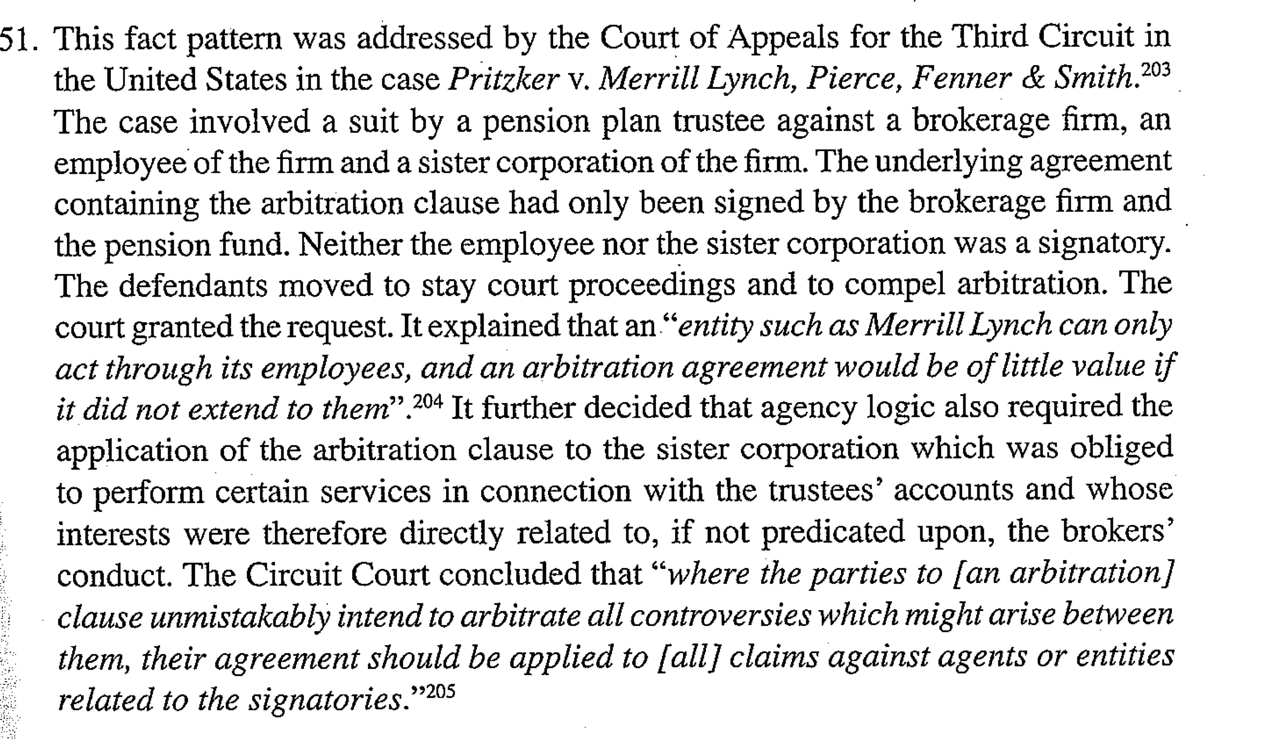

🡺 Such a liberal approach would not have been adopted by a court in Europe in the absence of specific circumstances showing, at least implicitly, the intention of the employee and the sister company to be bound by the arbitration clause.

1. **Extension to Another Company, Unrelated to the Signatory**

USA: Ervin v. Nokia Inc.

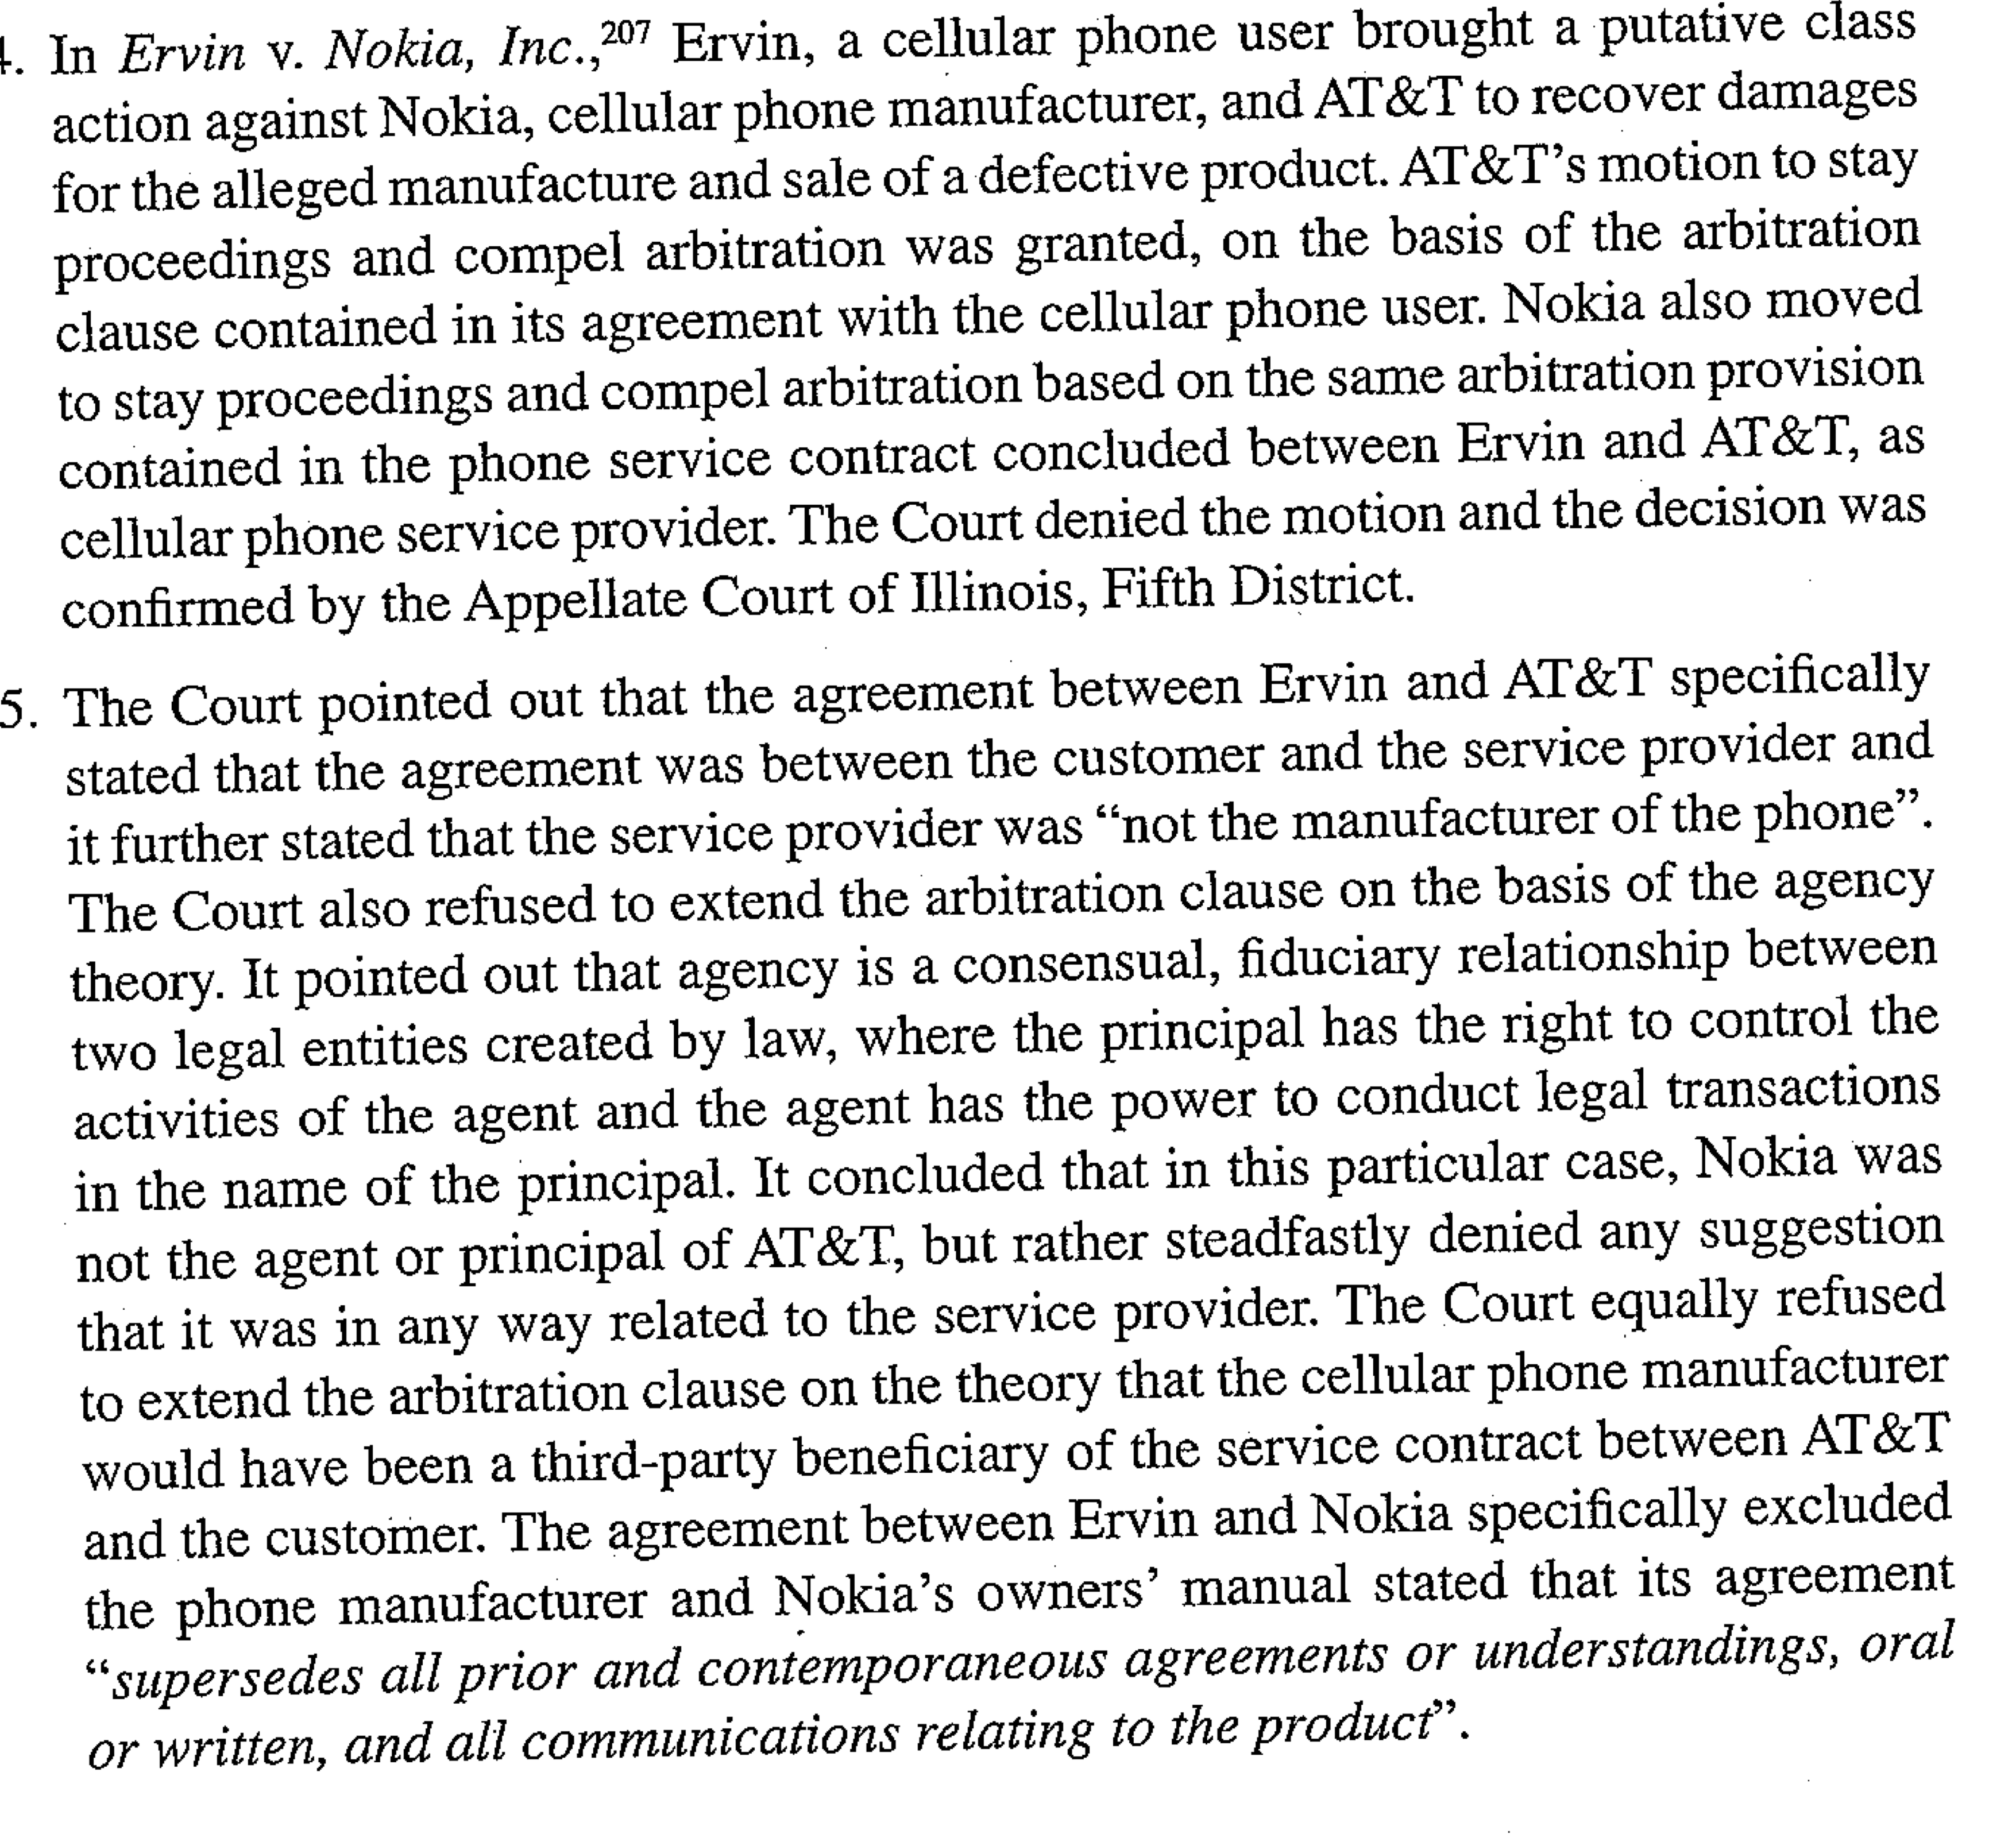

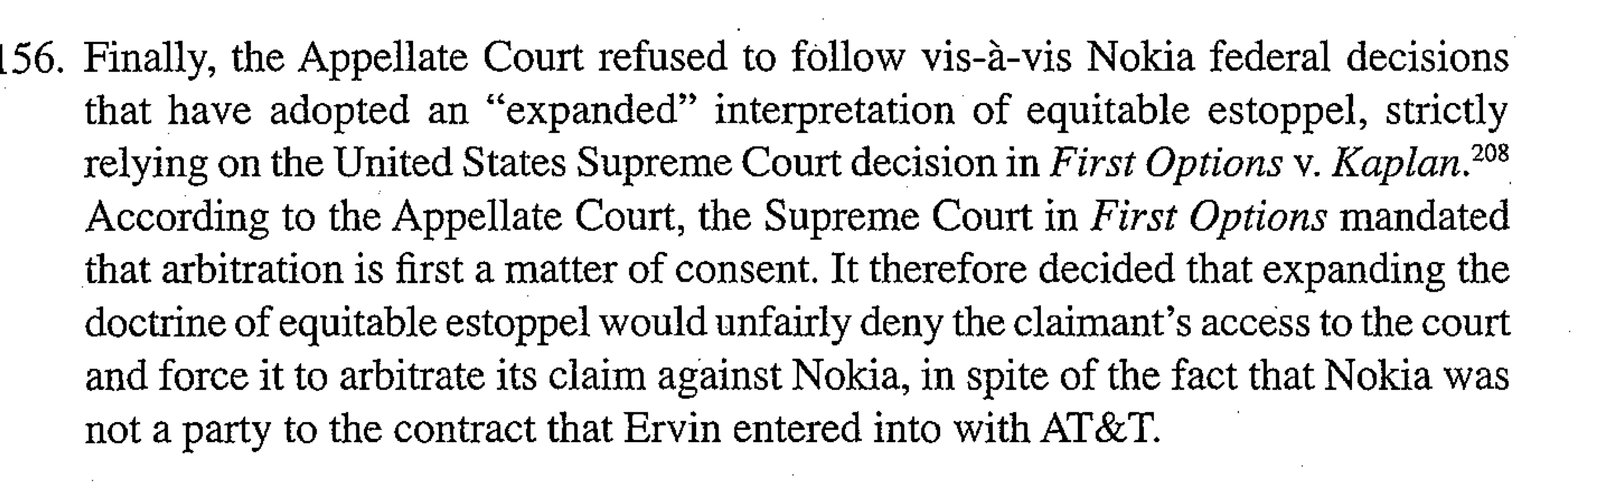

1. **Extension to a director of General Manager or CEO or to the Owner of the Group.**

ICC case n°4972 of 1989

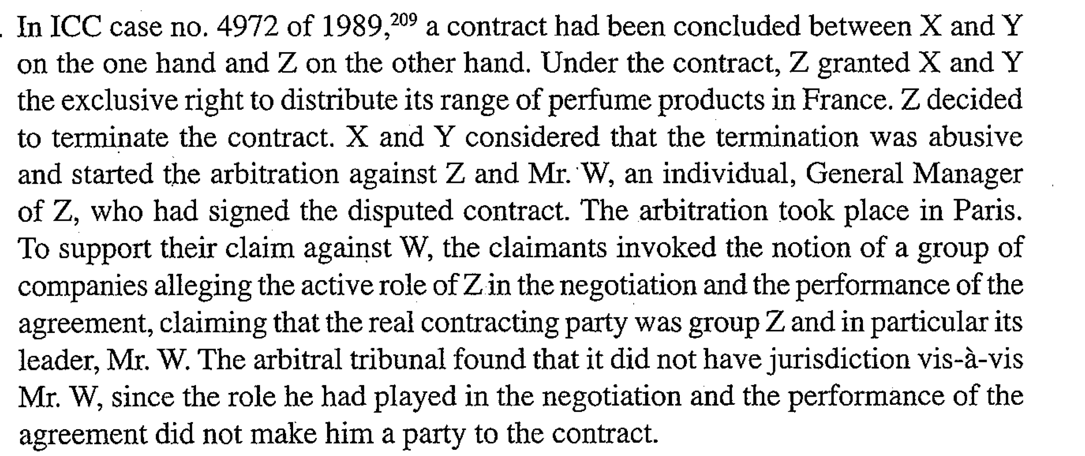

USA: Kaplan v. First Options

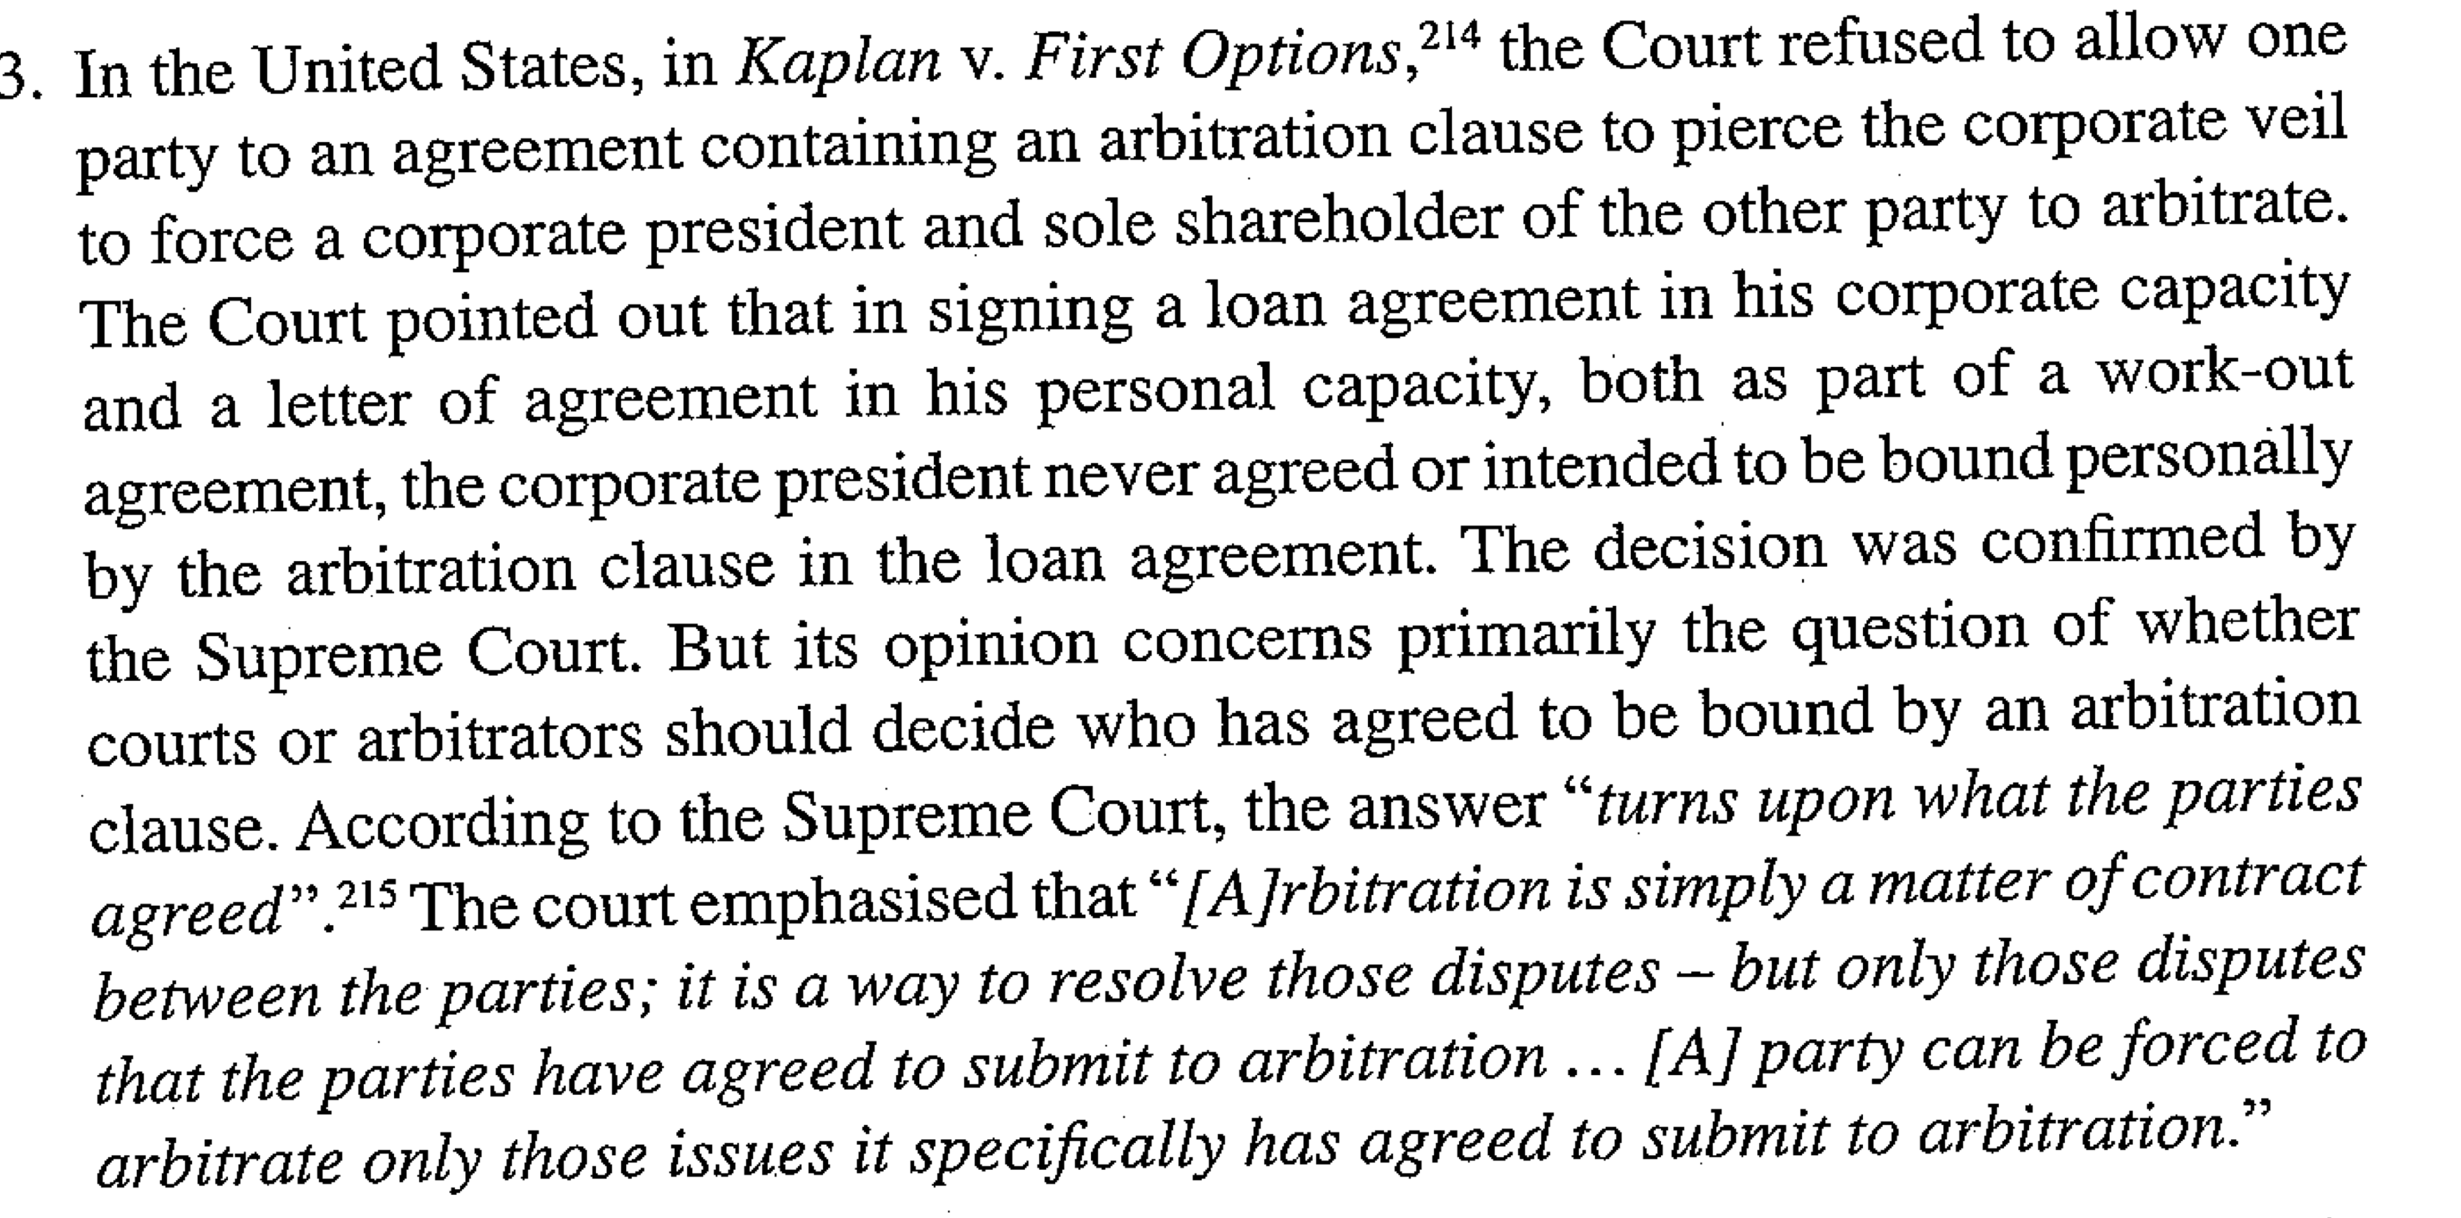

1. **Extension to an Individual (Possibly a Majority Shareholder of the Group) and another company within the Group.**

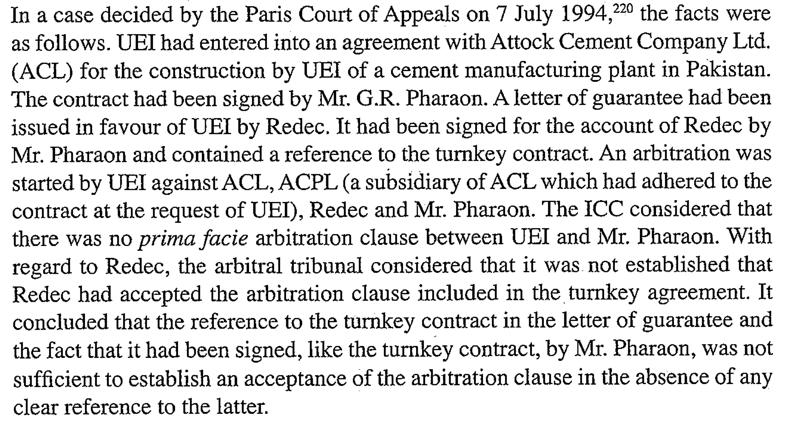

**Sub-section III : Extension to One or More Non-signatories as Additional Claimants**

1. **Extension to the parent company**

ICC: AT decided that the the second claimant might well own the intellectual property rights licensed to the defendant did not give him the quality of co owner of the contractual rigfhts ad obligations flowing from the disputed agreements containing the Arb clause

Amco Asia v Indonesia: ICSID tribunal disagreed with the gov and recognized the parent company as capable of bringing an arbitration

1. **Extension to a State**

NPF and state X: the lack of independence of the NPF from the state was confirmed by the effective control of the state authorities on the management of the NPF

The AT reached the conclusion that the NPF was a functional part of the state and that dealing with the NPF, the respondent were necessarily aware that they were dealing with the an organ of state X or its government.

The negociations process showed that NPF was an organ of state X, and implemented the will of the gov of state X as expressed by the ministry of finance

1. **Extension to an Individual (possibly a Majority shareholder of the Group) and other companies within the group**

Courts require proof of the existence of intent –at least implicit- of all the parties, that the non signatories be parties to the underlying contract and its arbitration clause

This intent must be common to the non-signatories and the other parties to the arbitration clause

One element that is also taken into consideration by the AT to determine the implicit intent of a non-signatories be party to the agreement is whether the non signatory may be deemed to have agreed to assume the obligations flowing from the underlying agreement in the same manner as the parties who have signed the agreement

1. **Extension to one or more subsidiaries or one or more companies within the Group that are not subsidiaries**

“*their situation and their activities give rise to the presumption that they were aware of the existence and the scope of the arbitration clause event though they were not signatories of the contract which provides for it*”

The AT determined the “test” to be applied as : “considering that the arbitration clauses expressly accepted by certain of the companies of the group should bind the other companies which, by virtue of their role in the conclusion, performance or termination of the contracts containing said clauses, and in accordance with the mutual intention of all parties proceedings, appear to have been veritable parties to these contracts or to have been principally concerned by them and the dispute to which they may give rise”

Cf. Dow Chemical France

1. **Extension to a director and principal shareholder**

**Conclusion :**

The extension of the arbitration clause to other companies of the group –non-signatories- started in France and still today its courts and arbitrators are among the most innovative in the development of this jurisprudence

The issue of who is party to the arbitration clause is therefore mainly viewed as an issue of consens, but “extension” may nevertheless be achieved by recourse to such other theories as agency, trust or piercing the corporate veil.

* First conclusion: The determination should be “fact specific” and may differ depending upon the circumstances of the case.
* Second conclusion: AT do not often base their decision to extend the clause or not on a prior determination of the applicable law

Group of company is not per se a sufficient element to allow the extension

In most cases, courts and tribunals require proof of the existence of an intention at least implicit of all the parties that the non signatories be parties to the underlying contract and arbitration clause

Some courts limit themselves to an awareness of the clause and the requirement that the additional party be concerned by the dispute. But the company concerned must have played a role in the conclusion and performance of the agreement and this has to be proved by the party requesting the extension

A parent company binds its subsidiaries but only parties that have participated in te conclusion and performance of the agreement will be bound by the contract and the arbitration clause

Lift of the corporate veil: usually limited to cases of fraud, abuse of rights and violation of mandatory rules

AT and courts have also emphasized the right to use a group structure as appropriate, but once the choice has been made, it must be fully assumed: the use of a company vehicle for tax or other reasons is not per se an argument to justify lifting the corporate veil and extend the Arb clause

Finally it appears that in relation to the issue of extension of the clause to non signatories, American case law is much more liberal than any Europe, at least in come circuits, the paramount concern of the courts being the federal policy favouring arbitration

* **Sub-Chapters 5.1 and 5.2 from the book by Greenberg, Kee and Weeramantry (see Chapter 5 re-attached); and**
* **Articles 6-10 of the 2012 ICC Rules of Arbitration (in the Syllabus binder and online).**